ALPS Analysis following Year 13 Mocks January 2023
When looking at this data it is important to remember how this cohorts KS4 APS was determined. This cohort was TAGs. Schools were tasked with how they were going to assess and determine grades so would have had different processes, and evidence bases. As you know we did internal exams in the normal way but the content as for all schools was reduced and schools were explicitly told to provide students with a content list for what they were going to be assessed upon. We take a number of students for a variety of schools and therefore we do not know what their process or evidence base was.
Given the methodology of ALPs using KS4 APS over a number of years to then set benchmarks for KS5 achievement – it does bring in the question of the validity of this data given that this cohorts KS4 APS cannot be compared to last years or previous years but it is a guide that can be used with this in mind.
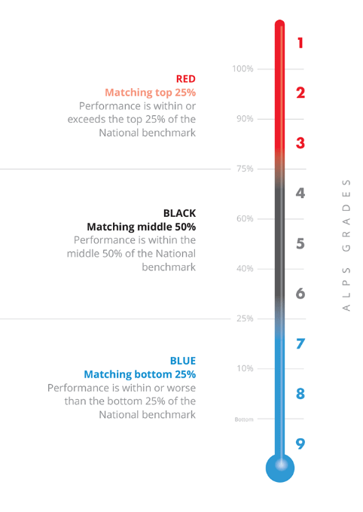
Art | Alps 5 - Black
Biology | Alps 6 – Black
Business | Alps 9 – Blue
Chemistry | Alps 7 – Blue
Theatre Studies | Alps 5 – Black
Economics | Alps 8 - Blue
English Language | Alps 8 – Blue
English Literature | Alps 8 – Blue
Film Studies | Alps 5 – Black
Geography | Alps 8 – Blue
History | Alps 9 – Blue
Law | Alps 8 – Blue
Maths | Alps 8 – Blue
Media Studies | Alps 8 – Blue
Music | Alps 7 – Blue
Philosophy | Alps 5 – Black
PE | Alps 6 - Black
Physics | Alps 7 – Blue
Psychology | Alps 8 - Blue
Sociology | Alps 7 - Blue
Spanish | Alps 6 - Blue

BTEC Ext Cert Music | Alps 9 – Blue
BTEC Ext Cert H&SC | Alps 3 – Red
BTEC Ext Cert Sport | Alps 5 – Black
BTEC Ext Dip Business | Alps 4 – Black
BTEC Ext Dip H&SC | Alps 6 – Black
BTEC Ext Dip PE | Alps 4 – Black

