Standards and Performance Governor’s Committee January 2019
Attendance report:
Report to Governors | DATE | DATE
 | Sept - 18 Dec 2018 | Sept - 19 Dec 2017
Overall Attendance Yrs7-11 | 94.9% | 95.1%
Overall PA (under 90%) | 13.8% | 13.7%
Overall PA (under 85%) | 8.0% | 6.1%
Overall Attendance by Year Group
Yr7 | 96.4% | 97.3%
Yr8 | 95.7% | 95.5%
Yr9 | 94.7% | 94.7%
Yr10 | 93.7% | 93.4%
Yr11 | 92.6% | 94.9%
MECES open cases | 0 | 2
Attendance of MECES open cases |  | 72.4%
Monthly Attendance Yrs 7-11
NOV | 94.1% | 95.8%
DEC | 93.2% | 93.2%
Attendance by category
BOYS | 94.7% | 95.5%
GIRLS | 94.5% | 94.8%
LAC | 96.4% | 87.0%
PP | 90.6% | 88.8%
SEND | 93.5% | 93.6%
EAL | 94.6% | 95.2%
OASIS | 91.0% | 85.9%

Key areas of focus this term:
5 Y11 students with difficulties attending; 3 Y10 students with long term difficulties; 2 Y8 students with long term difficulties.
Issues | School Response
VM – Y 11 with long history of attendance problems – MTE in Y8 from St martins. In mid y10 was diagnosed with ME. | On part time timetable, with additional tutor support.  Oasis support when here.  Big improvement in attendance this year.
TC – Y11 – MTE St Martins in y10. Never really settled well – difficulty in getting medical profession to acknowledge mental health issues. | Additional tutor support. Attendance remains very patchy depending on how he is feeling.  Oasis support when here.
JB – Y11 - MTE BCHS – came here with acknowledged health problems – under medical investigation. No issue ever diagnosed – but often feels sick – potential eating disorder. | Full time Oasis support when here. Attendance is very patchy depending on how she is feeling.
RG – Y11 – many behavioural issues and issues at home. Very low attendance | Additional tutor support. Slow improvement.
AM – Y11 – developed mental health and anxiety issues this year. | Initially brought back into school under a P/T timetable – and now in full time with oasis support – still struggling.
HB – y10 MTE Anglo European – no issues until 12 weeks after arrival – then Mum claimed high anxiety but no medical diagnosis or support of this. | Team around the family meeting in school – and oasis support – attendance is still patchy but improved.
AS – y10 – issue outside of school hit confidence and created high anxiety. | TAF meeting; home visits and CSS health referral. Oasis support when in.  No improvement to date.
SCT – Yr8 – School refuser, poor parenting skills | Family Solutions working with family, Team Around the Family meeting in school
JH – Yr8 – Medical diagnosis Anorexia, Mental Health Issues | Working with medical professionals
LB – Yr10 – Behaviour outside of school | Hard to reach Parent, various outside agencies have been offered to the family

Attendance challenge – monetary incentive for improving attendance aimed at PP students just into persistent absenteeism:
Yr10
MG 85.4%; JG 86.2%; SS 86.2%; GH 87.1%; KB 88.7%; KJ 88.7%; CT 88.7%

Yr9
HP 85.5%; PH 87.9%
Yr8
AM 85.4%
Results to be analysed 14.02.19.
Positive postcards sent to students between PA and expected attendance of 95% to give them a boost before attendance becomes a problem:
Yr7
LC; RM; TO; SR; BR
Yr8
HA; CB; MC; AH; FH
Yr9
DE; LE; CH; TH; AP
Results to be analysed 14.02.19.
Number of absences taken for holidays in Autumn Term:
Year | Holiday absences (Number) | Number authorised | Penalty noticed issued.
Y7 | 46 sessions | 18 sessions | 3
Y8 | 102 sessions | 34 sessions | 2
Y9 | 50 sessions | 2 sessions | 1
Y10 | 42 sessions | 20 sessions | 0
Y11 | 4 sessions | 2 sessions | 1
Y12 | 10 sessions | 4 sessions | 0
Y13 | 31 sessions | 11 sessions | 0

2 sessions make one day. Penalty notices cannot be applied for unless attendance is already below 90% and/or only of the holiday is more than 5 consecutive days. This limits the number we can apply for, but generally by following these rules, we are successful in those that we do apply for. Penalty notices for irregular absences – this has to be under 90% and 10 absences in a 10 week block. We have issued 8 of these this year, and two sets of parents have gone to court for possible custodial sentences regards their child’s non-attendance. In both cases, parents were given Community Service orders, and more importantly, a key worker to help them set proper boundaries for their child. In both cases attendance has improved tremendously.

Types of absence Y7 – 11
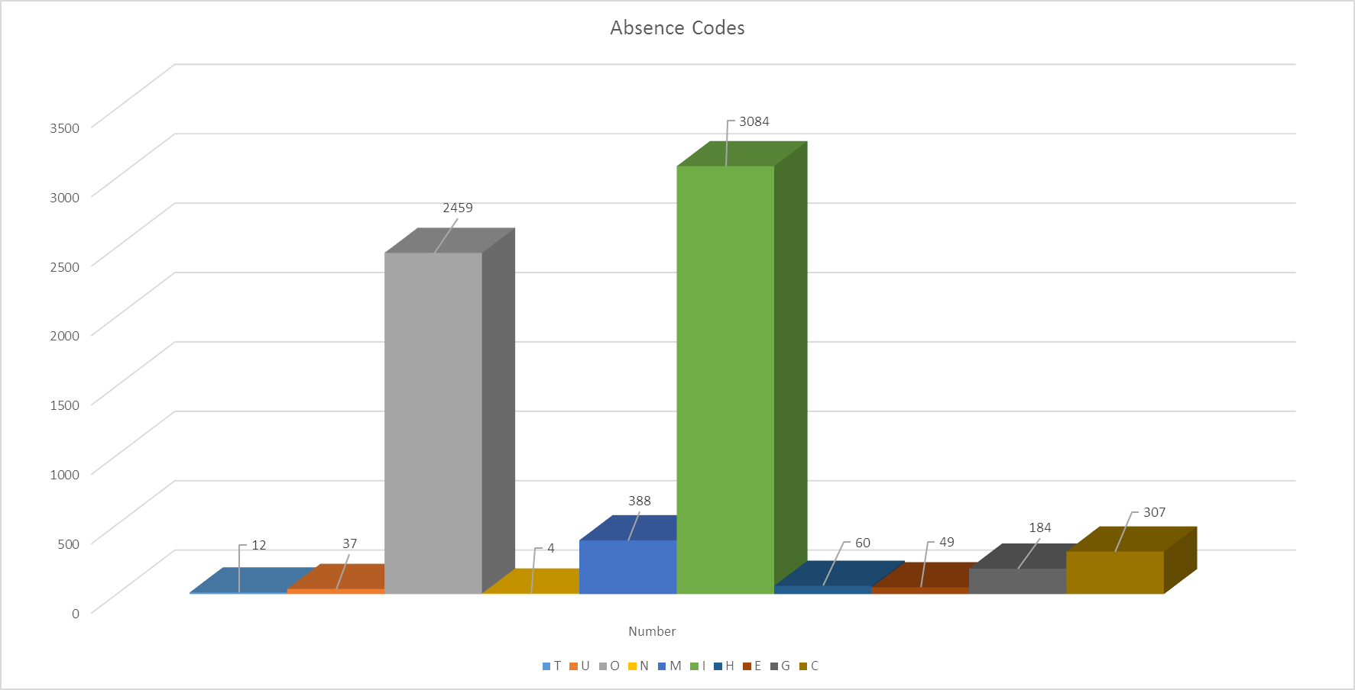
Green block = evidenced illnesses and the grey block = unauthorised absences, the mustard black at the end = authorised absences and the dark grey block is unauthorised holiday. This puts into context what our absence pattern looks like – we can do nothing about evidenced illnesses and we use many different strategies to try and deal with the large number of unauthorised absences.

