Extraordinary Report to Governors during Covid19 School Closure
July 2020

This is the fourth extraordinary report issued since the closure of the school due to the COVID19 pandemic and should be read in conjunction with the reports for March, April and May to get a full picture of our actions and considerations during this unprecedented time.

This report will cover the following main areas:
- Arrangements for results days
- Arrangements and risk assessment for full opening in September
- Recommendations for next year’s School Improvement headlines
- Further arrangements for the new academic year.

The following documents have been taken into account when formulating our proposals:

Government guidance for the reopening of schools: Guidance for full opening: schools - GOV.UK

Ofqual consultation outcomes: Ofqual GCSE and A level consultation outcomes and autumn exam series proposals - GOV.UK

In preparation for our meeting, you may find it helpful to consult the following National Governance Association documents:
information sheet
governing in covid-19 times: continuity and recovery
set of FAQs

i) Arrangements for results days

Results will be sent out by email at 8am on 13th August for A Level and BTEC Level 3 and on 20th August for GCSEs and BTEC Level 2.
Because of the unprecedented circumstances, there is no right of appeal this year and it has been determined by Ofqual that students who do not feel that their results reflect their ability can take exams in the autumn term. Clear information has been sent to students and parents about the process of awarding centre-assessed grades and the role of the exam boards in finalising grades through a standardisation process. The following info graphic is a helpful summary:
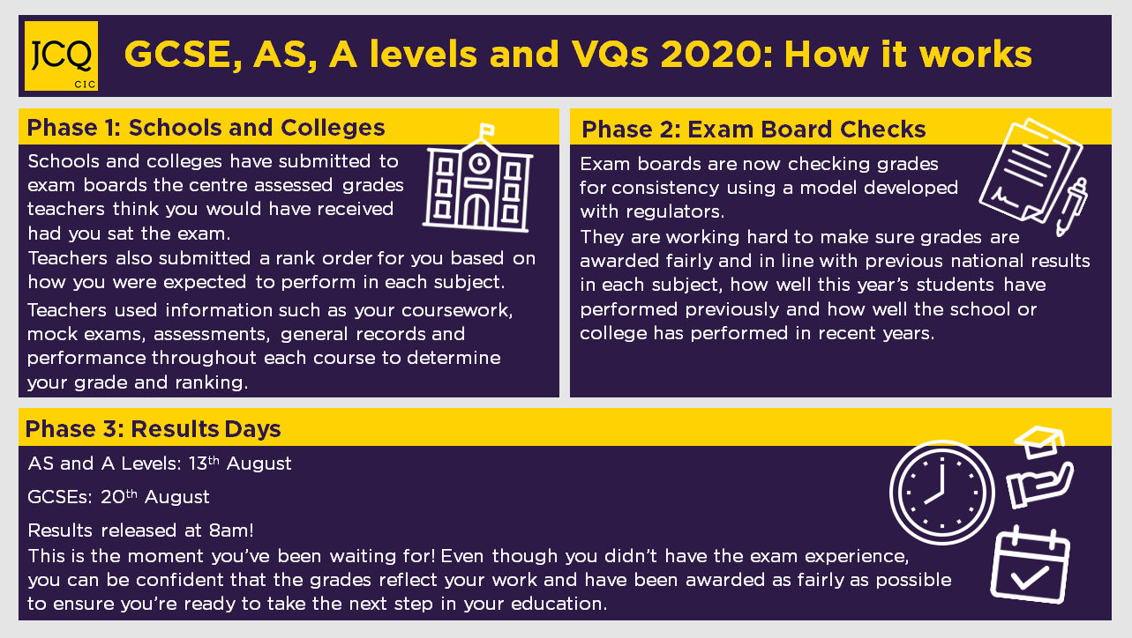
We have already analysed the centre-assessed grades of our internal students and are ready to offer sixth form places to both those who have met our entry criteria or for whom some exception can be made in these unique circumstances. In addition, Heads of Department will contact students following results publication to discuss entry onto courses but being subject to close monitoring.
External students wanting to secure a place in our sixth form will be invited to attend with proof of their results from noon onwards on results day. Appropriate safety measures are being put into place.

Preparation for full opening in September
It is our intention to deliver our full curriculum and allow students access to specialist rooms. Following detailed discussion, the following proposals follow the imperatives of government guidance and take full account of further advice in determining what we can make work in our context. This section of my report should be read in conjunction with Risk Assessment for Full Re-Opening.

Objective | Plan | Further operational detail | Comments
Arrangements for the beginning of term | - We will have a modified staggered start to the term:  - 1st September: Inset Day;  - 2nd September Y7 start and Y12 registration;  - 3rd September:  - Y8, 9 and 13 start;  - 4th September Y10 and Y11.  - 7th September Y12 start | - Y7 arrive between 8.30am and 9am  - Register in playground/South Hall – weather dependent – and go to form rooms  - Virtual assembly in forms and tasks. Stay in form until 10am  - 10am – timetable begins but induction lessons delivered. Forms accompanied by form tutor.  - Arrangements to be made to organise fingerprints.  - As other year groups start, normal timings. Some information delivered in period 1 re safety measures or slightly extended tutor time. tbc
Reducing contacts in school | - In Y7, Y8 and some of Y9 students are in mixed attainment groups and each class can be treated as a bubble as far as possible. They will be with the same students in each lesson and move to each lesson with appropriate safeguards in place  - Y10-13 will be grouped according to curriculum needs and move from lesson to lesson with appropriate safeguards in place  - One way systems and other appropriate arrangements will be put in place to manage safe movement around the school. Students will be dismissed through external exits where possible and outdoor routes between buildings will be taken.  - Staff to always be at threshold of classroom and scanning classroom vicinity. Supervision of hand sanitising on entry. At lesson end, to be in corridors and dismiss students when safe to do so – ie being mindful of other groups leaving at the same time.  - At break and lunchtime, each year group has a designated area of the school:  Y7 – pavilion  Y8 and 9 – refectory. Y8 enter through internal door; Y9 enter through external door. Seated in year groups. Exit via exit door.  Y10 – Food Cube, picnic area and South Hall.  Y11 – Y11 café and immediate outdoor vicinity  Y12/13 – Sixth Form café. Sixth form may only leave at lunchtime if they have not got a period 5 lesson and are therefore leaving for the day.  - Mixed year group activities will not take place until further notice  - Extra-curricular activities will be risk assessed. Likely that most arts activities on hold until further notice.  - Staff encouraged to run year-specific clubs/Prep sessions  - Staff to teach from the front where possible and keep an appropriate distance from students where possible.
Safe entry at the beginning of the day and transport | - There is a natural staggering of arrival at the beginning of the day. Students to stay outside unless going to the refectory.  - Students advised about safe travel, including the use of a face covering on public transport and school buses. Disposable face masks to be removed safely and disposed of safely on entry to school. Bins will be sited at entrances.  - Refectory open for breakfast. Seating to be socially distanced.  - School will liaise with transport providers prior to September start.
Safe exit at the end of the day | - Exit from school supervised by staff. Staff to lead their class towards the exits and be a presence while students disperse.  - Students waiting for second bus may wait in the playground as usual.
Management of lesson changeovers | - A one-way system will be implemented where possible with the requirement to walk quickly on outside routes wherever possible.  - Students dismissed through external exits where possible.  - Door propped open to minimise touch points where safe to do so. All rooms well ventilated.  - Evacuation procedure to be modified
Management of break and lunchtime | - Y7, Y11 and the Sixth form have designated areas for eating and socialising  - Y8 and 9 use refectory, enter and sit in separate year groups.  - Library open to different year groups on different days. Y7- Monday, Y8 Tuesday etc. Sixth Form library assistants to be recruited so before and after school library opening is possible.  - Astroturf open to Y7 in first instance, except on Football Academy days
Extra-curricular activities | - In-school extra-curricular activities will be individually risk assessed  - Careful attendance records using Edulink will be kept of any extra-curricular activities that take place to ensure track and trace can be utilised if necessary.  - There will be no overnight trips planned for the autumn term, neither will any further overnight trips be planned for the future until further notice.  - Residential trips already scheduled will be assessed over time as more information and advice becomes available.  - Day trips, if any, will be – as always – subject to a thorough risk assessment
Management of site, equipment and environment | - Students expected to bring all of their own necessary equipment to prevent sharing. Students also encouraged to bring their own sanitiser.  - Sanitising dispensers will be placed in as many rooms as possible.  - All reusable equipment to be appropriately cleaned between classes  - Doors should be propped open where safe to do so and all rooms should be ventilated.  - Students will sit in the safest possible arrangement in each room. This will usually be facing front and side by side. Computer rooms have fixed arrangements.  - Respiratory and hand hygiene will be encouraged.  - Bins and tissues will be provided for every classroom. These will be emptied daily and disposed of safely.  - Mobile washing units to be leased and placed in designated areas of the school.  - Face covering will not generally be in operation in school but PPE will be provided for staff engaged in intimate care.  - First aiders will wear a face covering when attending anyone requiring assistance, especially if displaying Covid-type symptoms.  - The Oasis and Waves Rooms will be risk assessed and their use modified appropriately  - Cleaning team to cleanse surfaces throughout the day  - Arrangements to be made with Churchill’s for enhanced cleaning | - Whiteboards and spare equipment to be collected to aid ensuring that all students have their own equipment. Further mini whiteboards to be purchased so students have one each. TLs to organise collection of all mini whiteboards from old learning trolleys to a central collection point for sanitising and re-distribution.
Reducing risks associated with large groups being in once space | - A virtual Awards Evening is being planned  - Open Evening will not take place in the usual format.  - Virtual meetings will take place where possible  - Assemblies will be minimised and presented virtually where possible. | Virtual Open Evening:  Audio powerpoint for Head’s presentation; virtual tours; students’ voices using what has been recorded for transition; dept presentations and tasks
Reducing risks in offices and work spaces | - Staff encouraged to work at a safe distance from colleagues in non-contact periods – side-by-side or back-to-back.  - Additional cleaning of offices to take place. Staff to also be provided with sanitising wipes/spray to use as required.  - Meetings will take place in well ventilated rooms. Virtual meetings will take place where possible.  - Training days and meetings will minimise contact between dept teams
Reducing the risk for clinically vulnerable staff | - Discussion will be had with staff in a clinically vulnerable category, and other staff as appropriate, to determine any additional modifications to practice that need to take place
Engagement with track and trace | - Standard letter to be produced to advise school community of our full compliance with track and trace guidance.  - Should a positive case or outbreak emerge in the community, contact will be made with local public health protection team and advice will be fully followed
Risk assessment | - A risk assessment of all matters relating to opening and daily operations is produced and updated at regular intervals or when advice or experience indicate a need to do so.  - Staff will have the opportunity to conduct additional risk assessment in their own working areas and to contribute any further issues for consideration.
Preparation for the possibility of staff absence or a further period of closure | - Try to minimise the need for external supply. With access to Oak Academy online resources, BBC Bitesize and pre-recorded Shenfield-produced lessons, purchase agreed devices so that students can work individually with supervised oversight. Utilise staff for supervision while still adhering to ‘rarely cover’ arrangements as far as possible.  - Prepare to revert to remotely-accessed learning in the case of a local lockdown | - Staff likely to be used for cover more regularly but cover will consist of the supervision of students while they access pre-recorded materials either on individual devices with headphones, or as a class with the cover teacher playing pre-recorded material on projector.

- School Improvement Headlines

It is not possible to give a full report on the agreed Improvement Headlines for 2019/20. The Senior Team would like to recommend the following areas of focus as Improvement Headlines for 2020/21:

- To manage effectively the process of re-opening the school following the period of closure with full regard to:
- safety,
- student and staff wellbeing
- academic support and progress
- planning for remote learning should a further period of closure be required
- To further develop our practice using the curriculum as our model of progress.
- To further develop student leadership and participation in the school community through revised systems and development of culture
- To work towards all students being able to read to at least their chronological age and to develop students’ writing ability.

As always, these are broad headlines for publication and to provide a reporting framework. A great deal of work has already taken place in all areas and so these headlines will be supported by detailed plans as we move into the new year. For example, during the period of closure we have expanded our capacity in our Thinking Reading initiative and have trained 5 further staff so that reading, particularly for those students who have fallen further behind, can be supported immediately. While this meeting will not be the time for detailed discussion of each area, further detail and plans will be reported through committee during the next academic year.

- Further arrangements for the new academic year

- Please see the updated Behaviour for Learning Policy and its addendum. This needs to be agreed at the meeting on Tuesday 14th July.

- In advance of performance management reviews and pay decisions in the autumn term I would refer you to the NGA guidance and the joint professional association statements in the linked documents at the beginning of this report. My recommendation is that, so that staff do not suffer detriment due to the period of closure, that expected pay progression is upheld for September 2020. During the period of closure, all teaching staff have been continuing with their professional development through a variety of means and CPD portfolios will be updated and complete by the end of term. We will implement our usual process of reviewing all professional development areas of focus and achievements but without linking this to pay decisions.
The Governing Body will need to consider the Head’s Performance Management process at a later date.

Carole Herman
July 2020

