Headteacher’s report to
the governing body

September 2023

- School Population

  - Numbers currently on roll

Year 7 | 241 | Year 11 | 237
Year 8 | 239 | Year 12 | 166
Year 9 | 236 | Year 13 | 141
Year 10 | 240 | TOTAL | 1500

There are currently a number of applications in progress that will add to our numbers

  - Year Group Demographics

 | No. Boys | No. Girls | % PP | % SEND
Year 7 | 135 | 106 | Unknown | 17%
Year 8 | 131 | 108 | 19.67% | 25.9%
Year 9 | 119 | 117 | 25.42% | 25.8%
Year 10 | 125 | 115 | 15.00% | 19.5%
Year 11 | 142 | 95 | 13.45% | 27.19%
Year 12 | 92 | 74 | 9.04% | 10%
Year 13 | 77 | 64 | 12.06% | 6.38%
All Years | 821 | 679 | 13.80% | 17%

This data is still subject to some changes as information for year 7 and year 12 external students is still being verified

  - Leavers
 |  | Number of leavers
Current year group | Year of entry | 2022-23 | 2021-22 | 2020-2021 | Current Total
8 | 2022-23 | 9 |  |  | 9
9 | 2021-22 | 11 | 11 |  | 22
10 | 2020-21 | 13 | 8 | 10 | 31
11 | 2019-20 | 5 | 10 | 11 | 26
2023 leavers | 2018-19 | 3 | 9 | 10 | 29*
Total |  | 41 | 40 | 41

*Included date from 2019-20 not shown here
Year | Local Schools | Other Schools | EHE | Relocation | PEX | Other
2019-20 | 1 | 2 | 1 | 0 | 1 | 2
2020-21 | 7 | 17 | 13 | 1 | 0 | 3
2021-22 | 18 | 14 | 1 | 7 | 0 | 0
2022-23 | 20 | 9 | 4 | 2 | 3 | 0
Reasons

The numbers we need to be most concerned about are those where our students have chosen to leave us to then join another local school in particular, but also other schools in the area where there has been no change in address. For local schools I have included all Brentwood schools but also Ongar Academy and The Anglo European School. Other schools range from Chelmsford, Billericay, and Basildon schools to a little further afield.
The large number of students leaving us in 2020-21 to be electively home educated was a phenomenon experienced across the country as a response to Covid anxiety.

We have not as yet logged information about the PP or SEND status of the children and nor do we have evidence of why a parent may have decided to move their child. Anecdotally, last year, the message we were receiving most frequently was that we weren’t ‘pushing’ their child enough academically.

- Staffing

  - New staff
Monty Arojojoye | SEND team
Maria Awogu | English
Megan Barrett | History
Ben Benjeddi | Computer Science
Lucy Blasse | SEND team
Elham Clayton | Art
Rory Costello | Course Leader Food
Joe Cowdrey | Media & Film
Olayemi Hassan | Geography
Jordan Kelly | Performing Arts
Ellie Kiff | PE
Ana Lopez | MfL
Alistair Mc Gregory | Social Sciences
Naoual El Malhouf | MfL
Tom Poole | AHT & English
Jessica Sawkins | SEND Team
Diane Sossou | Science & Engineering
Celio Souza | Science
Charlie Walker | Mental Health & Wellbeing Support
Julie Woodhouse | SEND Team
Gary Tucker | Site Team
Carmen Ariyanayagam | Maths Trainee
Sean Alexander | English Trainee

  - ECTs and Mentors

Staff Name | Mentor | Subject | Mentor | Start Date
Dalia Garcia | ECT Y2 | MFL | Anand Shaunak | Sep-22
Sonia Milki | ECT Y2 | Maths | Nidhi Taneja | Sep-22
Dominic Walmsley | ECT Y2 | History | Henry Springett | Sep-22
Edd Miller | ECT Y1 | Maths | Nidhi Taneja | Sep-23
Megan Barrett | ECT Y1 | History | Trudy Arnold | Sep-23
Jordan Kelly | ECT Y1 | Drama | Emma Sherwood | Sep-23
Ellie-Grace Kiff | ECT Y1 | PE | Gemma Cosentino | Sep-23
Joe Cowdrey | ECT Y1 | Media and Film | Matt Sheriff | Sep-23
Sean Alexander | Trainee | English | John Ninian | Sep-23
Carmen Ariyanayagam | Trainee | Maths | Nidhi Taneja | Sep-23

2.3. New Senior Staff Structure
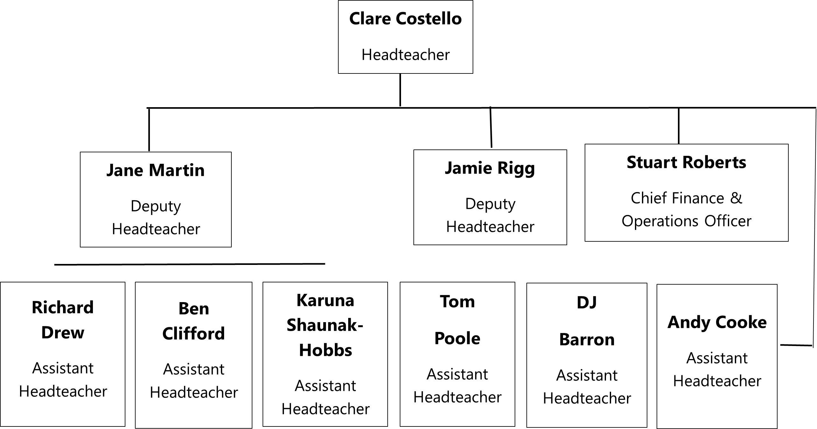

Please see appendix for an overview of roles and responsibilities

3.0. Outcomes
A full, subject by subject analysis will be provided in the standards and performance committee meeting together with a look ahead as to lessons learned for our new year 11 and 13. I have only provided headline figures in this report.

3.1. Key stage 4
Context of year group:
This year 11 was a more complex one with more diversity of need than seen previously. There were seven students who missed a lot of school during KS4 due to medical and mental health diagnosis; three of these students needed home invigilation. One student from the year group was educated at CSS ( offsite provision) and one left the school in February of year 11. However, due to census dates the results of this student is still accountable to us. There was also one school refuser.
In addition, there were 16 students who joined this year group in KS4 and a further ten joined the year group in year 9.

Comparison of year group profile with 2019 cohort

 | 2019 Cohort | 2023 Cohort
Size of cohort | 144 | 242
Boys | 77 (53.5%) | 128 (53%)
Girls | 67 ( 46.5%) | 114 (47%)
PP | 28 (19.4%) | 33 ( 13.6%)
SEND | 23 (16%) | 52 (21.5%)
Low prior attaining (LPA) | 9 (6%) | 38 (15.7%)
Middle Prior attaining (MPA) | 73 ( 51%) | 142 (58.7%)
High prior attaining (HPA) | 54 (37.5%) | 46 (19%)

Overview of outcomes
- 12 Subjects (out of 19) (63%) improved the % of students achieving 7+ by an average 8.9%.
- 11 subjects improved 5+%
- 9 subjects improved 4+%
- 13 subjects saw an improvement in APS
- 10 subjects have an APS +5 versus only 4 subjects in 2019.
However, more subjects posted U grades in 2023 compared to 2019 (12 vs 8)

Attainment 8
The A8 figure has increased whole school and for all ability groups compared to 2019. It is encouraging to see an increase of +8.54 in the high ability group as this is close to a whole grade improvement
 | SHS 2019 | SHS 2023 | Essex 2023
Attainment 8 | 44.90 | 45.83 (+ 0.93) | 46.6 (+0.77)
English and Maths 9 - 5% | 37 | 38 (+1) | 44 (+6)
English and Maths 9 - 4% | 63 | 65.3 (+2.3) | 64.6 (-0.7)
This table also shows our performance on the basics measure i.e. the % of students that achieve that grade threshold in both English and maths. Our results here have not shifted indicating mor work to be done on identifying where this cross over does not exist and subsequent targeting of such students
 | 2019 | 2023 |  | Essex 2023
SHS All Students | 44.90 | 45.83 (+ 0.93) |  | 46.6 (+0.77)
High Ability | 55.45 | 63.99 (+8.54)
 | 37.5% of the cohort | 19% of the cohort
Middle Ability | 38.93 |  | 44.85 (+5.92)
 | 50.7% of the cohort | 58.7% of the cohort
Low | 25.03 | 27.26 (+2.23)
 | 6.25% of the cohort | 15.7% of the cohort
No KS2 | 5% of the cohort | 6.6% of the cohort

English and Maths
There iHigh Prior Attaining s little difference between 2019 and 2023 when looking at the grade 4+ and grade 5+ thresholds but we do see progress when looking at the grade 7+ threshold
 | SHS 2019 | SHS 2023 | Essex 2023 | National 2023
English Best 9 - 4% | 78 | 78 | 75 (-3)
Maths 9 - 4% | 69 | 71 (+2) | 69.4 (-1.6) | 61 (-10)
English Best 9 - 5% | 58 | 60 (+2) | 60.2
Maths 9 - 5% | 44 | 42 (-2) | 48.8 (+6.8)
English Best 9 - 7% | 13 | 20
Maths 9 - 7% | 12.96 | 15.75 |  | 17.2 (+1.45)

Boys versus Girls
 | 2019 | 2023
Boys A8 | 43.93 | 43.27 (- 0.66)
Girls A8 | 46.00 | 48.70 (+2.7)

- Largest Gap between Boys and Girls in English with Girls 20% higher than Boys Best English 9 - 5 (71% vs 51%)
- Girls were 16% higher than Boys at Best English 9 – 4% (87% vs 71%)
- Girls were 13% Higher than Boys at Best English 9 -7 (27% vs 14%)
- Girls were a whole grade higher in Language and 0.88 of a grade higher in Literature
- In Maths there is very little difference in performance. 9 - 4% Boys 70%, Girls 74%, 9 - 5% same at 42%, 9 - 7% Boys 17% and Girls 13%

Pupil Premium
 | 2019 | Gap | 2023 | Gap
Attainment 8 | 38.29 | -8.06 | 38.78 | -8.16
English Language Ave Grade | 3.50 | -0.88 | 3.91 | -0.94
English Literature Ave Grade | 3.38 | -1.07 | 3.88 | -0.84
Maths Ave Grade | 3.88 | -0.47 | 3.82 | -0.67
English and Maths 9 - 4% | 42% | -25 % | 55% | -12%
English and Maths 9 – 5% | 23% | -17% | 24% | -15%

Whilst the performance of our disadvantaged student fairs well in comparison to other Brentwood schools ( see later table) we can see that we have not made any significant inroads on reducing the gap until the Basics measure at grade 4 and above where the gap has halved

SEND
 | 2019 | Gap | 2023 | Gap
Attainment 8 | 39.36 | -6.59 | 35.16 | -10.67 *
English Language Ave Grade | 3.61 | -0.73 | 3.67 | -1.34
English Literature Ave Grade | 3.65 | -0.73 | 3.40 | -1.53
Maths Ave Grade | 3.87 | -0.48 | 3.44 | -1.22
English and Maths 9 - 4% | 52% | -13% | 38% | -35%
English and Maths 9 – 5% | 22% | -18% | 25% | -16%

It is apparent that within this cohort our students with SEND fell further behind their peers than those in 2019
For both the pupil premium and SEND cohorts (33 and 52 students respectively) we need to look at individual performance more carefully to identify lessons that we take forward.
*Measured on a different scale

High Prior Attaining Students
The performance of our high prior attaining students was identified as an improvement point in our last Ofsted inspection in 2018
It is encouraging to see an increase in key measures, some of which are significant. It is important for us to identify how this was achieved and what value added did the provision and practice of the school make
 | 2019 | 2023
Attainment 8 High Ability | 55.45 | 63.99 (+nearly a grade)
English and Maths 9 – 4% | 91 | 96 (+5)
English and Maths 9 – 5% | 63 | 83 (+20)
English Best 9 - 7 % | 24 | 61 (+37)
English Best 9 - 5% | 80 | 91 (+11)
Maths 9 – 7% | 26 | 48 (+22)
Maths 9 – 5% | 74 | 85 (+11)

 | 2019 | 2023
English Language Ave Grade | 5.06 | 6.39
English Literature Ave Grade | 5.07 | 6.43
Maths Ave Grade | 5.50 | 6.37

A8 Comparison with Brentwood Schools
There are very different contexts seen in the schools of Brentwood; possibly the most useful comparison is between us and St. Martins. Our results for our disadvantaged students compare well here but our no-disadvantaged are lagging behind Essex and St. Martins and only half a grade higher than BCHS

School | Students at end of KS4 |  |  |  | Attainment 8 score
 | All | Disad. | Non disad. | % pupils disad. | All | Disad. | Non disad.
ESSEX | 15091 | 2999 | 12092 | 19.9% | 46.5 | 34.3 | 49.5
Brentwood County High School | 98 | 19 | 79 | 19.4% | 39.0 | 29.0 | 41.4
Becket Keys Church of England School | 160 | 27 | 133 | 16.9% | 56.4 | 39.0 | 59.9
Brentwood Ursuline Convent High School | 168 | 14 | 154 | 8.3% | 61.7 | 60.4 | 61.8
Anglo European School | 221 | 22 | 199 | 10.0% | 54.8 | 41.0 | 56.3
Shenfield High School | 242 | 33 | 209 | 13.6% | 45.8 | 38.8 | 46.9
St Martin's School | 287 | 38 | 249 | 13.2% | 48.6 | 32.9 | 51.0

3.2. Key stage 5
- 3 Subjects achieved 100% A*- C​
- 9 Subjects achieved 100% A* - D​
- 4 Subjects improved A*-A compared to 2019. (Bio, Film, Geog, Phil)​
- 6 subjects achieved the same or higher A* - B% than 2019​
- 5 subjects posted U grades (10 in total) (Bio, Chem, Ec, Law, Maths)​
- 7 Subjects B- or higher APS​
- 18 Subjects C- or higher APS​
- 3 Subjects D/D- APS

GCE A Level ​ | 2019​  A Level ​ | 2023 Results ​ | 2023 National (Provisional)​
Av Prior Attainment (GCSE)​ | 5.63​ | 6.36​ | ​
No of Students​ | 127​ | 147​ | ​
No of Entries​ | 325​ | 414​ | ​
A*-A%​ | 23.69​ | 13.04​ | 26.5%​
A*-B %​ | 54.77​ | 40.10​ | 48.9%​
A*-C %​ | 82.77​ | 73.19​ | 75.4%​
A*-D%​ | 93.23​ | 90.10​ | ​
A*-E %​ | 98.77​ | 97.58​ | 97.2%​
APS/Student​ | 92.05​ | 89.18​ | ​
APS/Entry​ | 35.97​ | 31.67​ | ​
APS/Entry as a Grade​ | B-​ | C​ | ​

It is clear that our performance compared to 2019 is poorer even though we are at national at the A*-C ad A8-E thresholds

BTEC Extended Diploma​ | 2019 Nat Result​ | 2019 SHS Result​ | 2023 Results​
Av Prior Attainment​ | n/a​ | 4.40​ | 5.09​
No of Students​ | n/a​ | 28​ | 49​
No of Entries​ | n/a​ | 84​ | 147​
Distinction (D*-D) %​ | 38.3​ | 85.71​ | 77.55​
Merit (D*-M) %​ | 75​ | 100.00​ | 98.64​
Pass (D*-P) %​ | 97.2​ | 100.00​ | 100.00​
APS/Student​ | n/a​ | 116.25​ | 112.55​

We had significantly more entries in 2023 than 2019 and managed to maintain our position except at the distinction threshold and above. This is not the case for the extended certificate where our % of D-D* increased by approximately 50%.
BTEC Extended Certificate​ | 2019 Nat Result​ | 2019 SHS Result​ | 2023 Results​
Av Prior Attainment​ | n/a​ | 4.82​ | 5.81​
No of Students​ | n/a​ | 30​ | 14​
No of Entries​ | n/a​ | 33​ | 14​
Distinction (D*-D) %​ | 38.3​ | 42.42​ | 64.29​
Merit (D*-M) %​ | 81​ | 96.97​ | 92.86​
Pass (D*-P) %​ | 98​ | 100.00​ | 100.00​
APS/Student​ | n/a​ | 32.83​ | 33.93​

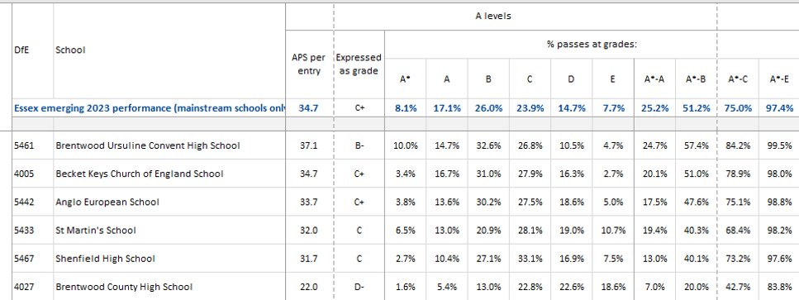

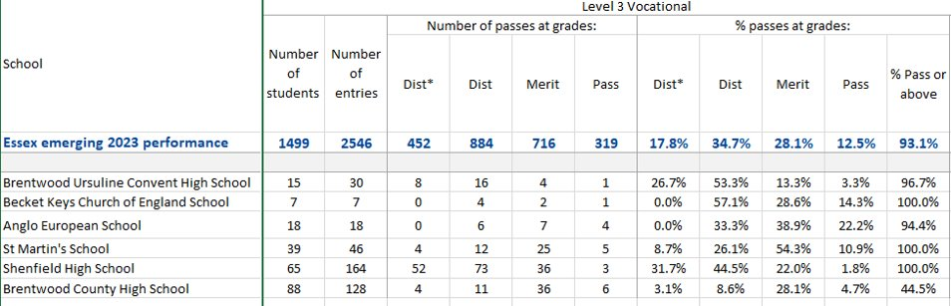

4. Premises Update
A huge amount of work has been undertaken over the summer break and the site team are to be commended for their efforts and willingness to go over and above. Credit must also be given to Stuart who coordinated and kept oversight of the work throughout the summer.
The priorities that were chosen reflected the need to: improve working conditions of staff and the working conditions of students; provide the school population with the view that the school is moving forward in all areas; improve safeguarding and provide the visiting public with a more professional appearance.
In addition to these improvements to the fabric of the building the IT team were very busy installing nearly 300 new computers and monitors into classrooms and upgrading the email system onto the cloud bring us up to date.
Cleaning remains an issue across the site and despite the appointment of a new area manager by Churchill we have no confidence n their ability or motivation to improve our service; notice is to be served on the contract in the coming days.

- School Improvement Priorities
The two whole school objectives this year are:
- Refocus on the primacy of lessons
- Support leadership at all levels
These two objectives form the umbrellas under which the key actions and individual area priorities fall. These objectives have been shared with staff and also with all students in their first assemblies of the year. The first objective also forms the basis of a professional development plan objective that is to be shared by all staff in the newly redesigned process.

- Ofsted
Our previous inspection was in November 2018 and so it is increasingly likely that we will be inspected this year. The senior team have already started the planning that is needed to accommodate the initial chief inspector conversations and the operational aspects of the inspection.
It is worth governors familiarising themselves with the Ofsted framework ( updated for September).

Appendix

Senior Team Roles and Responsibilities
Clare Costello (CCO):

Headteacher
Line Manages
- Deputy Headteacher for Quality of Education (JMA)
- Deputy Headteacher for Behaviour annd Engagement (JRI)
- Assistant Headteacher for Sixth Form (ACO)
- Chief Finance & Operations Officer (SR)
- HR Manager (KWH)
- Science & Engineering (GPO & MHA)
- PA to HT and DHTs (CW)
Areas of Responsbility
The Headteacher is responsible, in conjunction with the governing board, for setting the strategic direction of the school and for overseeing school operations, statutory compliance and the welfare of all staff and students
Jane Martin (JMA):

Deputy Headteacher for Quality of Education
Line Manages
- AHTs for Assessment (RDR), Curriculum (BCL) and Teaching & Learning) KSH)
- Maths (NDE)
- English (SWI)
- Vocational Coordinator (AMA)
Areas of responsibility/ oversight

Strategic oversight of all aspects relating to curriculum design, implementation, and assessment.

Jamie Rigg (JRI):

Deputy Headteacher for Behaviour & Inclusion
Line Manages
- AHTs for Behaviour & Attendance (TPO) and Safeguarding & Inclusion (DJB)
- SENCo (ESM)
- Pastoral Coordinator (GED)
- Internal Suspension (SB)
- House coordinator (JMP)
Areas of responsibility/ oversight

Strategic oversight of all aspects relating to Behaviour, safeguarding, attendance and inclusion
Strategic and day to day line management of SEND
Stuart Roberts (SR):

Chief Finance and Operations Officer

Line Manages
- Premises & facilities (SA)
- Finance (SH)
- IT (DF)
- Director of Sport (GSA)
- CCF (SB)
Areas of Responsibility/ oversight

- Operational aspects of school management
- Health and safety
- Strategic oversight of school budget
- Contracts
- Strategic oversight of IT facilities
- GDPR
- Lettings
- Visit finance
DJ Barron (DJB):

Assistant Headteacher for Safeguarding & Inclusion
Line Manages
- Safeguarding officer (NBO)
- Pupil Impact Centre (PIC) (RM)
- Pupil Premium coordinator (MHO)
- Gateway manager (CW)
- First Aid (LH)

Areas of responsibility/ oversight

- Designated safeguarding Lead, DSL
- Pupil premium strategy and execution
- Looked After Children
- Young Carers
- Modified curriculum plans
- Alternative provision including offsite
- Visit planning and risk assessment
Ben Clifford (BCL):

Assistant Headteacher for Curriculum
Line Manages
- Art (DKE)
- PE (MHP)
- Film & Media (MSH)
- Careers (AKA)
- Law & Psychology (AKA)
- Library (JE & LW)

Areas of responsibility/ oversight
- Whole school curriculum design
- KS4 options process
- Curriculum area of website
- Whole school literacy and reading programme
- Catch-up tutoring programmes
- Most able student programme
Andy Cooke (ACO):

Assistant Headteacher, Head of Sixth Form
Line Manages
- Deputy Head of sixth form, Head of year 13 (JAM)
- Head of Year 12 (TBI)
- Social sciences (LHO)
- EPQ coordinator (BIR)
- Sixth form academic support (EP)
- Sixth form PA (JD)

Areas of responsibility/ oversight

- All aspects regarding sixth form e.g. strategy, outcomes, attendance, pastoral
- Promotion and marketing of the sixth form
- Sixth form recruitment and onboarding processes
- Sixth form income streams
Richard Drew (RDR):

Assistant Headteacher for Assessment
Line Manages
- Data Team (MM)
- Exams (KP)
- Computer science (DMA)
- MfL (ASH)
- Music (PWI)

Areas of responsibility/ oversight
- Assessment policies and protocols
- Whole school tracking systems
- Monitoring and support of assessment procedures across curriculum areas
- Student reports including Edulink and end of year reports
- Parents evenings
Tom Poole (TPO):

Assistant Headteacher for Behaviour & Attendance
Line Manages
- Heads of Year for years 7 to 11 (PCH, MFL, ATO, TAR, plus colleague joining in Jan ’24)
- Attendance Team (VN & AG)
Areas of responsibility/ oversight
- Day to day operation of the school’s pastoral and behaviour system and processes
- Support for staff with the management of individual students or classes
- Student attendance
- Liaison with external agencies
- Dealing with parental and community concerns
- Coordination of assembly programme
- Student voice and Student rewards
Karuna Shaunak Hobbs (KSH):

Assistant Headteacher for Teaching & Learning
Line Manages
- Business (BSH)
- Drama (ESH)
- Geography (HSP)
- History (SHO)
- Food (RCO)
Areas of Responsibility/ oversight
- Monitoring of teaching standards across the school
- Marking and feedback policy and protocol
- PREP/ Homework
- All aspects of ECT programme and support
- New staff induction
- Trainees
- Coordination of school CPDL programmes

