Headteacher’s report to the governing body

March 2023

  - Staff

  - Leavers
Kim Messenger – Behaviour for Learning Manager – Interventions and Coaching
Jonathon Sands – Deputy Headteacher
Arwen Bloomfield – Geography teacher

  - April Joiners
Sandra Hatton – Finance Manager
Edd Miller – Maths

  - Current Vacancies
Deputy Headteacher for Behaviour and Inclusion
Assistant Headteacher for Teaching & Learning
Team Leader for English
Attendance Officer
Cover supervisor

  - Absence and wellbeing: 1-12-22 to 10-3-23
Figures in brackets represent difference from last reporting period
 | Illness | Medical | Family | Courses/Training | Other/Unpaid | Total
Number of absences
Teaching Staff | 68 | 1 | 22 | 44 | 3 | 138 (-3)
Support Staff | 54 | 16 | 25 | 7 | 8 | 110 (+45)
Total days lost
Teaching Staff | 68 | .3 | 32 | 47.6 | 3 | 150.9 (-63)
Support Staff | 54 | 5.2 | 46.7 | 6.1 | 11 | 123 (-9)
Number of individuals
Teaching Staff | 47 | 1 | 18 | 28 | 3 | 97 (-19)
Support Staff | 35 | 11 | 16 | 6 | 6 | 74 (+17)

- Students
  - Numbers currently on roll
Year 7 | 239 = 1 MM | Year 11* | 238
Year 8 | 240 | Year 12 | 143
Year 9 | 232 | Year 13 | 196
Year 10 | 242 + 1 MM | TOTAL | 1530
  - Mobility
 | Leavers | Joiners | Net Movement | Waiting List
Year 7
Year 8
Year 9
Year 10
Year 11

  - % Attendance

 | No. on roll | % Attendance | % Unauthorised absence | % Persistent absence | Number of severely absent students <50%
Year 7 | 239 | 93.43 | 1.97 | 20.49 | 0
Year 8 | 240 | 90.57 | 3.59 | 30.03 | 5
Year 9 | 232 | 92.68 | 2.12 | 25.83 | 1
Year 10 | 242 | 92.12 | 2.87 | 22.45 | 5
Year 11 | 238 | 91.38 | 2.37 | 22.13 | 6
Boys | 823 | 91.87 | 2.2 | 24.37 | 9
Girls | 707 | 91.7 | 2.91 | 23.68 | 8
PP | 1197  (Years 7 to 11 | 85.49 | 6.05 | 38.3 | 7
SEND | 287  (Years 7 to 13) | 89.09 | 4.7 | 29.33 | 8
Total | 1530 | 92.16 | 2.7 | 24.26 | 17

All measures have shown a decline since the last reporting period

  - Suspensions
 | No. on roll | Number of suspensions | Number of students receiving a suspension | Total Days | Suspension Rate
Year 7 | 239 | 23 | 9 | 48 | 9.6
Year 8 | 240 | 13 | 7 | 29.5 | 5.4
Year 9 | 232 | 3 | 2 | 21.5 | 1.2
Year 10 | 242 | 19 | 13 | 44 | 7.8
Year 11 | 238 | 4 | 2 | 7.5 | 1.7
Boys | 823 | 48 | 27 | 127 | 5.8
Girls | 707 | 19 | 11 | 36 | 2.7
PP | 208 | 31 | 16 | 95.5 | 14.9
SEND | 303 | 36 | 15 | 72 | 11.9
Total | 1191 | 67 | 38 | 163 | 5.6

Contextual info:
Comparative Suspension data for 2019/20
 | Brentwood State Secondary’s | Essex State Secondary’s | National
FTE volume | 447 | 6142 | 310,773
FTE Rate | 5.92% | 6.88% | 3.76%

  - Safeguarding
Safeguarding was a significant element explored in the recent governor’s monitoring visit on 21st February. See agenda item 20.
The following table provides data for the year to date
 | Number of safeguarding entries | Number of students entries represent
Year 7 | 172 | 133
Year 8 | 139 | 95
Year 9 | 109 | 77
Year 10 | 157 | 107
Year 11 | 140 | 97
Year 12 | 70 | 61
Year 13 | 69 | 53
Boys | 438
Girls | 418
PP | 290
SEND | 259
Total | 856

  - Admissions for September 2023

Number of Applications and Breakdown
LAC | 0
Siblings | 83
Staff | 3
Priority Area | 126
Primary | 0
Sport | 21
PA | 3
ECHP | 10
Total | 246

There is currently an over offer of 6 because Essex County Council only knew about 5 EHCP and they made a mistake, by not sending an offer that should have been made on 1st March. This will be adjusted to our PAN of 240 when rejections are received.

3.0. Updates
3.1. Senior Team Roles from Easter
Following the departure of Mr Sands at Easter we have had to redistribute some of the responsibilities across the senior team to accommodate the gap.
The largest part of this has been the redistribution of curriculum line management with core and EBacc subjects now being line managed by Jane Martin except for science which will be line managed by myself.
A new Deputy Headteacher post is being advertised with a closing date of 23rd March 2023.

3.2. Senior Team Structure from September 2023
Context
Mr Sands’ responsibilities had ranged from CPD, teaching and learning to assessment and PREP whilst Jane Martin’s responsibilities are for student outcomes, curriculum, exams, timetabling and operations.
Neither Deputy Headteacher had responsibility for Pastoral, SEND or safeguarding; all of these areas report directly into myself. Furthermore, there was a disconnect between curriculum, assessment and outcomes.
Mr Clifford, Assistant Headteacher, held the responsibility of Team Leader for English which, through no fault of his own, compromised his ability to be a full time Assistant Headteacher with a strategic role.
Finally, the structure included an Associate Assistant Headteacher post. This post is filled by Miss Shanuak-Hobbs who is also Team Leader for MfL and runs the ECT programme. This post is not remunerated on the same scale as the Assistant Headteacher role but the level of responsibility is certainly on a par with the role held by Mr Clifford.
With the departure of Mr Sands an opportunity has arisen to revisit the senior team roles in the context of current and emerging school priorities.

New Structure
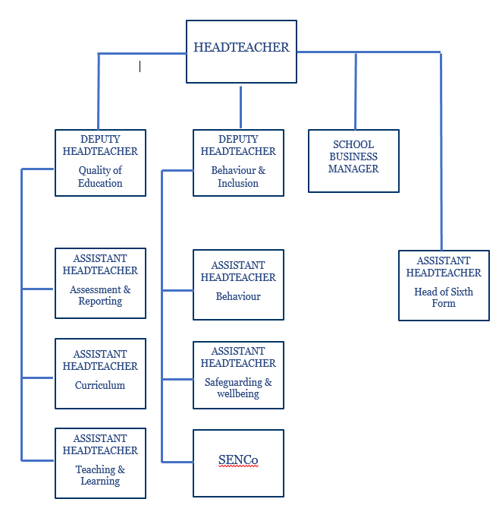

The vacant Deputy Headteacher role is for someone to bring together the pastoral, SEND and inclusion teams. This will help drive strategy in this area and provide a line management level between the Leaders of those teams and myself.
Jane will lead the Quality of Education team bringing together Curriculum, teaching and learning and assessment; this will ensure an integrated strategy between these intertwined areas of provision.
The responsibility for English has been decoupled from the assistant Headteacher role to improve much needed capacity and a new role of Assistant Headteacher for Teaching & Learning has been advertised that will bring together monitoring of teaching quality, professional development and training and ITTs, ECTs/ new entrants.
3.3. Curriculum Development
Our daily experience and the behaviour data tells us that we have a small group of students that are not coping with a ‘normal’ mainstream provision. The image below, whilst slightly tongue in cheek, (used in a recent senior team meeting) illustrates the current impact of these challenges on our school community.

As reported previously, there is no support available externally with alternative programmes or provision and so we must look to make reasonable adjustments to our own curriculum model. The next two images are slides taken from the same senior team meeting that bring together our discussions over an extended period.
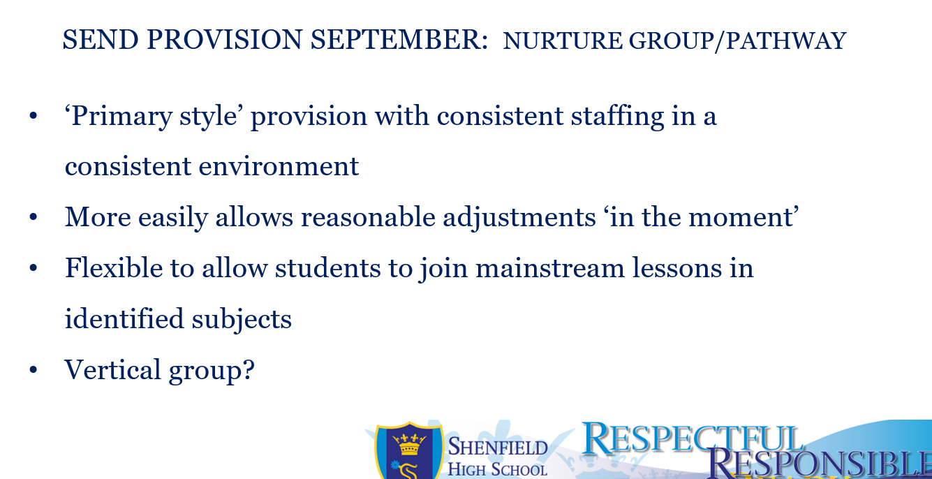

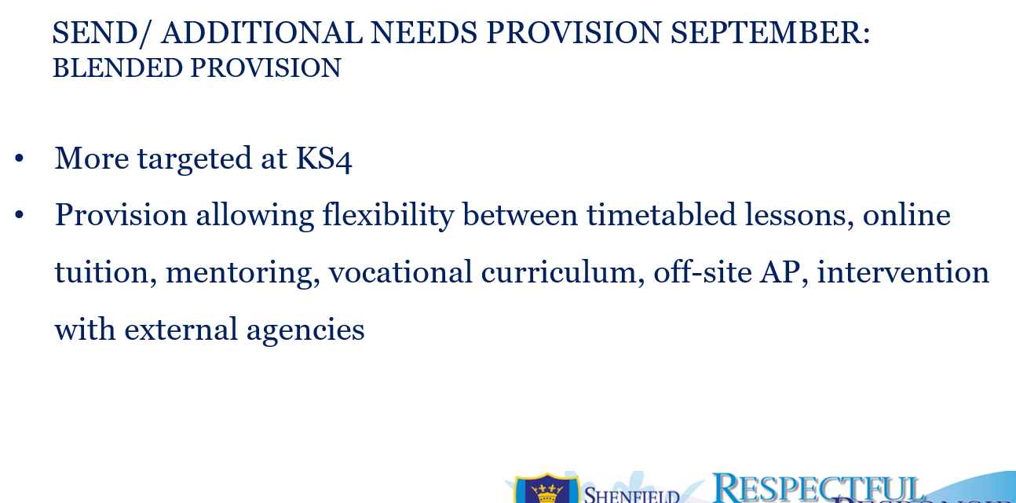

Potential benefits of such changes
- Individual student needs are better met
- Other student needs are better met
- Opportunity to develop expert practice that can then be shared with other staff, peer to peer
- Reduces strain on school systems
- Improves staff wellbeing

Potential risks
- Drains resources
- It sterngthens our reputaion as a ‘SEND School’

This last point is an important one to consider as part of our strategy going forward and in answeringthe question of “what kind of school do we want to be?”
The senior team have been considering what Shenfield High School needs in oredr to strengthen its ability to meet the needs of ALL students and also to be known as the school of choice for meeting the needs of all children.
The image below sets out to describe the need for a new equilibrium.

Discussions have so far centred around the need for an aspiration curriculum for our ablest students. This could involve specific curriculum opportunities and/ or a shift from our current mixed attainment model to banding.

Clare Costello

