**Shenfield High School**

**Headteacher’s Report**

**to the Governing Body**

**July 2018**

**Numbers currently on roll: 1151**

|  |  |  |  |
| --- | --- | --- | --- |
| Numbers on Roll | | | |
| Y7 | 222 | Y11 | 114 |
| Y8 | 179 | Y12 | 181 |
| Y9 | 147 | Y13 | 165 |
| Y10 | 143 | **TOTAL** | **1151** |

# 

**Attendance Data**

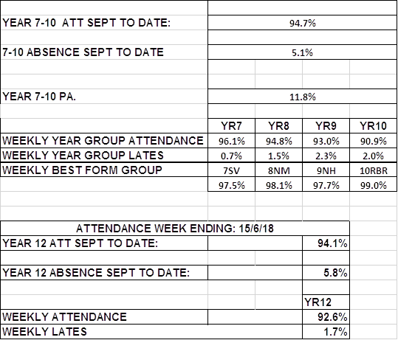

**Staffing**

The following staff are leaving Shenfield High School at the end of the academic year:

|  |  |  |
| --- | --- | --- |
| **Name** | **post** | **Reason for leaving** |
| Andy Christiani | Vocational and Outdoor Education Coordinator | New post in Germany |
| Rachel Eglinton | PE Technician | Secured new post in London |
| Kim Garnish | Team Leader for Drama | To spend time with her daughter |
| David Gray | Teacher of English | New post at Castle View |
| Becky Laidler | Teacher of Geography | retiring |
| Helen Minns | Teacher of English | relocating |
| Samantha Raoult | Teacher of Spanish | Leaving teaching |
| Cathryn Rayner | Pastoral Coordinator | Relocating |

The following new colleagues will be joining Shenfield High School in September 2018

|  |  |
| --- | --- |
| **Name** | **Post** |
| Isaac Acquah | Teacher of English |
| Philip Ball | Performing Arts Technician |
| Ellie Gibbons | Teacher of PE (Maternity leave) |
| Alan Gray | Teacher of Geography |
| Jacqui Hicks | Teacher of Science |
| Mairead Hogan | Teacher of Geography |
| Erin Horgan | Teacher of English |
| Rosie Lee | Teacher of alternative curriculum (P/T) |
| Rebecca Lynch | Team Leader for Drama |
| Katherine Murphy | Teacher of Spanish and French |
| Vicki Senior | Pastoral Manager |
| Elizabeth Smith | Teacher of Computing and Maths |
| Karen Vidler | Teacher of Science |
| To be appointed: | Teacher of Spanish and French |
|  | Chemistry Technician |
|  | PE Technician |

In addition, the following internal appointments have been made:

Matt Hall - Team Leader for PE

Garry Sapsford – Director of Sport

Lisa Hart – Science Teaching Apprentice

Georgia Day – Pastoral Coordinator

**Healthy Schools Status**

Our Healthy Schools Status has been confirmed through, this year, a full day’s moderation exercise. The very complimentary letter of confirmation is available as a separate document. It has been indicated that there is little more we need to do to achieve Enhanced healthy Schools status, and we will be submitting our bid for that award in the coming year. My thanks to Jenny Comerford for her coordination of the award – there are many different elements to it!

**Behaviour data**

The up-to-date record of behaviour data is available a separate document on the weebly website. The statistics reflect our lower level of tolerance to behaviour that does not meet expectations. We are paying attention to the rate of recidivism but can only draw tentative conclusions because new elements of our behaviour policy have been introduced this year.

|  |  |  |  |  |
| --- | --- | --- | --- | --- |
|  | **Year to date** | **%** | **2016/17** | **%** |
| **C3** | 140/194 | 72 | 116/207 | 56% |
| **3 to 4** | 13/83 | 16% |  |  |
| **BLUE Room** | 21/88 | 24% | 74/150 | 49% |

**KS3 Assessment**

For some time, we have looked at KS3 assessment by judging whether students are on, above or below target with targets being based on a trajectory from KS2 SATS results to where students “ought” to be by the time they reach GCSE. This matches our accountability – the school is judged on this basis via Progress and Attainment 8 – but it tells us nothing about students’ learning and what we might do about it. Indeed, because the “trajectory” is based on only English and Maths at KS2, it is at best a proxy indicator and, in fact, masks underachievement in different subjects. We are moving away from this to a system which is based on making a judgement in each subject about whether a student is achieving the expectations within that particular subject at a particular point. In this way, the curriculum becomes our progression model and depends upon the skilful construction of that curriculum and subject expertise, rather than a proxy indicator based on the two core subjects.

We are committed to providing an engaging and inspirational curriculum at KS3. Although we have “backward-planned” from new requirements on the GCSE specifications, this does not mean that we begin specifically working towards those specifications from Y7 onwards. Instead, we want to engage students with their learning in each subject, and know from very early in a student’s school career how they are achieving in each one. That way, we can do something about underachievement and further enhance particular talent. Because assessment will be against the expectations of each subject, we will not be leaving until KS4 the recognition of underachievement when it is almost too late and interventions have to be put in place urgently.

This means that the way we report to the Standards and Performance Committee will become different. Different information will be generated which supports our understanding of how individuals are doing in each subject, and therefore what we must do in that subject for each child to ensure maximum achievement. As part of the governor monitoring visit on 4th July, three SLT colleagues will be explaining this in greater detail.

**PREP, the Super-Curriculum, Cadre 86 and parental engagement.**

These major step-change developments have continued this term. A governor training session led by Gill Power took place on 19th June. The powerpoint presentation is available as a separate document.

The first meeting of the Parent Council took place on 25th June. 25 parents attended. A presentation similar to the governor training session was delivered and discussion about next steps for parent engagement were discussed.

A new addition to our calendar - Prep4Sept - is on 12th July – an evening to introduce Y9 parents and students to the demands of GCSE now their option choices have been confirmed.

**Strategic Headline Review**

In a Strategic Review Meeting on 22nd June, the Senior Team reviewed the year’s Strategic Headlines and discussed draft headlines for 2018-19. The review document is available separately on weebly.

Published newsletters can be viewed via the link:

<http://www.shenfield.essex.sch.uk/newsletters/overview.aspx>

Please follow us on twitter [Shenfield High Sch](https://twitter.com/ShenfieldHigh)@ShenfieldHigh

**Dates for your diary:**

**26th June 2018 Sports Awards Evening**

**2nd and 3rd July 2018 Lower School play**

**4th July 2018 Summer Concert**

**16th August A Leve results**

**23rd August GCSE results**

**13th September KS4 and 5 Awards Evening.**

**Carole Herman**

**July 2018**