Shenfield High School

Headteacher’s Report
to the Governing Body

September 2017

Numbers currently on roll: 1201 (to be confirmed)

Numbers on Roll
Y7 | 225 | Y11 | 114
Y8 | 186 | Y12 | 200 tbc
Y9 | 149 | Y13 | 176
Y10 | 151 | TOTAL | 1201 tbc

New staff from 1 September.

Preferred  Forename | Preferred  surname | Role
Ronan | Conway | Teacher of Science
Chantelle | Dyson | Teacher of Maths, i/c KS3
Samantha | Murray | Pastoral Manager
Wendy | O’Dell | Science maternity
Barry | Owen | Cover supervisor
Samantha | Raoult | Teacher of Spanish
Christine | Robinson | Teacher of Maths
Liam | Stevens | Performing Arts technician
Pooja | Toshniwal | Teacher of Maths

Exam results
The Leadership overview sheets are attached. Some results may be subject to change following reviews and re-marks. A full analysis will be presented to the Standards and Performance Committee.

Summary notes:
A Level

- A*- B 55% 2016 Result was 54% 2016 National Result 53.6%
- A- E 99% 2016 Result was 100% 2016 National Result 98.8%
- 4 Us

BTEC Level 3 Extended Diploma (equivalent to 3 A Levels)

- 100% pass
- 90% Distinction/Distinction* (91% last year)

AS

AS performance is much more difficult to compare because we have a mixture of old and new courses and a mixture of externally validated AS exams and internal assessments. The significant drop indicated by the raw figures will be investigated further through subject exam reviews. Improvement in the performance of this year group will be a major priority for the year ahead.

- A-B 34% (2016 – 55%)
- A-C 66% (2016 – 80%)
- A-D 83% (2016 - 93%)
- A-E 94% (2016 – 97%)

GCSE

This is the first year of a new system. English and Maths are new courses designed to be more demanding and graded 9 to 1. The new grade 7 is equivalent to the old A; the new grade 4 is equivalent to an old C and is now labelled a “standard” pass. The new grade 5 is considered a “good” pass.

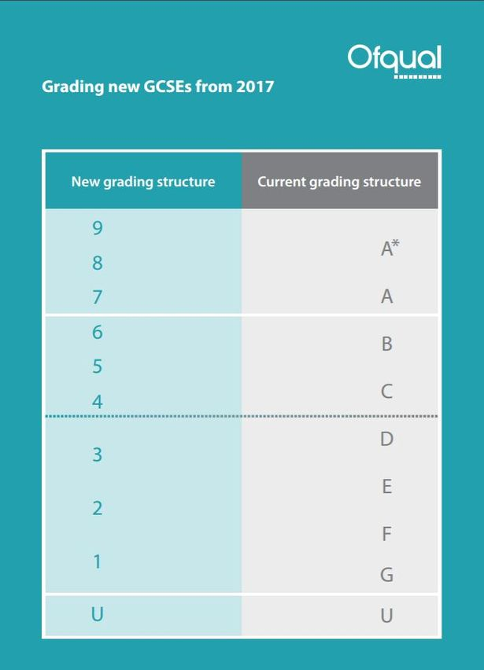

All other subjects are still graded A* to G this year with many more subjects converting to new courses with new grading for Summer 2018. The old statistics such as 5 A* to C including English and Maths cannot now be calculated as an equivalent because it would mix old and new courses. For students, grades 9 to 4 will be recognised as passes. We have been informed, however, that schools will be judged on the percentage of good passes (9 to 5) as well as Attainment 8, Progress 8 and the English Baccalaureate. Until this cohort of our students is assessed against national data, it is very difficult to assess how we have done. What we do know is that we 69% of our Y11 cohort achieved grades 9 to 4 in both English and Maths; last year 67% of the cohort achieved English and Maths at A* to C. 37% of our Y11 cohort achieved 9 to 5 in English and Maths, but there is no equivalence from previous years to compare this with.

Separate statistics for English and Maths were as follows:

English (best results from English Language and English Literature):

Grades 9-4 81%
Grades 9-5 62%

Maths

Grades 9-4 73%
Grades 9-5 43%

Detailed analysis takes place when national figures are known and in subject exam reviews.

Worthy of note because of the concerns we have had, history achieved 67% and Geography achieved 56%, demonstrating that the interventions that have been in place and the hard work of the Team Leader and her team are bearing fruit.

Modern Foreign Languages will be seeking a marking review for the Writing element of the exams in Spanish and German as the published results appear to be much lower than the moderated marks submitted. This is underway.

From our analysis so far, we are aware for the need to focus on:
- The achievement of boys
- The percentage of top grades achieved – we are below the national average
- The progress and attainment of the most able
- The attainment of disadvantaged and SEN children – we have case studies for these but it will be a continuing focus

A detailed analysis will be presented to the Standards and Performance Committee.

Published newsletters can be viewed via the link:
http://www.shenfield.essex.sch.uk/newsletters/overview.aspx

Please follow us on twitter Shenfield High Sch@ShenfieldHigh

Dates for your diary:

7th September - FGB
14th September – Awards Evening
5th October - Open Evening
10th October – Governors’ in-house training
12th October – Standards and Performance
12th October – Careers Fair
9th November – 6th Form Open Evening
13th and 14th December – Christmas concerts

Carole Herman
September 2017

