12th December 2023
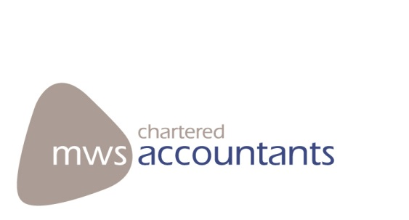

Our ref: S627/CS/SRS/CJ

Private & Confidential
The Governors
Shenfield High School
Alexander Lane, Shenfield
Brentwood
Essex CM15 8RY

Dear Sirs

REPORT TO MANAGEMENT

During the course of our audit and regularity assurance engagements for the year ended 31st August 2023 a number of matters arose which although we do not consider to be significant (as defined under ISA 265) we are however bringing the below to your attention for consideration.

Enclosed is a memorandum noting these points, these matters came to light during the course of our normal audit and assurance tests which are designed to assist us in forming our opinion on the financial statements and providing a limited assurance conclusion on regularity. Our tests may not necessarily disclose all errors or irregularities and should not be relied upon to do so. Matters we consider significant are not also reported here but are included within our audit findings letter which is addressed to the Trustees of the Academy Trust.

This letter has been prepared for the sole use of the Management of Shenfield High School. No copies of this letter may be provided to third parties without our prior consent. Consent is, and will only be, granted on the basis that such copies are not distributed with the interests of anyone other than the academy in mind and that we accept no duty or responsibility to any other party. No responsibilities are accepted by MWS towards any party acting or refraining from action as a result of this letter.

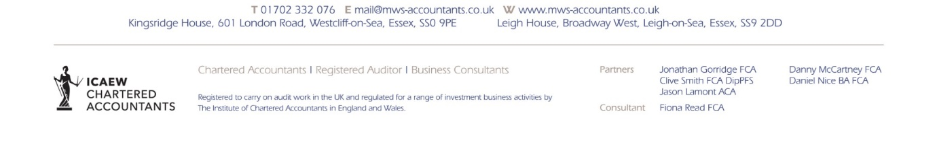

Area for consideration | Details
Finance Regulations wording | The wording in the finance regulations led to some misunderstanding regarding authorisation of BACS payments for invoices above £25,001. The current wording suggests that any invoices above that should have the BACs authorised by an approved trustee. The CFOO has advised that the Trust intended that the invoices themselves should be authorised by a trustee before payment. This is the process that is being followed, which supports their intention. CFOO has said the finance regulations will be amended to reflect this.
Quotes | In line with the financial regulations, 3 quotes should be obtained for all orders above the threshold set. This is generally adhered to, however one instance was found where this was not the case. The 3 quotes should be from 3 separate companies offering the same product/service so that they are fully comparable.
IR35 | Ensure a conclusion is left with every employment status check – one check sampled had an ‘unable to make a determination’ result and there was no reason as to why the Trust had considered them ‘self-employed.’
Purchase orders | A few instances were identified where the purchase order date was after the invoice date. The finance regulations state that once an internal order form is received and sufficient funds are identified, an official purchase order should be raised. It also specifies that for urgent orders a purchase order should be raised as soon as possible to register the financial commitment, and waiting until the invoice is received before entering onto the system is not acceptable.
IT | We recommend introducing multi-factor authentication across all accounts. We recommend a cyber response plan is put in place.
Payroll | Ensure the payroll posting by FMS is correct. Currently, for additional hours, it posts the total of the pay, pension and NI into the gross pay nominal which is incorrect and should be split out.
Website | We recommend that your whistleblowing policy is published on your website, as recommended by the DofE.

This information is provided purely for management purposes and although, where requested, we will discuss the content of this letter with management these are matters that under International Auditing Standards need not be communicated in writing.

Yours Faithfully
MWS

