Shenfield High School
Student Attainment and Progress 2022 (DRAFT)

Purpose
This report provides a preliminary analysis of our results for Governors. Figures are provisional at the time of printing. Results of re-marks and appeals are still outstanding. Please note that some figures contained in the report may not total 100 per cent because of rounding.

Executive Summary

GCSE/BTEC
- We had 207 students in Year 11. 3 students followed an Alternative Pathway which gave them qualifications but not qualifications that can be counted in the performance tables. We had one student who spent most of Year 11 in Hospital and one who did their exams through CSS Health (Maths, Eng Lang and Science).
- Although it is suggested that Results in 2019 to 2022 cannot be compared given the different ways they were conducted and the different mitigations to assessment that have been applied in 2021 and 2022.
Our English results shows an increase from 2019.
  - 9 – 7% has increased by 7% from 2019
  - 9 – 5% has increased by 9% from 2019
  - 9 – 4% has increased by 10% from 2019
In Maths there has also been an increase from 2019
  - 9 – 7% has increased by 5% from 2019
  - 9 – 5% has increased by 9% from 2019
  - 9 – 4% has increased by 10% from 2019
- Our % 9 - 4 in Maths and English is 75% - 12% higher than our 2019 result.
- Our % 9 -5 in Maths and English is 49% - 12% higher than our 2019 result.
- The following subjects achieved 30%+ 9 - 7 – Art (36.8%), Drama (42.8%) Music (57.1%), PE (31.7%), Spanish (33.3%)and BTEC Health and Social Care (35.71% D*-D)
- The following subjects achieved 70%+ 9 – 5 – Art (86.8%), Biology (70.4%), Drama (85.7%), Film (77.1%), Music (100%), PE (86.7%), Spanish 77.8%)
- The following subjects achieved 80%+ 9 to 4 – Art (92.1%), Drama (85.7%), English Lang (83.2%), English Lit (81.7%) Film (91.4%), Music (100%), PE (96.7%), Spanish 91.7%) and BTEC Business (88.63% D* - P), BTEC Performing Arts (91.66% D* -P), BTEC Health and Social Care (80.94% D* - P).

A Level
- These are the first public exams to be sat in 3 years. This cohort of students has never taken public exams before.
- It should also be noted that the student Av Prior attainment comes from CAGs
- We improved since our mock results sat in January but the results are lower than our 2019 result and 2022 National.
  - A*- A% is below our 2019 result and 2022 National
  - A*- B% is below 2022 National and 1.88% below our 2019 result.
  - A* - C% is 2.33% below 2022 National
  - A* - E% is 97.69%, 0.71% below 2022 National
- We obtained 8 U grades (1 in Chemistry, 1 in English Language, 1 in Law, 2 in Maths, 2 in PE and 1 in Psychology.
- Subjects with over 30% A*- A were English Literature (30%), Sociology (34.2%) and Theatre Studies (30.8%).
- Subjects and over 60% A* - B were Art (66.7%), Economics (71.9%), English Language (87.5%) English Literature (70%), Psychology (70%), Sociology (73.7%) and Theatre Studies (84.6%).
- KS5 BTEC Extended Diploma results are very good with D*-D% at 88.1%,
- BTEC Extended Certificates results are D*- D % of 62.5%

Key Stage 4 Results

Headlines | Attainment 8
 | All | Disad. | Non Disad.
SHS Results 2019 | 44.90
Essex 2022 | 49.2 | 36.4 | 51.6
Exam Results 2022 | 49.55 | 40.0 | 50.8

En & Ma | English (best)  9-5 | English (best)  9-4 | English (best)  9-7 | Maths  9-5 | Maths  9-4 | Maths  9-7 | %9-5 in both En&Ma | %9-4 in both En&Ma
SHS Results 2019 | 58% | 78% | 13% | 44% | 69% | 12% | 37% | 63%
Essex 2022 | 65.9% | 80.7% |  | 54.4% | 73.7% |  | 49.3% | 69.7%
National 2022 |  |  |  |  | 65% | 20%
Exam Results 2022 | 67.6% | 87% | 20% | 53.6% | 77.8% | 18% | 50% | 75%

Brentwood Schools Comparison
YEAR 11 DEMOGRAPHIC
ATTAINMENT 8 SCORES
AVERAGE KS2 SCORES

ATTAINMENT 8 SCORES

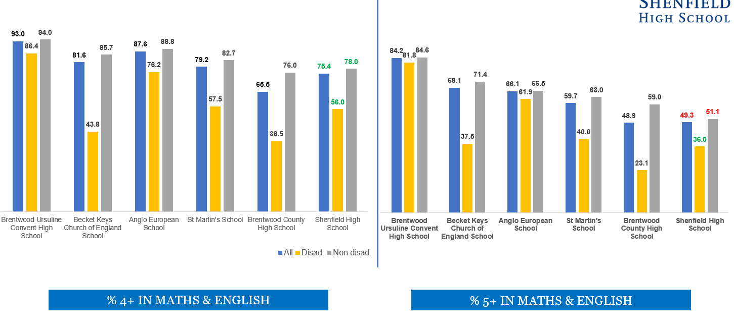

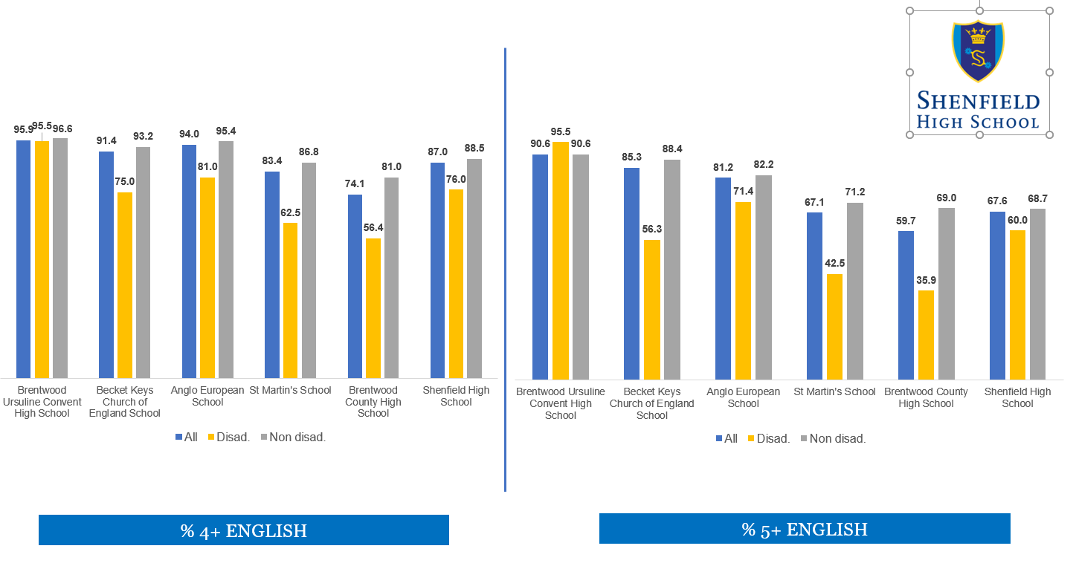

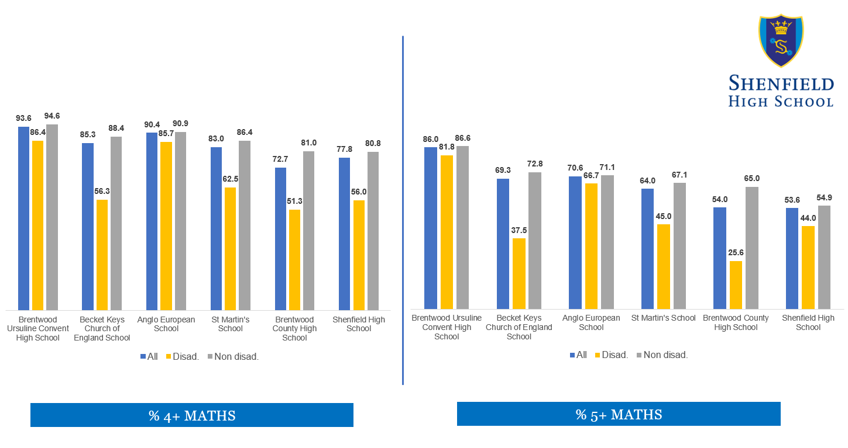

Performance of groups of students
Group | No of Students |  |  |  |  |  |  | Attainment 8 |  | English (best)  9-5 |  | English (best)  9-4 |  | English (best)  9-7 |  | Maths  9-5 |  | Maths  9-4 |  | Maths  9-7 |  | %9-5 in both En&Ma |  | %9-4 in both En&Ma
All | 144 |  |  | SHS Results 2019 |  |  |  | 44.90 |  | 58% |  | 78% |  | 13% |  | 44% |  | 69% |  | 12% |  | 37% |  | 63%
 | 207 |  |  | Exam Result 22 |  |  |  | 49.55 |  | 68% |  | 87% |  | 20% |  | 54% |  | 78% |  | 18% |  | 50% |  | 75%
Boys | 77 |  |  | SHS Results 2019 |  |  |  | 43.94 |  | 53% |  | 77% |  | 9% |  | 42% |  | 73% |  | 12% |  | 35% |  | 65%
 | 108 |  |  | Exam Result 22 |  |  |  | 48.54 |  | 66% |  | 84% |  | 15% |  | 54% |  | 81% |  | 21% |  | 50% |  | 77%
Girls | 67 |  |  | SHS Results 2019 |  |  |  | 46.00 |  | 63% |  | 79% |  | 18% |  | 46% |  | 66% |  | 12% |  | 39% |  | 61%
 | 33 |  |  | Exam Result 22 |  |  |  | 50.65 |  | 70% |  | 90% |  | 25% |  | 55% |  | 75% |  | 14% |  | 49% |  | 74%
Pupil Premium | 28 |  |  | SHS Results 2019 |  |  |  | 38.29 |  | 27% |  | 54% |  | 8% |  | 35% |  | 54% |  | 15% |  | 23% |  | 42%
 |  |  |  | Essex 2022 |  |  |  | 36.4 |  | 42.2% |  | 60.4% |  |  |  | 29.9% |  | 49.9% |  |  |  | 25.5% |  | 44.9%
 | 25 |  |  | Exam Result 22 |  |  |  | 40.02 |  | 60% |  | 76% |  | 12% |  | 44% |  | 56% |  | 0% |  | 36% |  | 56%
Non-Pupil Premium | 116 |  |  | SHS Results 2019 |  |  |  | 46.35 |  | 64% |  | 83% |  | 14% |  | 46% |  | 73% |  | 11% |  | 40% |  | 68%
 | 182 |  |  | Exam Result 22 |  |  |  | 50.86 |  | 69% |  | 88% |  | 21% |  | 55% |  | 81% |  | 20% |  | 52% |  | 78%
Pupil Premium Gap |  |  |  | SHS Results 2019 |  |  |  | -8.06 |  | -37% |  | -29% |  | -7% |  | -11% |  | -19% |  | 4% |  | -17% |  | -25%
 |  |  |  | Exam Result 22 |  |  |  | -10.84 |  | -9% |  | -12% |  | -9% |  | -11% |  | -25% |  | -20% |  | -16% |  | -22%
High Ability - 2019 was old KS2 scores - can't compare | 54 |  |  | SHS Results 2019 |  |  |  | 55.45 |  | 80% |  | 94% |  | 24% |  | 74% |  | 96% |  | 26% |  | 63% |  | 91%
 | 51 |  |  | Exam Result 22 |  |  |  | 65.71 |  | 96% |  | 100% |  | 45% |  | 90% |  | 94% |  | 51% |  | 88% |  | 94%
Middle Ability - 2019 was old KS2 scores - can't compare | 73 |  |  | SHS Results 2019 |  |  |  | 25.03 |  | 11% |  | 22% |  | 0% |  | 0% |  | 11% |  | 0% |  | 0% |  | 0%
 | 118 |  |  | Exam Result 22 |  |  |  | 47.45 |  | 66% |  | 89% |  | 14% |  | 51% |  | 83% |  | 8% |  | 45% |  | 80%
Low Ability - 2019 was old KS2 scores - can't compare | 9 |  |  | SHS Results 2019 |  |  |  | 25.03 |  | 11% |  | 22% |  | 0% |  | 0% |  | 11% |  | 0% |  | 0% |  | 0%
 | 31 |  |  | Exam Result 22 |  |  |  | 34.13 |  | 29% |  | 61% |  | 0% |  | 13% |  | 42% |  | 0% |  | 10% |  | 39%
SEN All | 23 |  |  | SHS Results 2019 |  |  |  | 39.36 |  | 30% |  | 65% |  | 13% |  | 39% |  | 65% |  | 4% |  | 22% |  | 52%
 | 40 |  |  | Exam Result 22 |  |  |  | 37.44 |  | 40% |  | 58% |  | 10% |  | 30% |  | 55% |  | 15% |  | 30% |  | 48%
SEN Support – K | 21 |  |  | SHS Results 2019 |  |  |  | 38.68 |  | 29% |  | 62% |  | 10% |  | 38% |  | 67% |  | 5% |  | 19% |  | 52%
 | 35 |  |  | Exam Result 22 |  |  |  | 39.64 |  | 43% |  | 63% |  | 9% |  | 31% |  | 60% |  | 17% |  | 31% |  | 51%
EHCP/Statement | 2 |  |  | SHS Results 2019 |  |  |  | 46.50 |  | 50% |  | 100% |  | 50% |  | 50% |  | 50% |  | 0% |  | 50% |  | 50%
 | 5 |  |  | Exam Result 22 |  |  |  | 22.00 |  | 20% |  | 20% |  | 20% |  | 20% |  | 20% |  | 0% |  | 20% |  | 20%
Year 11 |  |  | % 9-7 |  |  |  | % 9-5 |  |  |  |  |  | % 9-4 |  |  |  |  |  | % 9-1 |  |  |  |  |  | APS
GCSE Subject |  | Entries | SHS 2019 |  | Nat 2022 | Result 2022 | SHS  2019 |  | Nat 2022 |  | Result 2022 |  | SHS 2019 |  | Nat 2022 |  | Result 2022 |  | SHS 2019 |  | Nat 2022 |  | Result 2022 |  | SHS 2019 |  | Result 2022
Art (Fine and Textile Design) |  | 38 | 28.13 |  | 28.38 | 36.84 | 68.75 |  | TBC |  | 86.84 |  | 96.88 |  | 81.563 |  | 92.11 |  | 100.00 |  | 99.6 |  | 100.00 |  | 5.69 |  | 6.08
Biology |  | 81 | 17.31 |  | 50.01 | 29.63 | 61.54 |  | TBC |  | 70.37 |  | 76.92 |  | 92.02 |  | 79.01 |  | 100.00 |  | 99.45 |  | 100.00 |  | 4.96 |  | 5.36
Business Studies |  | 53 | 15.91 |  | 28.6 | 22.64 | 56.82 |  | TBC |  | 66.04 |  | 63.64 |  | 75.566 |  | 79.25 |  | 100.00 |  | 99.02 |  | 100.00 |  | 4.82 |  | 5.11
Chemistry |  | 81 | 13.46 |  | 50.03 | 16.05 | 48.08 |  | TBC |  | 51.85 |  | 73.08 |  | 92.961 |  | 76.54 |  | 96.15 |  | 99.62 |  | 100.00 |  | 4.42 |  | 4.78
Computer Science |  | 34 | 10.00 |  | 34.07 | 11.76 | 70.00 |  | TBC |  | 52.94 |  | 70.00 |  | 75.308 |  | 64.71 |  | 100.00 |  | 98.02 |  | 97.06 |  | 4.90 |  | 4.41
Drama GCSE |  | 21 | N/A |  | 34.24 | 42.86 | N/A |  | TBC |  | 85.71 |  | N/A |  | 81.109 |  | 85.71 |  | N/A |  | 99.03 |  | 100.00 |  | N/A |  | 6.14
English Language |  | 204 | 10.42 |  | 20.41 | 15.76 | 51.39 |  | TBC |  | 60.10 |  | 74.31 |  | 70.204 |  | 83.74 |  | 100.00 |  | 98.66 |  | 100.00 |  | 4.55 |  | 5.01
English Literature |  | 204 | 7.64 |  | 24.11 | 15.35 | 47.22 |  | TBC |  | 58.42 |  | 68.06 |  | 77.549 |  | 81.68 |  | 97.92 |  | 98.42 |  | 100.00 |  | 4.26 |  | 4.87
Film Studies |  | 35 | 8.82 |  | 23.65 | 17.14 | 52.94 |  | TBC |  | 77.14 |  | 76.47 |  | 73.462 |  | 91.43 |  | 100.00 |  | 98.11 |  | 100.00 |  | 4.71 |  | 5.46
Food Technology |  | 37 | n/a |  | 24.47 | 11.11 | n/a |  | TBC |  | 36.11 |  | n/a |  | 73.388 |  | 63.89 |  | n/a |  | 99.06 |  | 100.00 |  | n/a |  | 4.19
Geography |  | 79 | 13.33 |  | 30.83 | 17.72 | 40.00 |  | TBC |  | 50.63 |  | 51.67 |  | 72.676 |  | 72.15 |  | 96.67 |  | 98.51 |  | 98.73 |  | 3.82 |  | 4.63
History |  | 74 | 12.96 |  | 30.11 | 24.32 | 37.04 |  | TBC |  | 63.51 |  | 53.70 |  | 71.391 |  | 74.32 |  | 96.30 |  | 97.58 |  | 98.65 |  | 3.80 |  | 5.15
Maths |  | 204 | 11.81 |  | 20.07 | 18.23 | 43.75 |  | TBC |  | 55.17 |  | 69.44 |  | 64.997 |  | 79.21 |  | 99.31 |  | 97.40 |  | 100.00 |  | 4.27 |  | 4.80
Music |  | 14 | 53.85 |  | 44.48 | 57.14 | 92.31 |  | TBC |  | 100.00 |  | 100.00 |  | 83.572 |  | 100.00 |  | 100.00 |  | 98.77 |  | 100.00 |  | 6.46 |  | 6.86
Physics |  | 81 | 15.38 |  | 50.61 | 25.93 | 46.15 |  | TBC |  | 62.96 |  | 76.92 |  | 93.797 |  | 85.19 |  | 100.00 |  | 99.58 |  | 100.00 |  | 4.60 |  | 5.32
Physical Education |  | 60 | 20.45 |  | 34.87 | 31.67 | 77.27 |  | TBC |  | 86.67 |  | 88.64 |  | 82.435 |  | 96.67 |  | 100.00 |  | 99.69 |  | 100.00 |  | 5.57 |  | 6.07
Science - Grade 1 |  | 123 | 9.78 |  | 10.75 | 12.30 | 35.87 |  | TBC |  | 48.36 |  | 61.96 |  | 60.948 |  | 77.87 |  | 98.91 |  | 98.04 |  | 99.18 |  | 4.08 |  | 4.57
Science - Grade 2 |  | 123 | 5.43 |  | 10.75 | 8.20 | 25.00 |  | TBC |  | 36.89 |  | 46.74 |  | 60.948 |  | 61.48 |  | 98.91 |  | 98.04 |  | 99.18 |  | 3.52 |  | 4.06
Sociology |  | 49 | 20.75 |  | 27.75 | 26.53 | 45.28 |  | TBC |  | 61.22 |  | 49.06 |  | 72.629 |  | 71.43 |  | 98.11 |  | 98.60 |  | 97.96 |  | 4.19 |  | 4.94
Spanish |  | 73 | 44.44 |  | 32.07 | 33.33 | 77.78 |  | TBC |  | 77.78 |  | 77.78 |  | 78.026 |  | 91.67 |  | 100.00 |  | 98.77 |  | 100.00 |  | 6.33 |  | 5.90

SUBJECT APS

SUBJECT RESIDUALS
 | Exam Results 2022
GCSE Subject | 9 | 8 | 7 | 6 | 5 | 4 | 3 | 2 | 1 | U/N
Art (Fine & Textile) | 3 | 5 | 6 | 11 | 8 | 2 | 2 | 1
Biology | 3 | 7 | 14 | 11 | 22 | 7 | 15 | 2
Business Studies | 3 | 3 | 6 | 9 | 14 | 7 | 5 | 5 | 1
Chemistry | 3 | 4 | 6 | 11 | 18 | 20 | 13 | 5 | 1
Computer Science |  | 1 | 3 | 9 | 5 | 4 | 5 | 5 | 1 | 1
Drama GCSE | 2 | 3 | 4 | 6 | 3 |  | 2 | 1
English Language | 5 | 12 | 15 | 38 | 52 | 48 | 27 | 4 | 2
English Literature | 3 | 12 | 16 | 36 | 51 | 47 | 20 | 13 | 4
Film Studies | 1 | 3 | 2 | 12 | 9 | 5 | 1 | 2
Food Technology | 1 | 1 | 2 | 4 | 5 | 10 | 7 | 4 | 2
Geography | 3 | 7 | 4 | 11 | 15 | 17 | 8 | 9 | 4 | 1
History | 7 | 4 | 7 | 15 | 14 | 8 | 11 | 5 | 2 | 1
Maths | 5 | 14 | 18 | 21 | 54 | 49 | 23 | 11 | 8
Music | 2 | 1 | 5 | 5 | 1
Physics | 5 | 5 | 11 | 14 | 16 | 18 | 9 | 3
Physical Education | 4 | 8 | 7 | 20 | 13 | 6 | 2
Science - Grade 1 | 3 | 4 | 8 | 14 | 30 | 36 | 14 | 10 | 2
Science - Grade 2 |  | 5 | 5 | 6 | 29 | 30 | 31 | 11 | 4
Sociology | 2 | 5 | 6 | 5 | 12 | 5 | 8 | 3 | 2 | 1
Spanish | 8 | 10 | 6 | 13 | 19 | 10 | 6
TOTALS | 63 | 114 | 151 | 271 | 390 | 329 | 209 | 94 | 33 | 4

Year 11 | D*-D |  | D*-M |  | D*-P |  | APS
BTEC | 2019 Result | Final Result | 2019 Result | Final Result | 2019 Result | Final Result | 2019 Result | Final Result
Business BTEC | 15.56 | 29.54 | 48.88 | 54.54 | 82.2 | 88.63 | 4.6 | 5.18
Performing Arts BTEC | 54.55 | 8.33 | 63.64 | 41.66 | 90.91 | 91.66 | 5.98 | 4.67
Engineering BTEC | 14.29 | 7.32 | 66.67 | 21.95 | 95.24 | 68.29 | 5.32 | 4.04
Health & Social Care | 35.29 | 35.71 | 58.82 | 45.23 | 94.11 | 80.94 | 5.25 | 5.11
Music BTEC | n/a | 0.00 | n/a | 31.25 | n/a | 68.75 | n/a | 3.53

 | 2022 Final Result
BTEC | D* | D | M | P | D1 | M1 | P1 | UXN
Business BTEC | 1 | 12 | 11 | 15 | 5 | 0 | 0 | 0
Performing Arts BTEC | 0 | 1 | 4 | 6 | 1 | 0 | 0 | 0
Engineering BTEC | 1 | 2 | 6 | 19 | 8 | 5 | 0 | 0
Health & Social Care | 3 | 12 | 4 | 15 | 7 | 1 | 0 | 0
Music BTEC | 0 | 0 | 5 | 6 | 0 | 0 | 4 | 1
Total | 5 | 27 | 30 | 61 | 21 | 6 | 4 | 1

A Level Results
- These are the first public exams to be sat in 3 years. This cohort of students has never taken public exams before.
- It should also be noted that the student Av Prior attainment comes from CAGs
- We have improved since our mock results sat in January.
  - A*- A% is below our 2019 result and 2022 National.
  - A*- B% is below 2022 National and 1.59% below our 2019 result.
  - A* - C% is 1.43% below 2022 National
  - A* - E% is 97.69%, 0.51% below 2022 National
- We obtained 8 U grades (1 in Chemistry, 1 in English Language, 1 in Law, 2 in Maths, 2 in PE and 1 in Psychology.

GCE A Level | 2019  A Level | 2022  Nat Result | Essex 2020  Results | 2022 Mock Exams (Jan) | 2022 Results
Av Prior Attainment (GCSE) | 5.63 |  |  | 6.1 | 6.09
No of Students | 127 |  |  | 131 | 130
No of Entries | 325 |  |  | 348 | 345
A*-A% | 23.69 | 36.4 | 34.6 | 15.80 | 17.63
A*-B % | 54.77 | 62.8 | 60.8 | 37.07 | 53.18
A*-C % | 82.77 | 82.6 | 81.2 | 65.23 | 79.77
A*-D% | 93.23 | 93.6 |  | 81.03 | 91.33
A*-E % | 98.77 | 98.4 | 98.2 | 96.56 | 97.69
APS/Student | 92.05 |  |  | 79.69 | 91.31
APS/Entry | 35.97 | 38.84 |  | 30.00 | 34.31
APS/Entry as a Grade | B- | B | B- | C | C+

Brentwood School Comparison

School | No. Students | APS per entry | APS as a Grade | A*-A | A*-B | A*-C | A*-E
Anglo European | 138 | 35.8 | B- | 27.3% | 54.7% | 76.5% | 98.6%
Beckett Keys | 112 | 36.4 | B- | 24.8% | 54.9% | 83.5% | 99.7%
Brentwood County High School | 99 | 29.3 | C | 12.9% | 39.1% | 61.4% | 95.3%
Brentwood Ursuline | 96 | 39.5 | B | 35.7% | 68.3% | 85.3% | 100%
Shenfield High School | 130 | 34.3 | C+ | 17.63% | 53.18% | 79.77% | 97.69%
St Martins | 181 | 37.2 | B- | 29.2% | 56.7% | 82.9% | 98.8%

 |  | A*-A |  |  | A*-B |  |  | A*-C |  |  | A*-D |  |  |  | A*-E |  |  |  | APS
A Level Subject | No.  Students | 2019 SHS Result | 2022 Nat Result (A2 only) | 2022 Result | 2019 SHS Result | 2022 Nat Result (A2 only) | 2022 Result | 2019 SHS Result | 2022 Nat Result (A2 only) | 2022 Result | 2019 SHS Result | 2022 Nat Result (A2 only) | 2022 Result | 2019 SHS Result |  | 2022 Nat Result (A2 only) | 2022 Result | 2019 SHS Result |  | 2022 Result
Art | 6 | 83.3 | 38.7 | 16.7 | 100.0 | 70.3 | 66.7 | 100.0 | 90.4 | 100.0 | 100.0 | 97.3 | 100.0 | 100.0 |  | 99.5 | 100.0 | 55.0 |  | 40.0
Biology | 15 | 13.3 | 34.9 | 20.0 | 33.3 | 56.5 | 26.7 | 53.3 | 76.0 | 60.0 | 80.0 | 90.2 | 73.3 | 100.0 |  | 97.8 | 100.0 | 28.0 |  | 28.0
Business Studies | 38 | 19.5 | 25.2 | 15.8 | 68.3 | 59.8 | 52.6 | 92.7 | 83.6 | 94.7 | 97.6 | 94.7 | 100.0 | 97.6 |  | 98.7 | 100.0 | 38.1 |  | 36.6
Chemistry | 10 | 0.0 | 39.4 | 20.0 | 50.0 | 59.5 | 20.0 | 50.0 | 76.3 | 40.0 | 75.0 | 89.3 | 60.0 | 100.0 |  | 97.5 | 90.0 | 27.5 |  | 23.0
Economics | 32 | 35.3 | 38.3 | 21.9 | 88.2 | 66.8 | 71.9 | 100.0 | 86.0 | 93.8 | 100.0 | 95.3 | 100.0 | 100.0 |  | 98.8 | 100.0 | 42.9 |  | 39.4
English Language | 16 | 18.8 | 22.5 | 25.0 | 50.0 | 57.6 | 87.5 | 87.5 | 85.6 | 93.8 | 87.5 | 96.9 | 93.8 | 100.0 |  | 99.4 | 93.8 | 35.0 |  | 39.4
English Literature | 10 | 22.2 | 36.7 | 30.0 | 44.4 | 67.2 | 70.0 | 77.8 | 88.2 | 90.0 | 100.0 | 97.1 | 90.0 | 100.0 |  | 99.3 | 100.0 | 34.4 |  | 38.0
Film Studies | 12 | 11.1 | 23.6 | 9.1 | 55.6 | 61.5 | 45.5 | 100.0 | 87.4 | 100.0 | 100.0 | 96.9 | 100.0 | 100.0 |  | 99.1 | 100.0 | 37.8 |  | 35.5
Further Maths | 1 | n/a | 67.8 |  | n/a | 83.0 |  | n/a | 92.2 |  | n/a | 97.0 | 100.0 | n/a |  | 99.0 | 100.0 | n/a |  | 20.0
Geography | 16 | 10.0 | 33.8 |  | 60.0 | 64.5 | 43.8 | 90.0 | 86.0 | 62.5 | 100.0 | 95.7 | 87.5 | 100.0 |  | 99.0 | 100.0 | 36.0 |  | 29.4
History | 22 | 23.8 | 35.1 | 4.6 | 38.1 | 66.8 | 54.6 | 76.2 | 87.8 | 81.8 | 100.0 | 96.7 | 95.5 | 100.0 |  | 99.2 | 100.0 | 34.3 |  | 33.6
Law | 17 | 38.1 | 25.6 | 18.8 | 47.6 | 49.9 | 56.3 | 90.5 | 72.0 | 68.8 | 95.2 | 88.6 | 87.5 | 100.0 |  | 97.4 | 93.8 | 37.6 |  | 33.1
Maths | 19 | 19.1 | 48.2 | 5.3 | 23.8 | 64.3 | 15.8 | 52.4 | 79.1 | 42.1 | 81.0 | 90.7 | 47.4 | 100.0 |  | 97.8 | 89.5 | 28.1 |  | 20.0
Media Studies | 26 | 22.9 | 23.6 | 23.0 | 65.7 | 61.5 | 57.7 | 91.4 | 87.4 | 84.6 | 100.0 | 96.9 | 100.0 | 100.0 |  | 99.1 | 100.0 | 38.6 |  | 36.9
Music | 4 | 0.0 | 42.3 |  | 25.0 | 66.9 |  | 100.0 | 85.2 | 25.0 | 100.0 | 95.0 | 100.0 | 100.0 |  | 98.8 | 100.0 | 32.5 |  | 22.5
Physical Education | 21 | 10.0 | 32.3 | 4.8 | 50.0 | 58.6 | 19.1 | 70.0 | 80.7 | 61.9 | 100.0 | 93.3 | 85.7 | 100.0 |  | 98.4 | 90.5 | 33.0 |  | 26.2
Physics | 8 | 0.0 | 39.5 |  | 16.7 | 60.0 | 25.0 | 33.3 | 77.6 | 87.5 | 66.7 | 90.3 | 100.0 | 83.3 |  | 97.5 | 100.0 | 20.0 |  | 31.3
Psychology | 20 | 52.9 | 28.7 | 25.0 | 94.1 | 56.9 | 70.0 | 100.0 | 79.4 | 95.0 | 100.0 | 92.6 | 95.0 | 100.0 |  | 98.2 | 95.0 | 45.3 |  | 38.5
Sociology | 38 | 32.4 | 26.8 | 34.2 | 52.9 | 57.5 | 73.7 | 88.2 | 82.1 | 89.5 | 94.1 | 94.3 | 97.4 | 97.1 |  | 98.5 | 100.0 | 37.7 |  | 40.5
Spanish | 4 | 0.0 | 51.0 |  | 0.0 | 74.9 |  | 0.0 | 89.7 | 25.0 | 0.0 | 96.8 | 100.0 | 100.0 |  | 99.5 | 100.0 | 10.0 |  | 22.5
Theatre Studies | 13 | 37.5 | 39.2 | 30.8 | 87.5 | 71.9 | 84.6 | 100.0 | 91.0 | 92.3 | 100.0 | 97.8 | 100.0 | 100.0 |  | 99.5 | 100.0 | 45.0 |  | 41.5

A2 Grade Distribution

 | 2022 Results
A LEVEL | A* | A | B | C | D | E | U
Art | 1 |  | 3 | 2
Biology |  | 3 | 1 | 5 | 2 | 4
Business Studies | 1 | 5 | 14 | 16 | 2
Chemistry |  | 2 |  | 2 | 2 | 3 | 1
Economics | 2 | 5 | 16 | 7 | 2
English Language |  | 4 | 10 | 1 |  |  | 1
English Literature |  | 3 | 4 | 2 |  | 1
Film Studies |  | 1 | 4 | 6
Further Maths |  |  |  |  | 1
Geography |  |  | 7 | 3 | 4 | 2
History |  | 1 | 11 | 6 | 3 | 1
Law | 1 | 2 | 6 | 2 | 3 | 1 | 1
Maths |  | 1 | 2 | 5 | 1 | 8 | 2
Media Studies | 1 | 5 | 9 | 7 | 4
Music |  |  |  | 1 | 3
Physical Education |  | 1 | 3 | 9 | 5 | 1 | 2
Physics |  |  | 2 | 5 | 1
Psychology | 1 | 4 | 9 | 5 |  |  | 1
Sociology | 4 | 9 | 15 | 5 | 3 | 1
Spanish |  |  |  | 1 | 3
Theatre Studies | 1 | 3 | 7 | 1 | 1

BTEC Results

- BTEC Extended Diploma D* - D % this year was 88.1% this year, 2.4% higher than 2019.
- BTEC Extended Certificate D*-D% this year was 62.5%, 20% higher than 2019.

BTEC Extended Diploma | 2019 Nat Result | 2019 SHS Result | 2022 Results
Av Prior Attainment | n/a | 4.40 | 4.86
No of Students | n/a | 28 | 28
No of Entries | n/a | 84 | 84
Distinction (D*-D) % | 38.3 | 85.71 | 88.10
Merit (D*-M) % | 75 | 100.00 | 100.00
Pass (D*-P) % | 97.2 | 100.00 | 100.00
APS/Student | n/a | 116.25 | 119.11
BTEC Extended Certificate | 2019 Nat Result | 2019 SHS Result | 2022 Results
Av Prior Attainment | n/a | 4.82 | 5.32
No of Students | n/a | 30 | 26
No of Entries | n/a | 33 | 32
Distinction (D*-D) % | 38.3 | 42.42 | 62.50
Merit (D*-M) % | 81 | 96.97 | 93.75
Pass (D*-P) % | 98 | 100.00 | 100.00
APS/Student | n/a | 32.83 | 40.00

Brentwood School Comparison

School | No. Students | Dist* | Dist | Merit | Pass | % Pass or Above
Anglo European | 37 | 21.6% | 0.0% | 51.4% | 18.9% | 91.9%
Beckett Keys | 7 | 0.0% | 28.6% | 71.4% | 0.0% | 100%
Brentwood County High School | 57 | 3.9% | 29.9% | 33.8% | 2.6% | 70.1%
Brentwood Ursuline | 32 | 35.7% | 50.0% | 12.5% | 0.0% | 100%
Shenfield High School | 59 | 29.6% | 48.0% | 20% | 2.4% | 100%
St Martins | 46 | 8.1% | 43.5% | 37.1% | 9.7% | 98.4%

 |  | D*-D |  | D*-M |  | D*-P |  | APS
BTEC | No.  Students | 2019 SHS Result | 2022 Result | 2019 SHS Result | 2022 Result | 2019 SHS Result | 2022 Result | 2019 SHS Result | 2022 Result
Business (Ext Dip) | 13 | 83.3 | 86.7 | 100 | 100.0 | 100 | 100.0 | 113.1 | 117.5
Health & Social Care (Ext Dip) | 8 | 96.7 | 91.7 | 100 | 100.0 | 100 | 100.0 | 123.5 | 125.0
PE BTEC (Ext Dip) | 12 | 90.5 | 86.7 | 100 | 100.0 | 100 | 100.0 | 121.4 | 116.0
Business (XCert) | 12 | 43.8 | 33.3 | 93.8 | 91.7 | 100 | 100.0 | 28.75 | 28.8
Health & Social Care (XCert) | 11 | 66.7 | 90.9 | 100 | 100.0 | 100 | 100.0 | 36.7 | 36.8
Music BTEC (XCert) | 3 | 100 | 33.3 | 100 | 66.7 | 100 | 100.0 | 50 | 25.0
Sport BTEC (XCert) | 5 | 27.3 | 80.0 | 100 | 100.0 | 100 | 100.0 | 27.7 | 36.0
PE BTEC (XCert) | 1 | n/a | 100.0 | n/a | 100.0 | n/a | 100.0 | n/a | 35.0
Business (Dip) | 2 | n/a | 50.0 | n/a | 100.0 | n/a | 100.0 | n/a | 60
PE BTEC (Dip) | 1 | n/a | 50.0 | n/a | 100.0 | n/a | 100.0 | n/a | 60
Business (F Dip) | 1 | n/a | 0.0 | n/a | 100.0 | n/a | 100.0 | n/a | 37.5
H&SC BTEC (Dip) | 0 | n/a | n/a | n/a | n/a | n/a | n/a | n/a | n/a
H&SC BTEC (F Dip) | 1 | 100 | 0.0 | 100 | 0.0 | 100 | 100.0 | 52.5 | 22.5

 | 2022 Results
BTEC | D* | D | M | P | U
Business (Ext Dip) | 11 | 15 | 4
Health & Social Care (Ext Dip) | 12 | 10 | 2
PE BTEC (Ext Dip) | 10 | 16 | 4
Business (XCert) | 1 | 3 | 7 | 1
Health & Social Care (XCert) | 2 | 8 | 1
Music BTEC (XCert) | 0 | 1 | 1 | 1
Sport BTEC (XCert) | 1 | 3 | 1
PE BTEC (XCert) | 0 | 1
Business (Dip) | 0 | 2 | 2
PE BTEC (Dip) | 0 | 1 | 1
Business (F Dip) | 0 | 0 | 1
H&SC BTEC (Dip) | 0 | 0 | 0
H&SC BTEC (F Dip) | 0 | 0 | 0 | 1

