Shenfield High School
Student Attainment and Progress 2023 (DRAFT)

Purpose
This report provides a preliminary analysis of our results for Governors. Figures are provisional at the time of printing. Results of re-marks and appeals are still outstanding. Please note that some figures contained in the report may not total 100 per cent because of rounding.

Executive Summary

GCSE/BTEC
- We had 242 students in Year 11. This year was a complex year and more diverse needs than we have known previously in one year group. We had 7 students who missed a lot of school during KS4 due to Medical and MH diagnosis (3 of which were home invigilated). 1 student was educated at CSS and 1 left us in February of Year 11 but due to the time they left we were still accountable for their results. 1 school refuser. There were 16 students that joined Shenfield in KS4 (3 in Year 11, 13 in Year 10). A further 10 joined Shenfield in Year 9.
- It is suggested that 2023 is a return to 2019 standards.
- Our English results in comparison to 2019 and Essex 2023.
  - 9 – 7% has increased by 7% from 2019
  - 9 – 5% has increased by 3% from 2019 and is 1% higher than Essex
  - 9 – 4% is the same as 2019 and 3% higher than Essex
Our Maths results in comparison to 2019 and Essex 2023
  - 9 – 7% has increased by 2.8% from 2019 but is 1.45% below National
  - 9 – 5% has decreased by 2% from 2019 and is 6.8% lower than Essex
  - 9 – 4% has increased by 2 from 2019 and is 1.6% higher than Essex and 10 higher than National
- Our % 9 - 4 in Maths and English is 65.3% - 2.3% higher than our 2019 result and 0.7% higher than Essex.
Our % 9 -5 in Maths and English is 38% - 1% higher than our 2019 result but 6% lower than Essex.
- The following subjects achieved 30%+ 9 - 7 – Art (33.3%), Computer Science (42.5%) Spanish (40.82%) and BTEC Music (37.5% D*-D)
- The following subjects achieved 75%+ 9 – 5 – Art (75%), Computer Science (75%), Music (80%).
- The following subjects achieved 80%+ 9 to 4 – Art (100%), Biology (83.8%), Computer Science (80%),Film (85.3%), Music (100%), PE (83.6%) and BTEC Performing Arts (100% D* -P), BTEC Health and Social Care (87.1% D* - P), BTEC Music 87.5% D*-P).
- 12 Subjects (out of 19) (63%) improved the % of students achieving 7+ by an average 8.9%.
- 11 subjects improved 5+%
- 9 subjects improved 4+%
- 13 subjects saw an improvement in APS
- 10 subjects have an APS +5 versus only 4 in 2019.
- However, more subjects posted Us in 2023 compared to 2019 (12 vs 8)

A Level
- These are the first public exams this cohort has sat as they were awarded TAGS in Year 11 (2021). There were no concessions to this year groups exams and there was a return to grade boundaries akin to 2019. Therefore, comparisons to previous years cannot really be made.
- We improved since our mock results sat in January but the results are lower than our 2019 result and 2023 National.
  - A*- A% is 10% below our 2019 result and 12.6% below 2023 National
  - A*- B% is 8.3% below ours 2019 result and 8.1% below 2023 National
  - A* - C% is 0.77% below our 2019 result and 2% below 2023 National
  - A* - E% is very marginally better than 2023 National
- We obtained 10 U grades (3 in Biology, 2 in Chemistry, 1 in Economics, 1 in Law 3 in Maths.
- Subjects with over 25% A*- A were Art (57.1) and Sociology (26%)
- Subjects and over 50% A* - B were Art (100%), Business (56.5%) Economics (52.8%), English Literature (58.3%), Film Studies (71.4%) Philosophy (66.7%), Sociology (66%) and Theatre Studies (71.4%).
- 3 Subjects achieved 100% A*- C
- 9 Subjects achieved 100% A* - D
- 4 Subjects improved A*-A compared to 2019. (Biology, Film, Geography, Philosophy)
- 6 subjects achieved the same or higher A* - B% than 2019
- 7 Subjects B- or higher APS
- 18 Subjects C- or higher APS
- 3 Subjects D/D- APS
- KS5 BTEC Extended Diploma results are good with D*-D% at 77.55% (although below 2022 and 2019),
- BTEC Extended Certificates results are D*- D % of 64.3%

Actions
- Exam review meetings to forensically analyse the results, determine action points and set targets where appropriate.
- JMA working with Maths to establish a strategy to improve KS5 Maths outcomes
- CCO working with Science to establish a strategy to improve KS5 Science outcomes
- JMA working with English and Maths in achieving the targets set for English and Maths. Starting with a Year 11 English and Maths support session on Thursday 28th September.
- Focus on particular groups of students by SLT and the Year Team. With meetings with parents and an academic support plan.
- Form time programme of intervention for English, Maths and Science.
- 6th form taster day in December to encourage and entice more SHS students to apply and stay at our 6th form. Meetings with students showing that they are on track to achieve the entry requirements for 6th form interviewed much earlier.
- Progress of students is an objective that is within all staff members Professional Development Plans and a thread that runs through school at all levels. Alongside primacy of lessons.
- The reintroduction of grades at the end of Year 10 and 12 has enabled a clearer means of identifying how students are performing towards our headline results and within subjects which has aided whole school and subject intervention to happen much sooner than previously.
- Student prior attainment data and reading ages more accessible to staff in order to help them plan appropriately for their students.
- Targets have been set for 2024 outcomes so we know what we are working towards.

 | SHS 2019 | SHS 2023 | Year 10 | 2024 Targets
Attainment 8 | 44.90 | 45.87 (+ 0.97) | 40.51 (-5.36) | 50
English and Maths 9 - 5% | 37% | 38% (+1%) | 24% (-14%) | 45% (108 of students getting Maths need English as well)
English and Maths 9 - 4% | 63% | 65.3% (+2.3%) | 43% (-22.3%) | 70% (168 of students getting Maths need English as well).

 | SHS 2019 | SHS 2023 | SHS Year 10 | 2024 Targets
English Best 9 - 4% | 78% | 78% | 66% (-12%) | 85% = 204 students
Maths 9 - 4% | 69% | 71% (+2%) | 47% (-24%) | 75% = 180 students
English Best 9 - 5% | 58% | 61% (+3%) | 48% (-13%) | 65% = 156 Students
Maths 9 - 5% | 44% | 42% (-2%) | 27% (-15%) | 50% = 120 students
English Best 9 - 7% | 13% | 20% | 24% (+4%) | 25% = 60 students
Maths 9 - 7% | 12.96% | 15.75% | 0.42% (-15.33%) | 20% = 48 students

GCE A Level | 2023 Mock Exams (Jan) | 2023 Results | Year 12 | 2024 Targets
Av Prior Attainment (GCSE) | 6.36 | 6.36 | 6.05
No of Students | 147 | 147 | 129
No of Entries | 416 | 414 | 378
A*-A% | 12.74 | 13.04 | 17.99 | 26.5% = 100 Grades
A*-B % | 31.97 | 40.10 | 40.21 | 48.9% = 185 Grades
A*-C % | 58.65 | 73.19 | 70.90 | 75.4% = 284 Grades
A*-D% | 82.69 | 90.10 | 88.62
A*-E % | 94.23 | 97.58 | 96.83 | 100% = 378 Grades
APS/Student | 80.54 | 89.18 | 93.95
APS/Entry | 28.46 | 31.67 | 32.06
APS/Entry as a Grade | C | C | C+

Key Stage 4 Results

Headlines | Attainment 8
 | All | Disad. | Non Disad.
SHS Results 2019 | 44.90
Essex 2023 | 46.5 | 34.3 | 49.5
Exam Results 2023 | 45.87 | 38.8 | 46.9

En & Ma | English (best)  9-5 | English (best)  9-4 | English (best)  9-7 | Maths  9-5 | Maths  9-4 | Maths  9-7 | %9-5 in both En&Ma | %9-4 in both En&Ma
SHS Results 2019 | 58% | 78% | 13% | 44% | 69% | 12% | 37% | 63%
Essex 2023 | 60.2% | 75% |  | 48.8% | 69.4% |  | 43.8% | 64.6%
National 2023 |  |  |  |  | 65% | 20%
Exam Results 2023 | 61% | 78% | 20% | 42% | 71% | 16% | 38% | 65%

Brentwood Schools Comparison

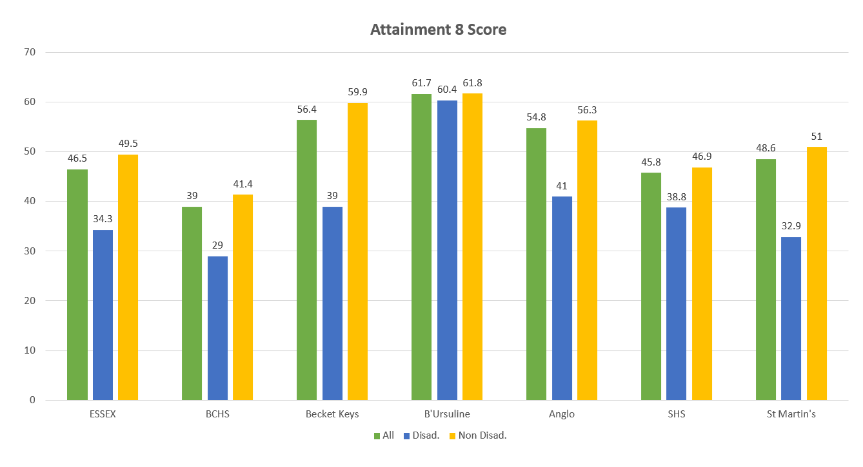

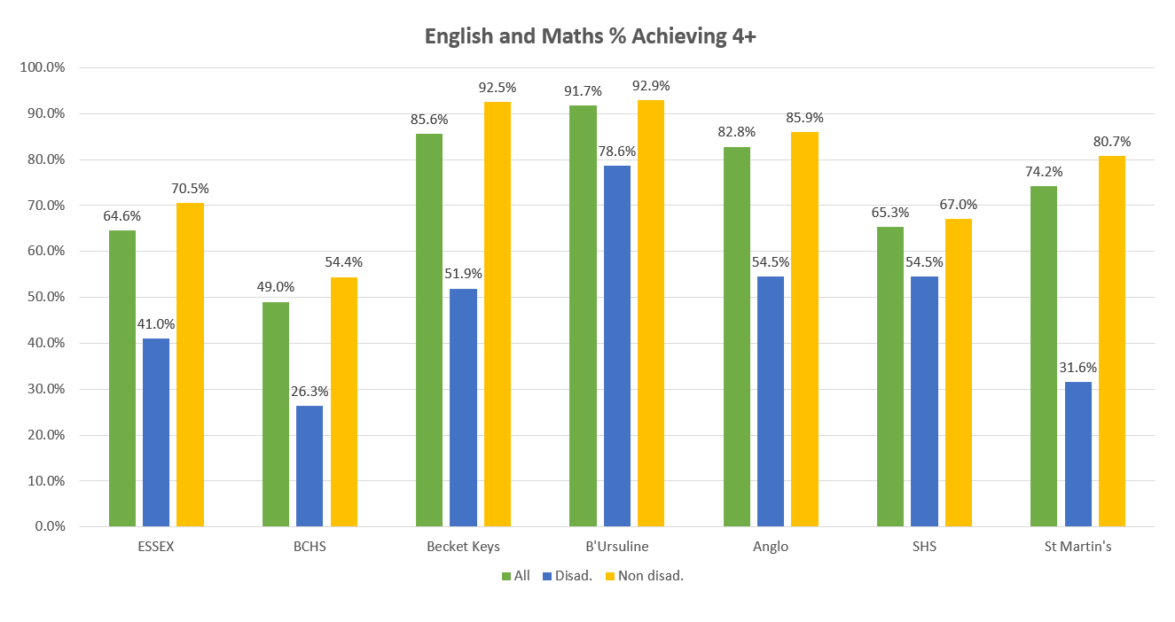

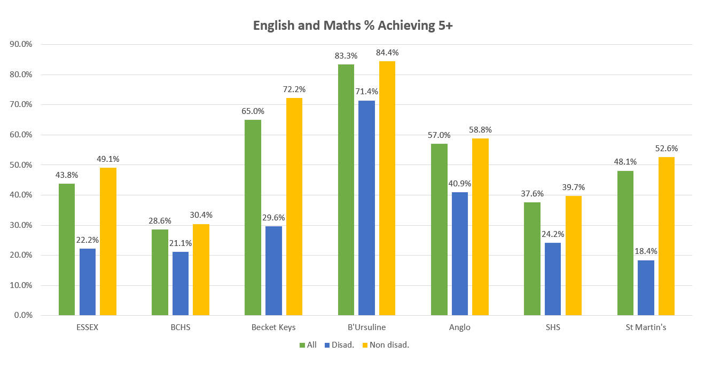

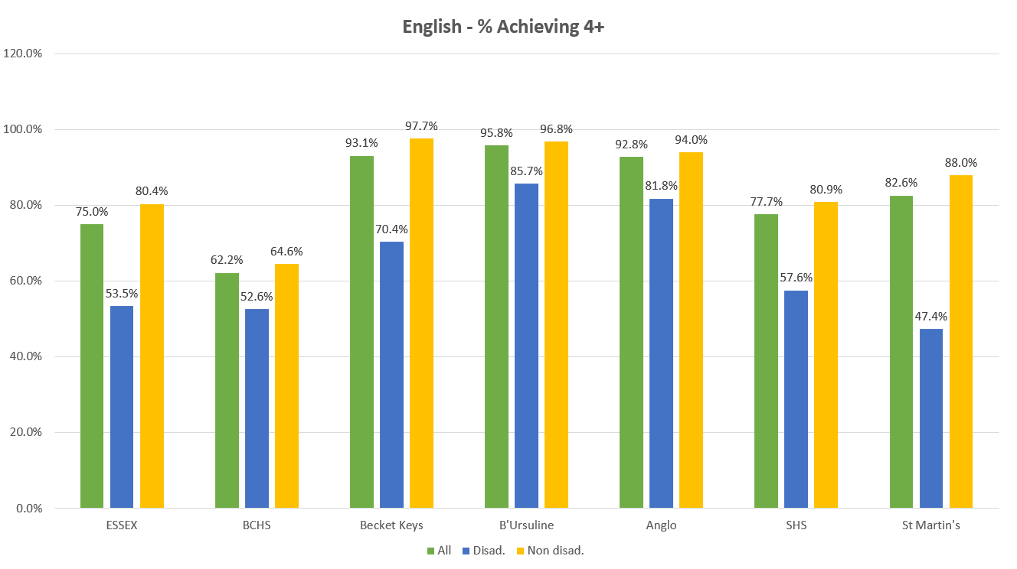

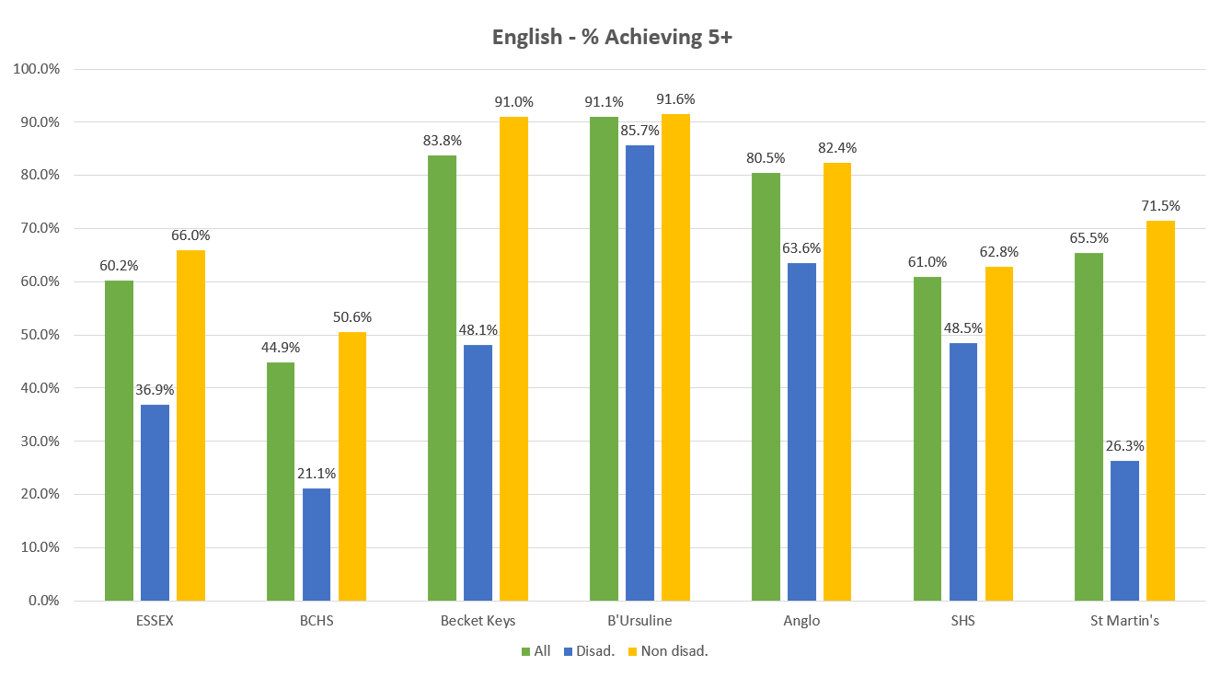

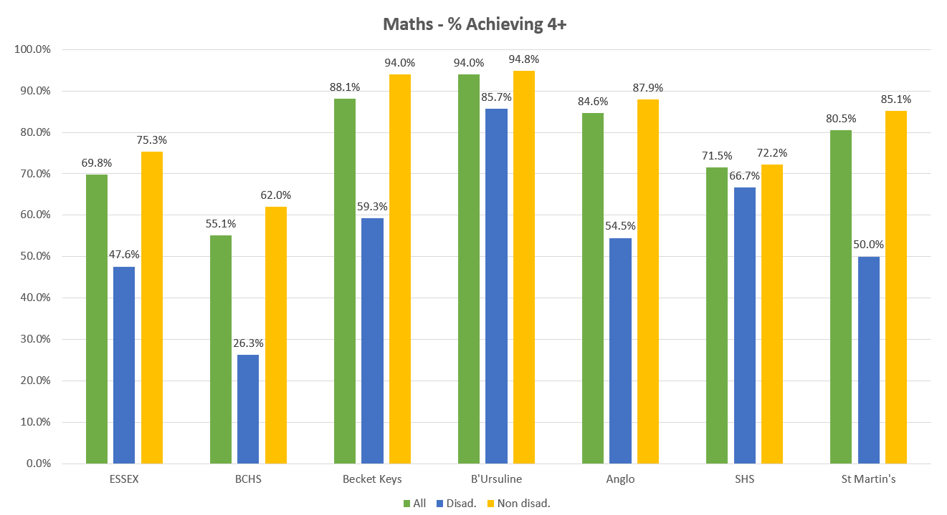

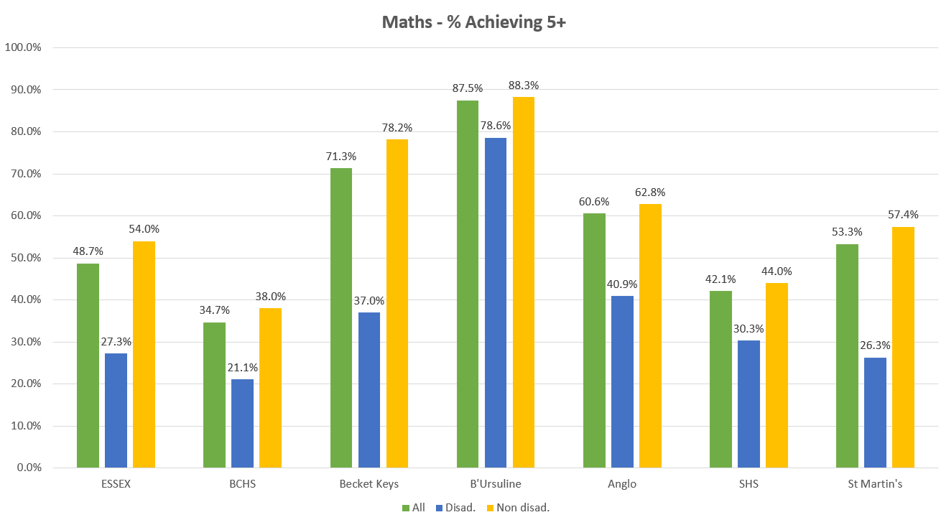

English and Maths Results Comparison
At 9 to 4 English Language and Literature perform similarly to Maths but when the best is applied then there is a 7% difference.
At 9 to 5 there is a 9 to 12% difference in performance in English Language and Literature compared with maths and then is extended to 18% when the best is taken.
At 9 to 7 Maths also performs similarly to the separate English Language and Literature results but when the best is taken English performs 4.25% better.

 | SHS 2019 | SHS 2023 | Essex 2023 | National 2023
English Best 9 - 4% | 78% | 78% | 75% (-3%)
English Language 9 - 4% | 74.31% | 71.85% |  | 64.7%
English Literature 9 - 4% | 68.06% | 71.31% |  | 74.3%
Maths 9 – 4% | 69% | 71% (+2%) | 69.4% (-1.2%) | 61% (-10%)
English Best 9 - 5% | 58% | 60% (+2%) | 60.2%
English Language 9 - 5% | 51.39% | 54.2%
English Literature 9 - 5% | 47.22% | 51.05%
Maths 9 – 5% | 44% | 42% (-2%) | 48.8% (+6.8%)
English Best 9 - 7% | 13% | 20%
English Language 9 - 7% | 10.42% | 15.55% |  | 16.3%
English Literature 9 - 7% | 7.64% | 15.19% |  | 21%
Maths 9 – 7% | 12.96% | 15.75% |  | 17.5%

Performance of groups of students

Group | No of Students |  | Attainment 8 | Progress 8 | English (best)  9-5 | English (best)  9-4 | English (best)  9-7 | Maths  9-5 | Maths  9-4 | Maths  9-7 | %9-5 in both En&Ma | %9-4 in both En&Ma
All | 144 | SHS Results 2019 | 44.90 | -0.22 | 58% | 78% | 13% | 44% | 69% | 12% | 37% | 63%
 | 242 | Exam Result 23 | 45.87 | -0.63 | 61% | 78% | 20% | 42% | 71% | 15% | 38% | 65%
Boys | 77 | SHS Results 2019 | 43.94 | -0.36 | 53% | 77% | 9% | 42% | 73% | 12% | 35% | 65%
 | 128 | Exam Result 23 | 43.33 | -0.68 | 52% | 71% | 14% | 42% | 70% | 17% | 35% | 60%
Girls | 67 | SHS Results 2019 | 46.00 | -0.06 | 63% | 79% | 18% | 46% | 66% | 12% | 39% | 61%
 | 114 | Exam Result 23 | 48.72 | -0.57 | 71% | 87% | 27% | 42% | 74% | 14% | 41% | 71%
Pupil Premium | 28 | SHS Results 2019 | 38.29 | -0.42 | 27% | 54% | 8% | 35% | 54% | 15% | 23% | 42%
 | 33 | Exam Result 23 | 38.78 | -1.24 | 48% | 58% | 9% | 30% | 67% | 6% | 24% | 55%
Non-Pupil Premium | 116 | SHS Results 2019 | 46.35 | -0.18 | 64% | 83% | 14% | 46% | 73% | 11% | 40% | 68%
 | 209 | Exam Result 23 | 46.99 | -0.53 | 63% | 82% | 22% | 44% | 72% | 17% | 40% | 67%
Pupil Premium Gap |  | SHS Results 2019 | -8.06 | -0.24 | -37% | -29% | -7% | -11% | -19% | 4% | -17% | -25%
 |  | Exam Result 23 | -8.21 | -0.71 | -14% | -24% | -13% | -14% | -6% | -11% | -16% | -12%
SEN All | 23 | SHS Results 2019 | 39.36 | -0.25 | 30% | 65% | 13% | 39% | 65% | 4% | 22% | 52%
 | 52 | Exam Result 23 | 35.22 | -0.74 | 41% | 57% | 8% | 27% | 42% | 8% | 27% | 38%
Non SEN Students | 121 | SHS Results 2019 | 45.95 | -0.22 | 63% | 80% | 13% | 45% | 70% | 13% | 40% | 65%
 | 190 | Exam Result 23 | 48.79 | -0.60 | 66% | 84% | 23% | 46% | 79% | 18% | 41% | 73%
SEN Gap |  | SHS Results 2019 | -6.59 | -0.03 | -33% | -15% | 0% | -6% | -5% | -9% | -18% | -13%
 |  | Exam Result 23 | -13.57 | -0.14 | -25% | -27% | -15% | -19% | -37% | -10% | -14% | -34%

P8 should be viewed with caution. The DFE do warn against schools trying to predict P8 in advance of official provisional data being available in the Autumn, as the P8 score is an in year relative measure. So, this is just an estimate and could change once the 2023 and 2024 cohorts are compared to their peers Nationally.

Performance of Ability Band groups of students

Group | No of Students |  | Attainment 8 | Progress 8 | English (best)  9-5 | English (best)  9-4 | English (best)  9-7 | Maths  9-5 | Maths  9-4 | Maths  9-7 | %9-5 in both En&Ma | %9-4 in both En&Ma
High Ability - 2019 was old KS2 scores - can't compare | 54 | SHS Results 2019 | 55.45 | -0.35 | 80% | 94% | 24% | 74% | 96% | 26% | 63% | 91%
 | 46 | Exam Result 23 | 64.10 | -0.60 | 91% | 96% | 61% | 85% | 100% | 50% | 83% | 96%
Middle Ability - 2019 was old KS2 scores - can't compare | 73 | SHS Results 2019 | 38.93 | -0.14 | 44% | 71% | 7% | 25% | 55% | 3% | 19% | 48%
 | 142 | Exam Result 23 | 44.88 | -0.64 | 62% | 82% | 12% | 37% | 77% | 8% | 32% | 69%
Low Ability - 2019 was old KS2 scores - can't compare | 9 | SHS Results 2019 | 25.03 | -0.16 | 11% | 22% | 0% | 0% | 11% | 0% | 0% | 0%
 | 38 | Exam Result 23 | 27.29 | -0.62 | 22% | 41% | 0% | 5% | 18% | 0% | 5% | 16%

Our HPA A8 has improved by almost a grade this year although the % of HPA is the same as 2019 (although on different KS2 measures). The HPA has improved in Maths and English in comparison to 2019 but the 9-7 in English and Maths (albeit not at high as English) is where the biggest difference can be seen.

Subject Performance

Year 11 |  | % 9-7 |  |  |  | % 9-5 |  |  | % 9-4 |  |  |  | % 9-1 |  |  |  | APS
GCSE Subject | Entries | Exam 2019 | Nat 2019 (Prov) | Nat 2023 | Result 2023 | Exam 2019 | Nat 2019 (Prov) | Result 2023 | Exam 2019 | Nat 2019 (Prov) | Nat 2023 | Result 2023 | Exam 2019 | Nat 2019 (Prov) | Nat 2023 | Result 2023 | Exam 2019 | Result 2022 | Result 2023
Art | 36 | 28.13 | 22.70 | 24.20 | 33.33 | 68.75 | 58.10 | 75.00 | 96.88 | 75.00 | 76.40 | 100.00 | 100.00 | 99.30 | 99.50 | 100.00 | 5.69 | 6.08 | 5.72
Biology | 74 | 17.31 | 43.20 | 42.40 | 28.38 | 61.54 | 80.80 | 66.22 | 76.92 | 90.30 | 89.60 | 83.78 | 100.00 | 99.20 | 99.20 | 100.00 | 4.96 | 5.36 | 5.47
Business Studies | 73 | 15.91 | 17.90 | 20.10 | 13.70 | 56.82 | 51.10 | 46.58 | 63.64 | 65.40 | 67.30 | 61.64 | 100.00 | 98.30 | 98.70 | 98.63 | 4.82 | 5.19 | 4.36
Chemistry | 74 | 13.46 | 44.10 | 44.00 | 20.27 | 48.08 | 79.00 | 66.22 | 73.08 | 90.20 | 89.80 | 78.38 | 96.15 | 99.30 | 99.20 | 98.65 | 4.42 | 4.79 | 5.05
Computer Science | 40 | 10.00 | 21.40 | 24.60 | 42.50 | 70.00 | 48.60 | 75.00 | 70.00 | 62.30 | 64.80 | 80.00 | 100.00 | 96.50 | 96.80 | 95.00 | 4.90 | 4.41 | 5.60
Drama GCSE | 14 | N/A | 23.60 | 4.00 | 21.43 | N/A | 59.60 | 64.29 | N/A | 74.30 | 76.50 | 71.43 | N/A | 99.40 | 99.40 | 100.00 | N/A | 6.14 | 5.00
English Language | 238 | 10.42 | 17.30 | 16.30 | 15.97 | 51.39 | 53.00 | 54.62 | 74.31 | 70.00 | 64.70 | 72.27 | 100.00 | 98.40 | 98.10 | 98.32 | 4.55 | 5.01 | 4.76
English Literature | 237 | 7.64 | 20.20 | 21.00 | 15.61 | 47.22 | 56.20 | 51.05 | 68.06 | 73.30 | 74.30 | 71.31 | 97.92 | 97.90 | 98.10 | 99.16 | 4.26 | 4.87 | 4.60
Film Studies | 34 | 8.82 | 17.30 | 19.30 | 20.59 | 52.94 | 51.40 | 64.71 | 76.47 | 67.40 | 68.30 | 85.29 | 100.00 | 98.50 | 98.20 | 100.00 | 4.71 | 5.46 | 5.12
Food Technology | 72 | n/a | n/a | 20.10 | 9.72 | n/a | n/a | 29.17 | n/a | n/a | 67.10 | 43.06 | n/a | n/a | 98.20 | 94.44 | n/a | 4.19 | 3.44
Geography | 85 | 13.33 | 24.50 | 25.00 | 21.18 | 40.00 | 52.40 | 34.12 | 51.67 | 65.00 | 65.60 | 45.88 | 96.67 | 98.00 | 98.10 | 98.82 | 3.82 | 4.63 | 4.02
History | 127 | 12.96 | 24.50 | 25.80 | 15.75 | 37.04 | 51.20 | 36.22 | 53.70 | 63.30 | 64.40 | 49.61 | 96.30 | 96.50 | 96.80 | 92.13 | 3.80 | 5.15 | 3.78
Maths | 238 | 11.81 | 20.40 | 17.50 | 15.97 | 43.75 | 50.00 | 42.86 | 69.44 | 71.10 | 61.10 | 72.69 | 99.31 | 97.60 | 97.40 | 98.74 | 4.27 | 4.80 | 4.46
Music | 10 | 53.85 | 31.70 | 34.20 | 10.00 | 92.31 | 63.20 | 80.00 | 100.00 | 75.40 | 77.60 | 100.00 | 100.00 | 99.00 | 98.70 | 100.00 | 6.46 | 6.86 | 5.30
Physics | 74 | 15.38 | 43.90 | 43.40 | 27.03 | 46.15 | 79.30 | 62.16 | 76.92 | 90.90 | 90.20 | 78.38 | 100.00 | 99.30 | 98.90 | 100.00 | 4.60 | 5.33 | 5.28
Physical Education | 73 | 20.45 | 21.20 | 24.20 | 20.55 | 77.27 | 56.80 | 65.75 | 88.64 | 71.90 | 73.70 | 83.56 | 100.00 | 99.70 | 99.60 | 100.00 | 5.57 | 6.07 | 5.34
Science - Grade 1 | 164 | 9.78 | 7.50 | 8.90 | 8.54 | 35.87 | 34.00 | 37.20 | 61.96 | 55.30 | 57.10 | 64.02 | 98.91 | 97.60 | 97.20 | 98.78 | 4.08 | 4.57 | 4.13
Science - Grade 2 | 164 | 5.43 | 7.50 |  | 6.10 | 25.00 | 34.00 | 27.44 | 46.74 | 55.30 |  | 46.95 | 98.91 | 97.60 |  | 98.78 | 3.52 | 4.06 | 3.63
Sociology | 72 | 20.75 | 18.00 | 19.90 | 25.00 | 45.28 | 49.20 | 58.33 | 49.06 | 64.20 | 65.40 | 70.83 | 98.11 | 96.90 | 98.50 | 98.61 | 4.19 | 4.94 | 4.96
Spanish | 49 | 44.44 | 26.10 | 26.80 | 40.82 | 77.78 | 54.50 | 67.35 | 77.78 | 69.50 | 70.00 | 79.59 | 100.00 | 98.00 | 97.90 | 100.00 | 6.33 | 5.90 | 5.63

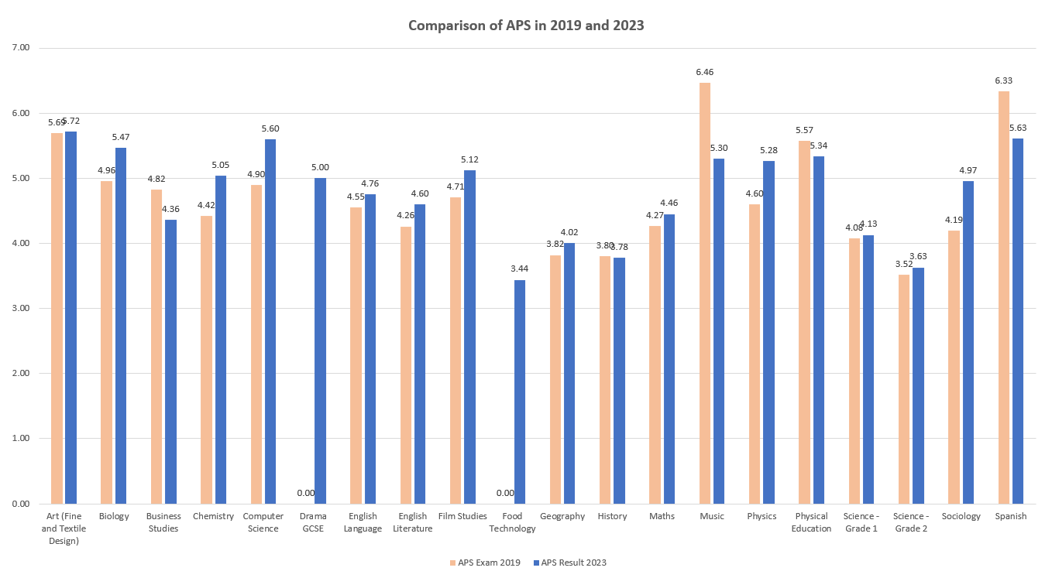

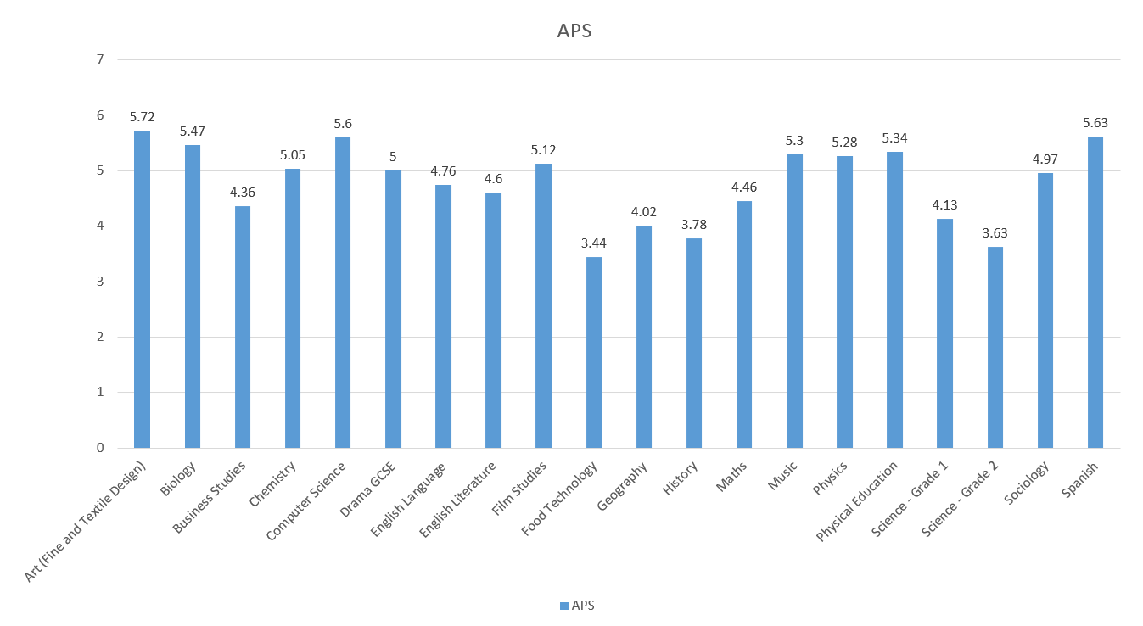
SUBJECT APS

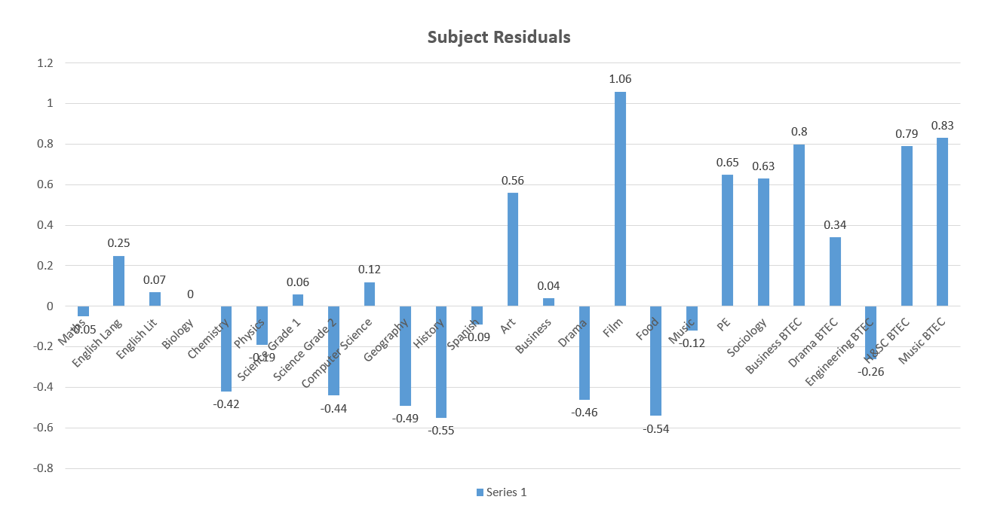
SUBJECT RESIDUALS

 | Subject APS | APS for students taking subject | Residual
Maths | 4.46 | 4.51 | -0.05
English Lang | 4.76 | 4.51 | 0.25
English Lit | 4.60 | 4.53 | 0.07
Biology | 5.47 | 5.47 | 0.00
Chemistry | 5.05 | 5.47 | -0.42
Physics | 5.28 | 5.47 | -0.19
Science Grade 1 | 4.13 | 4.08 | 0.06
Science Grade 2 | 3.63 | 4.08 | -0.44
Computer Science | 5.60 | 5.48 | 0.12
Geography | 4.02 | 4.51 | -0.49
History | 3.78 | 4.33 | -0.55
Spanish | 5.63 | 5.72 | -0.09
Art | 5.72 | 5.16 | 0.56
Business | 4.36 | 4.32 | 0.04
Drama | 5.00 | 5.46 | -0.46
Film | 5.12 | 4.05 | 1.06
Food | 3.44 | 3.99 | -0.54
Music | 5.30 | 5.42 | -0.12
PE | 5.34 | 4.69 | 0.65
Sociology | 4.97 | 4.34 | 0.63
Business BTEC | 4.29 | 3.49 | 0.80
Drama BTEC | 4.67 | 4.33 | 0.34
Engineering BTEC | 3.83 | 4.09 | -0.26
H&SC BTEC | 4.85 | 4.06 | 0.79
Music BTEC | 5.72 | 4.89 | 0.83

 | Exam Results 2023
GCSE Subject | 9 | 8 | 7 | 6 | 5 | 4 | 3 | 2 | 1 | U/N
Art (Fine & Textile) | 1 | 2 | 9 | 7 | 8 | 9 |  |  |  |  | 36
Biology | 3 | 6 | 12 | 21 | 7 | 13 | 9 | 3 |  |  | 74
Business Studies | 2 | 2 | 6 | 14 | 10 | 11 | 16 | 5 | 6 | 1 | 73
Chemistry | 2 | 7 | 6 | 15 | 19 | 9 | 9 | 4 | 2 | 1 | 74
Computer Science | 4 | 3 | 10 | 7 | 6 | 2 | 4 |  | 2 | 2 | 40
Drama GCSE |  |  | 3 | 4 | 2 | 1 | 3 | 1 |  |  | 14
English Language | 3 | 15 | 20 | 43 | 49 | 42 | 53 | 7 | 2 | 4 | 238
English Literature | 8 | 13 | 16 | 34 | 50 | 48 | 34 | 23 | 9 | 2 | 237
Film Studies | 1 |  | 6 | 6 | 9 | 7 | 4 | 1 |  |  | 34
Food Technology | 1 | 2 | 4 | 4 | 10 | 10 | 12 | 20 | 5 | 4 | 72
Geography | 4 | 3 | 11 | 5 | 6 | 10 | 24 | 12 | 9 | 1 | 85
History | 3 | 6 | 11 | 13 | 13 | 17 | 22 | 19 | 13 | 10 | 127
Maths | 5 | 11 | 22 | 23 | 41 | 71 | 32 | 21 | 9 | 3 | 238
Music |  |  | 1 | 3 | 4 | 2 |  |  |  |  | 10
Physics | 3 | 8 | 9 | 13 | 13 | 12 | 14 | 2 |  |  | 74
Physical Education | 3 | 6 | 6 | 22 | 11 | 13 | 11 |  | 1 |  | 73
Science - Grade 1 | 2 | 5 | 7 | 10 | 37 | 44 | 37 | 19 | 1 | 2 | 164
Science - Grade 2 | 2 | 2 | 6 | 10 | 25 | 32 | 47 | 28 | 10 | 2 | 164
Sociology | 3 | 8 | 7 | 12 | 12 | 9 | 12 | 6 | 2 | 1 | 72
Spanish | 5 | 7 | 8 | 5 | 8 | 6 | 6 | 3 | 1 |  | 49
TOTALS | 55 | 106 | 180 | 271 | 340 | 368 | 349 | 174 | 72 | 33 | 1948

Year 11 | D*-D |  | D*-M |  | D*-P |  | APS
BTEC | 2019 Result | Final Result | 2019 Result | Final Result | 2019 Result | Final Result | 2019 Result | Final Result
Business BTEC | 15.56 | 21.05 | 48.88 | 36.84 | 82.2 | 71.05 | 4.6 | 4.29
Performing Arts BTEC | 54.55 | 5.56 | 63.64 | 38.89 | 90.91 | 100.00 | 5.98 | 4.67
Engineering BTEC | 14.29 | 10.00 | 66.67 | 15.71 | 95.24 | 62.85 | 5.32 | 3.82
Health & Social Care | 35.29 | 16.13 | 58.82 | 51.61 | 94.11 | 87.09 | 5.25 | 4.85
Music BTEC | n/a | 37.50 | n/a | 62.50 | n/a | 87.50 | n/a | 5.72

 | 2023 Final Result
BTEC | D* | D | M | P | D1 | M1 | P1 | UXN
Business BTEC | 1 | 7 | 6 | 13 | 4 | 3 | 2 | 2
Performing Arts BTEC | 0 | 1 | 6 | 11 | 0 | 0 | 0 | 0
Engineering BTEC | 2 | 5 | 4 | 33 | 15 | 4 | 7 | 0
Health & Social Care | 1 | 4 | 11 | 11 | 2 | 1 | 1 | 0
Music BTEC | 3 | 0 | 2 | 2 | 0 | 0 | 1 | 0
Total | 7 | 17 | 29 | 70 | 21 | 8 | 11 | 2

A Level Results
- These are the first public exams this cohort has sat as they were awarded TAGS in Year 11 (2021). There were no concessions to this year groups exams and there was a return to grade boundaries akin to 2019. Therefore comparisons to previous years cannot really be made.
- We improved since our mock results sat in January but the results are lower than our 2019 result and 2023 National.
  - A*- A% is 10% below our 2019 result and 12.6% below 2023 National
  - A*- B% is 8.3% below ours 2019 result and 8.1% below 2023 National
  - A* - C% is 0.77% below our 2019 result and 2% below 2023 National
  - A* - E% is very marginally better than 2023 National
- We obtained 10 U grades (3 in Biology, 2 in Chemistry, 1 in Economics, 1 in Law 3 in Maths.

GCE A Level | 2019 Nat Result | 2019  A Level | 2023 National (Provisional) | 2023 Mock Exams (Jan) | 2023 Results
Av Prior Attainment (GCSE) | n/a | 5.63 | n/a | 6.36 | 6.36
No of Students | n/a | 127 | n/a | 147 | 147
No of Entries | n/a | 325 | n/a | 416 | 414
A*-A% | 23.3 | 23.69 | 26.5% | 12.74 | 13.29
A*-B % | 49.1 | 54.77 | 48.9% | 31.97 | 40.82
A*-C % | 74.2 | 82.77 | 75.4% | 58.65 | 73.43
A*-D% | 90.3 | 93.23 |  | 82.69 | 90.10
A*-E % | 97.4 | 98.77 | 97.2% | 94.23 | 97.58
APS/Student | n/a | 92.05 |  | 80.54 | 89.59
APS/Entry | 33.09 | 35.97 |  | 28.46 | 31.81
APS/Entry as a Grade | C+ | B- |  | C | C+

Brentwood School Comparison

School | Students at end of KS5 | A levels
 |  | APS per entry | Expressed as grade | % passes at grades:
 |  |  |  | A* | A | B | C | D | E | A*-A | A*-B | A*-C | A*-E
Essex emerging 2023 performance | 5426 | 34.7 | C+ | 8.1% | 17.1% | 26.0% | 23.9% | 14.7% | 7.7% | 25.2% | 51.2% | 75.0% | 97.4%
Brentwood Ursuline Convent High School | 73 | 37.1 | B- | 10.0% | 14.7% | 32.6% | 26.8% | 10.5% | 4.7% | 24.7% | 57.4% | 84.2% | 99.5%
Becket Keys Church of England School | 100 | 34.7 | C+ | 3.4% | 16.7% | 31.0% | 27.9% | 16.3% | 2.7% | 20.1% | 51.0% | 78.9% | 98.0%
Anglo European School | 146 | 33.7 | C+ | 3.8% | 13.6% | 30.2% | 27.5% | 18.6% | 5.0% | 17.5% | 47.6% | 75.1% | 98.8%
St Martin's School | 185 | 32.0 | C | 6.5% | 13.0% | 20.9% | 28.1% | 19.0% | 10.7% | 19.4% | 40.3% | 68.4% | 98.2%
Shenfield High School | 197 | 31.8 | C | 2.7% | 10.4% | 27.1% | 33.1% | 16.9% | 7.5% | 13.3% | 40.8% | 73.4% | 97.6%
Brentwood County High School | 186 | 22.0 | D- | 1.6% | 5.4% | 13.0% | 22.8% | 22.6% | 18.6% | 7.0% | 20.0% | 42.7% | 83.8%

Our APS is only 0.2 different to St Martins. Our A*-B is 0.5% better and our A% -C is 5% better. It is our A*-A where the biggest gap of 6.1% lies.

Although Essex has us and St Martin’s as C the 16 to 18 accountability measures: technical guidance April 202 places our APS as C+ (see below).

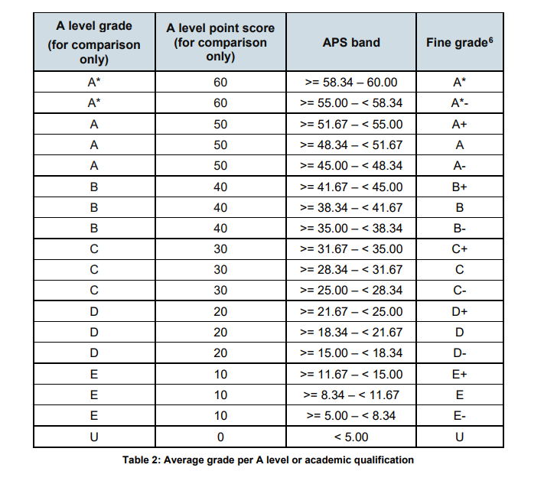

16 to 18 accountability measures: technical guidance April 2023
Subject Performance

 |  | A*-A |  |  | A*-B |  |  | A*-C |  |  | A*-D |  |  |  | A*-E |  |  |  | APS
A Level Subject | No.Students | 2019 SHS Result | 2023 National | 2023 Result | 2019 SHS Result | 2023 National | 2023 Result | 2019 SHS Result | 2023 National | 2023 Result | 2019 SHS Result | 2023 National | 2023 Result | 2019 SHS Result |  | 2023 National | 2023 Result | 2019 SHS Result |  | 2023 Result
Art | 7 | 83.3 | 31.2 | 57.1 | 100.0 | 62.6 | 100.0 | 100.0 | 85.1 | 100.0 | 100.0 | 95.4 | 100.0 | 100.0 |  | 99.0 | 100.0 | 55.0 |  | 48.6
Biology | 21 | 13.3 | 27.0 | 14.3 | 33.3 | 48.7 | 33.3 | 53.3 | 68.6 | 47.6 | 80.0 | 85.1 | 71.4 | 100.0 |  | 95.7 | 85.7 | 28.0 |  | 25.2
Business Studies | 46 | 19.5 | 16.2 | 19.6 | 68.3 | 46.7 | 56.5 | 92.7 | 75.1 | 93.5 | 97.6 | 91.4 | 100.0 | 97.6 |  | 97.6 | 100.0 | 38.1 |  | 37.6
Chemistry | 16 | 0.0 | 32.2 | 0.0 | 50.0 | 53.8 | 0.0 | 50.0 | 71.6 | 31.3 | 75.0 | 86.1 | 50.0 | 100.0 |  | 95.9 | 87.5 | 27.5 |  | 16.9
Economics | 36 | 35.3 | 29.3 | 22.2 | 88.2 | 58.2 | 52.8 | 100.0 | 80.2 | 77.8 | 100.0 | 92.7 | 88.9 | 100.0 |  | 98.0 | 97.2 | 42.9 |  | 34.2
English Language | 17 | 18.8 | 12.3 | 0.0 | 50.0 | 44.1 | 29.4 | 87.5 | 79.1 | 76.5 | 87.5 | 95.6 | 100.0 | 100.0 |  | 99.2 | 100.0 | 35.0 |  | 30.6
English Literature | 12 | 22.2 | 25.9 | 16.7 | 44.4 | 57.9 | 58.3 | 77.8 | 83.2 | 66.7 | 100.0 | 95.6 | 100.0 | 100.0 |  | 99.2 | 100.0 | 34.4 |  | 35.0
Film Studies | 7 | 11.1 | 13.0 | 14.3 | 55.6 | 48.7 | 71.4 | 100.0 | 81.0 | 100.0 | 100.0 | 95.2 | 100.0 | 100.0 |  | 98.9 | 100.0 | 37.8 |  | 40.0
Geography | 27 | 10.0 | 24.8 | 11.1 | 60.0 | 54.4 | 37.0 | 90.0 | 79.7 | 74.1 | 100.0 | 93.3 | 96.3 | 100.0 |  | 98.3 | 100.0 | 36.0 |  | 31.9
History | 22 | 23.8 | 24.7 | 0.0 | 38.1 | 56.3 | 18.2 | 76.2 | 80.8 | 59.1 | 100.0 | 94.0 | 90.9 | 100.0 |  | 98.6 | 100.0 | 34.3 |  | 26.8
Law | 19 | 38.1 | 17.0 | 5.3 | 47.6 | 40.4 | 26.3 | 90.5 | 64.6 | 57.9 | 95.2 | 83.8 | 94.7 | 100.0 |  | 95.6 | 94.7 | 37.6 |  | 27.9
Maths | 20 | 19.1 | 41.9 | 0.0 | 23.8 | 60.9 | 10.0 | 52.4 | 76.5 | 35.0 | 81.0 | 88.5 | 50.0 | 100.0 |  | 96.4 | 85.0 | 28.1 |  | 18.0
Media Studies | 32 | 22.9 | 13.0 | 6.3 | 65.7 | 48.7 | 34.4 | 91.4 | 81.0 | 90.6 | 100.0 | 95.2 | 93.8 | 100.0 |  | 98.9 | 100.0 | 38.6 |  | 32.5
Music | 4 | 0.0 | 24.2 | 0.0 | 25.0 | 50.5 | 0.0 | 100.0 | 75.5 | 50.0 | 100.0 | 90.6 | 100.0 | 100.0 |  | 97.7 | 100.0 | 32.5 |  | 25.0
Philosophy | 9 | 0.0 | 26.3 | 22.2 | 62.5 | 56.2 | 66.7 | 87.5 | 79.6 | 77.8 | 87.5 | 92.5 | 88.9 | 100.0 |  | 98.1 | 100.0 | 33.8 |  | 35.6
Physical Education | 28 | 10.0 | 18.7 | 10.7 | 50.0 | 43.9 | 14.3 | 70.0 | 69.1 | 71.4 | 100.0 | 87.5 | 92.9 | 100.0 |  | 96.8 | 100.0 | 33.0 |  | 28.9
Physics | 7 | 0.0 | 31.7 | 0.0 | 16.7 | 51.4 | 0.0 | 33.3 | 69.3 | 28.6 | 66.7 | 84.5 | 71.4 | 83.3 |  | 95.3 | 100.0 | 20.0 |  | 20.0
Psychology | 23 | 52.9 | 19.1 | 17.4 | 94.1 | 44.7 | 47.8 | 100.0 | 69.9 | 73.9 | 100.0 | 87.3 | 91.3 | 100.0 |  | 96.6 | 100.0 | 45.3 |  | 33.0
Sociology | 50 | 32.4 | 19.1 | 26.0 | 52.9 | 48.5 | 68.0 | 88.2 | 76.1 | 92.0 | 94.1 | 91.8 | 100.0 | 97.1 |  | 97.7 | 100.0 | 37.7 |  | 39.4
Spanish | 4 | 0.0 | 36.0 | 0.0 | 0.0 | 65.5 | 25.0 | 0.0 | 84.6 | 50.0 | 0.0 | 94.5 | 100.0 | 100.0 |  | 98.8 | 100.0 | 10.0 |  | 27.5
Theatre Studies | 7 | 37.5 | 21.5 | 0.0 | 87.5 | 56.4 | 71.4 | 100.0 | 83.3 | 100.0 | 100.0 | 96.0 | 100.0 | 100.0 |  | 99.2 | 100.0 | 45.0 |  | 37.1

A2 Grade Distribution

 | 2023 Results
A LEVEL | A* | A | B | C | D | E | U
Art | 2 | 2 | 3
Biology |  | 3 | 4 | 3 | 5 | 3 | 3
Business Studies | 3 | 6 | 17 | 17 | 3
Chemistry |  |  |  | 5 | 3 | 6 | 2
Economics | 1 | 7 | 11 | 9 | 4 | 3 | 1
English Language |  |  | 5 | 8 | 4
English Literature | 1 | 1 | 5 | 1 | 4
Film Studies | 1 |  | 4 | 2
Geography |  | 3 | 7 | 10 | 6 | 1
History |  |  | 4 | 9 | 7 | 2
Law |  | 1 | 4 | 6 | 7 |  | 1
Maths |  |  | 2 | 5 | 3 | 7 | 3
Media Studies |  | 2 | 9 | 18 | 1 | 2
Music |  |  |  | 2 | 2
Philosophy |  | 2 | 4 | 1 | 1 | 1
Physical Education |  | 3 | 1 | 16 | 6 | 2
Physics |  |  |  | 2 | 3 | 2
Psychology |  | 4 | 7 | 6 | 4 | 2
Sociology | 4 | 9 | 21 | 12 | 4
Spanish |  |  | 1 | 1 | 2
Theatre Studies |  |  | 5 | 2

BTEC Results

- BTEC Extended Diploma D* - D % this year was 77.55% below previous years but considerably higher than 2019 National.
- BTEC Extended Certificate D*-D% this year was 64.29%, higher than previous years.

BTEC Extended Diploma | 2019 Nat Result | 2019 SHS Result | 2022 Results | 2023 Nat  Result | 2023 Results
Av Prior Attainment | n/a | 4.40 | 4.86 |  | 5.09
No of Students | n/a | 28 | 28 |  | 49
No of Entries | n/a | 84 | 84 |  | 147
Distinction (D*-D) % | 38.3 | 85.71 | 88.10 |  | 77.55
Merit (D*-M) % | 75 | 100.00 | 100.00 |  | 98.64
Pass (D*-P) % | 97.2 | 100.00 | 100.00 |  | 100.00
APS/Student | n/a | 116.25 | 119.11 |  | 112.55

BTEC Extended Certificate | 2019 Nat Result | 2019 SHS Result | 2022 Results | 2023 Nat Result | 2023 Results
Av Prior Attainment | n/a | 4.82 | 5.32 |  | 5.81
No of Students | n/a | 30 | 26 |  | 14
No of Entries | n/a | 33 | 32 |  | 14
Distinction (D*-D) % | 38.3 | 42.42 | 62.50 |  | 64.29
Merit (D*-M) % | 81 | 96.97 | 93.75 |  | 92.86
Pass (D*-P) % | 98 | 100.00 | 100.00 |  | 100.00
APS/Student | n/a | 32.83 | 40.00 |  | 33.93

BTEC Diploma | 2019 Nat Result | 2019 SHS Result | 2022 Results | 2023 Nat Result | 2023 Results
Av Prior Attainment | n/a | 4.43 | 4.85 |  | 5.44
No of Students | n/a | 2 | 3 |  | 1
No of Entries | n/a | 3 | 6 |  | 2
Distinction (D*-D) % | 26.4 | 100.00 | 50.00 |  | 100.00
Merit (D*-M) % | 59.7 | 100.00 | 100.00 |  | 100.00
Pass (D*-P) % | 95.2 | 100.00 | 100.00 |  | 100.00
APS/Student | n/a | 52.50 | 60.00 |  | 85.00

BTEC Foundation Diploma | 2019 Nat Result | 2019 SHS Result | 2022 Results | 2023 Nat Result | 2023 Results
Av Prior Attainment | n/a | 4.43 | 3.65 |  | 4.89
No of Students | n/a | 2 | 2 |  | 1
No of Entries | n/a | 3 | 3 |  | 1.5
Distinction (D*-D) % | 26.4 | 100.00 | 0.00 |  | 0.00
Merit (D*-M) % | 59.7 | 100.00 | 50.00 |  | 100.00
Pass (D*-P) % | 95.2 | 100.00 | 100.00 |  | 100.00
APS/Student | n/a | 52.50 | 30.00 |  | 37.50

Brentwood School Comparison

School | Level 3 Vocational
 | Number of students | Number of entries | Number of passes at grades: |  |  |  | % passes at grades:
 |  |  | Dist* | Dist | Merit | Pass | Dist* | Dist | Merit | Pass | % Pass or above
Essex emerging 2023 performance | 1499 | 2546 | 452 | 884 | 716 | 319 | 17.8% | 34.7% | 28.1% | 12.5% | 93.1%
Brentwood Ursuline Convent High School | 15 | 30 | 8 | 16 | 4 | 1 | 26.7% | 53.3% | 13.3% | 3.3% | 96.7%
Becket Keys Church of England School | 7 | 7 | 0 | 4 | 2 | 1 | 0.0% | 57.1% | 28.6% | 14.3% | 100.0%
Anglo European School | 18 | 18 | 0 | 6 | 7 | 4 | 0.0% | 33.3% | 38.9% | 22.2% | 94.4%
St Martin's School | 39 | 46 | 4 | 12 | 25 | 5 | 8.7% | 26.1% | 54.3% | 10.9% | 100.0%
Shenfield High School | 65 | 164 | 52 | 73 | 36 | 3 | 31.7% | 44.5% | 22.0% | 1.8% | 100.0%
Brentwood County High School | 88 | 128 | 4 | 11 | 36 | 6 | 3.1% | 8.6% | 28.1% | 4.7% | 44.5%

Our BTEC results in comparison to the other Brentwood Schools are very good.

 |  | D*-D |  | D*-M |  | D*-P |  | APS
BTEC | No.  Students |  | 2023 Result |  | 2023 Result |  | 2023 Result |  | 2023 Result
Business (Ext Dip) | 17 |  | 72.5 |  | 100.0 |  | 100.0 |  | 103.8
Health & Social Care (Ext Dip) | 7 |  | 57.1 |  | 95.2 |  | 100.0 |  | 110.0
PE BTEC (Ext Dip) | 25 |  | 86.7 |  | 98.7 |  | 100.0 |  | 119.2
Health & Social Care (XCert) | 4 |  | 100.0 |  | 100.0 |  | 100.0 |  | 38.8
Music BTEC (XCert) | 3 |  | 0.0 |  | 66.7 |  | 100.0 |  | 21.7
Sport BTEC (XCert) | 7 |  | 71.4 |  | 100.0 |  | 100.0 |  | 36.4
H&SC BTEC (Dip) | 1 |  | 100.0 |  | 100.0 |  | 100.0 |  | 85.0
H&SC BTEC (F Dip) | 1 |  | 0.0 |  | 100.0 |  | 100.0 |  | 37.5

 | 2023 Results
BTEC | D* | D | M | P | U
Business (Ext Dip) | 8 | 29 | 14 | 0 | 0
Health & Social Care (Ext Dip) | 9 | 3 | 8 | 1 | 0
PE BTEC (Ext Dip) | 31 | 34 | 9 | 1 | 0
Health & Social Care (XCert) | 1 | 3
Music BTEC (XCert) |  |  | 2 | 1
Sport BTEC (XCert) | 2 | 3 | 2
H&SC BTEC (Dip) | 1 | 1
H&SC BTEC (F Dip) |  |  | 1

