INCIDENT MANAGEMENT
AND
BUSINESS CONTINUITY
PLAN
Confidential
Shenfield High School
Alexander Lane, Shenfield, Brentwood,
CM15 8RY
Detailing arrangements for:
    - Incident Management
    - Business Continuity
    - Recovery and Resumption of Normal School Activities
    - To be read in conjunction with:
      - SHS Lockdown procedures
      - SHS Evacuation plan

July 2021
Table of Contents
Section | Content | Page No.
1.0 | About this Plan
1.1 | Document Control
1.2 | Plan Purpose
1.3 | Plan Remit
1.4 | Plan Owner
1.5 | Plan Distribution
1.6 | Plan Storage
1.7 | Plan Review Schedule
2.0 | Plan Activation
2.1 | Circumstances
2.2 | Responsibility for Plan Activation
2.3 | Escalating a Serious Incident to Essex County Council
2.4 | Activation Process
3.0 | Roles and Responsibilities
3.1 | School Incident Management Team
3.2 | Additional Response and Recovery Roles
3.3 | The Role of Governors
4.0 | Incident Management
4.1 | Purpose of the Incident Management Phase
4.2 | Incident Management Actions
5.0 | Business Continuity
5.1 | Purpose of the Business Continuity Phase
5.2 | Business Continuity Actions
5.3 | Business Continuity Strategies
6.0 | Recovery and Resumption
6.1 | Purpose of the Recovery and Resumption Phase
6.2 | Recovery and Resumption Actions
7.0 | Appendices
A | Log Template
B | Impact Assessment Form
C | Lost Property Form
D | Financial Expenditure Log
E | Contents of Emergency Box
F | Risk Identification, Evaluation and Management Matrix
G | Incident Management Decision-Making Tool
H | Staff Contact List
I | Key Contacts List
J | School Buuiding Plans
K | Site Information

1.0 About this Plan

Document Control

Date | Revision/Amendment Details & Reason | Author
Oct 2018 | Initial version | SR
Feb 2020 | Annual Review | SR
July 2021 | Annual Review | SR

Plan Purpose

To provide a flexible response so that Shenfield High School can:

Respond to a disruptive incident (incident management)
- Maintain delivery of critical activities during an incident (business continuity)
- Return to ‘business as usual’ (resumption and recovery)

Examples of critical incidents impacting on schools include:
- Death or serious injury of a pupil/ member of staff in school or on a school trip
- Child protection incident
- Events which result in higher than normal absences
- Major fire, flood or other natural disaster
- Building collapse
- Missing person(s)/abductions
- Intense media interest
- Major ongoing power or services failure
- Local civil disturbance or terror related incident

Plan Scope

The following are covered by this Plan:

- teaching
- learning support
- pastoral care
- school administration
- catering
- out of school hours care
- school trips
- lettings
- governance
- Premises and environment
- Technology and systems

The following premises are covered by this Plan:

- Shenfield High School building and outside areas including the playing fields

1.5 Plan Owner

The School Business Manager is this Plan’s Owner and is responsible for ensuring that it is maintained, exercised and updated in accordance with School Policy for reviewing business continuity / emergency / critical incident / response plans.

1.6 Plan Distribution

This Business Continuity Plan is distributed as follows:

NAME | ROLE | ISSUE DATE | PLAN REF NO
C Herman | Headteacher | Feb 2019 | V1.0
J Martin | Deputy Head | Feb 2019 | V1.0
J Sands | Deputy Head | Feb 2019 | V1.0
S Roberts | Business Manger | Feb 2019 | V1.0
R Drew | Assistant Head | Feb 2019 | V1.0
B Clifford | Assistant Head | Feb 2019 | V1.0
A Taylor | Assistant Head | Feb 2019 | V1.0
DJ Barron | Assistant Head | Feb 2019 | V1.0
A Cooke | Assistant Head | Feb 2019 | V1.0
J Rigg | Assistant Head | Feb 2019 | V1.0
J Swettenham | Chair of Governors | Feb 2019 | V1.0
K Boulton | Vice Chair of Governors | Feb 2019 | V1.0
C Watson | SLT PA | Feb 2019 | V1.0
D Matthews | Finance Manager | Feb 2019 | V1.0
K Whordley | HR Manager | Feb 2019 | V1.0
L Smith | Finance & Premises Assistant | Feb 2019 | V1.0
Reception |  | Feb 2019 | V1.0
V Waites | Site Manager | Feb 2019 | V1.0
D Springett | Assistant Site Manager | Feb 2019 | V1.0
File Copy | Kept in the Safe | Feb 2019 | V1.0

1.7 Plan Storage

All parties on the distribution list above, are required to safely and confidentially store a copy of this plan at their regular place of work and off-site i.e. at home/ in vehicles (if appropriate).

1.8 Plan Review Schedule

This Plan will be updated as required and formally reviewed in line with the School’s review timetable.

When | By | Date completed
October 2019 | Business Manager | Feb 2020
July 2021 | Business Manager | July 2021
July 2022 | Business Manager

2.0 Plan Activation

2.1 Circumstances

This Plan will be activated in response to an incident causing significant disruption to the School, particularly the delivery of key/critical activities.

Examples of circumstances triggering activation of this Plan include:

- Loss of key staff or skills e.g. above normal levels of absenteeism due to illness or other scenarios such as severe weather, transport disruption
- Loss of critical systems e.g. ICT failure, power outage
- Denial of access, or damage to, facilities e.g. loss of a building through fire or flood, an external emergency with the School in the Emergency Service’s cordon preventing access, School facilities in use for General/Local Elections, severe weather scenarios or utilities failure
- Loss of a key resource e.g. an external supplier/partner vital to the delivery of a critical school activity such as catering provider or providers of transport e.g. for SEN pupils
- Local Civil disturbance or terror related incident e.g. travellers, local demonstrations, violent incidents in the local area
- Intense media interest – possibly linked to one or more of the above scenarios

2.2 Responsibility for Plan Activation

The Head Teacher or a member of the nominated School Incident Management Team will normally activate and stand down this Plan.

2.3 Escalating a Serious/Critical Incident

All serious incidents or incidents affecting the physical infrastructure of the school should be reported to Essex County Council via the two numbers listed below

Schools Communications Team  Email:  schools.communication@essex.gov.uk | 01245 434745 | Office Hours (9am – 5pm)
Emergency Duty Service (EDS) | 0345 6061212 | Out of Hours (5pm – 9am) and at weekends and Bank Holidays

If the incident is deemed to be of a ‘critical’ nature, the Incident Management Plan will be activated and other Council Services as well as the Department of Education should be notified to respond as appropriate.

2.4 Activation Process
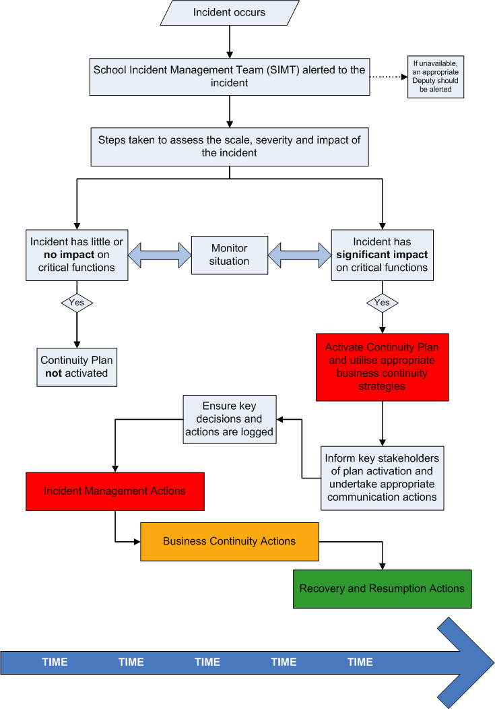

3.0 Roles and Responsibilities

3.1 School Incident Management Team

Role | Responsibilities | Accountability / Authority
Headteacher (Incident response leader) | - Senior responsible owner of Business Continuity Management in the School  - Ensuring the School has capacity within its structure to respond to incidents  - Determining the School’s overall response and recovery strategy  - Developing continuity arrangements and strategies e.g. alternative relocation site, use of temporary staff etc.  - Involving the School community in the planning process as appropriate  - Conducting ‘debriefs’ following an incident, test or exercise to identify lessons and ways in which the plan can be improved  - Training staff within the School on Business Continuity  - Embedding a culture of resilience within the School, involving all staff and pupils | The Headteacher has overall responsibility for day-to-management of the School, including lead decision-maker in times of crisis.
Business Manager | - Business Continuity Plan development and maintenance  - Developing continuity arrangements and strategies e.g. alternative relocation site, use of temporary staff etc.  - Plan testing and exercise  - Conducting ‘debriefs’ following an incident, test or exercise to identify lessons and ways in which the plan can be improved  - Training staff within the School on Business Continuity | The Business Manager will co-ordinate the maintenance and development of the Incident and Continuity Plan, on the authority of, and in conjunction with, the Headteacher
School Incident Management Team  (including Headteacher &  Business Manager) | - Leading the School’s initial and ongoing response to an incident  - Declaring that an ‘incident’ is taking place  - Activating the Business Continuity Plan  - Notifying relevant stakeholders of the incident, plan activation and ongoing response actions  - Providing direction and leadership for the whole School community  - Undertaking response and communication actions as agreed in the plan  - Prioritising the recovery of key activities disrupted by the incident  - Managing resource deployment  - Welfare of Pupils  - Staff welfare and employment issues | The School Incident Management Team has the delegated authority to authorise all decisions and actions required to respond and recover from the incident.

The following Staff have been identified as the School’s Incident Management Team:
Please see Key Contacts List (Appendix I) for home\mobile numbers.

Role / Organisation | Name | Telephone No.
Incident response leader | Carole Herman | 01277 219131 ext 221
Business manager | Stuart Roberts | 01277 219131 ext 237
Incident management team | Jane Martin | 01277 219131 ext 258
Incident management team | Jono Sands | 01277 219131 ext 406
Incident management team | Richard Drew | 01277 219131 ext 265
Incident management team | Ben Clifford | 01277 219131 ext 229
Incident management team | Tony Taylor | 01277 219131 ext 205
Incident management team | DJ Barron | 01277 219131 ext 254
Incident management team | Jamie Rigg | 01277 219131 ext 245
Incident management team | Andy Cooke | 01277 219131 ext 220
Chair of Governors | Jane Swettenham

3.2 Additional Response and Recovery Roles

Depending on the circumstances of the incident, it may be necessary to activate one or all of the roles described below.

Role | Responsibilities | Accountability / Authority
Incident record keeper | - Ensuring that all key decisions and actions taken in relation to the incident are recorded accurately | Reporting directly to the Headteacher or School Incident Management Team.
Media Coordinator | - Collating information about the incident for dissemination in Press Statements  - Liaison with Essex County Council’s Press Office to inform media strategy | The Media Co-ordinator should assist with providing information to the Press Office but should not undertake direct contact with Media.
Stakeholder Liaison | - Co-ordinating communication with key stakeholders as necessary. This includes (but does not cover all):  - Staff  - Parents/Carers/carers  - Governors  - Key Essex County Council Services  - School Transport Providers  - External agencies e.g. Emergency Services, Health and Safety Executive (HSE) etc. | All communications activities should be agreed by the School Incident Management Team. Information sharing should be approved by the Headteacher (or School Incident Management Team if the Headteacher is unavailable).
Site Manager | - Undertaking duties as necessary to ensure site security and safety in an incident  - Liaison with the School Incident Management to advise on any issues relating to the school physical infrastructure  - Lead point of contact for any Contractors who may be involved in incident response | Reporting to the Business Manager or School Incident Management Team.
IT Manager | - Ensuring the resilience of the School’s ICT infrastructure  - Ensuring recoverable backups are available for all critical data  - Work with the Business Manager and Incident support team to develop proportionate risk responses | IT Manager reports to the Business Manager for plan development issues.  In response to an incident, reporting to the Business Manager or School Incident Management Team.
Chair of Governors | - Assisting with reporting on the School’s recovery process  - Input into the recovery and resumption phases  - Identifying lessons as a result of the incident  - Liaison with Headteacher and Business Manager to ensure lessons are incorporated into the plan development | Is likely to already be a member of the School Incident Management Team. Reports directly to Headteacher.
Finance Manager | - To assist and advise on any Financial implications of incidents and recovery plans  - To keep an overview of any expenditure associated with the incident and recovery actions in association with the Incident Management Team  - Work with the Business Manager and Incident support team as required | Finance Manager reports to the Business Manager for plan development issues.  In response to an incident, reporting to the Business Manager or School Incident Management Team.
HR Manager | - To assist and advise on any HR implications of incidents and recovery plans  - Work with the Business Manager and Incident support team as required | HR Manager reports to the Business Manager for plan development issues.  In response to an incident, reporting to the Business Manager or School Incident Management Team.
The following School staff have been identified as people who may be able to undertake additional roles in your response to an incident:
Name | Role | Contact Details
C Watson | Incident record keeper | c.watson@shenfield.essex.sch.uk
C Watson & L Smith | Media Coordinator | c.watson@shenfield.essex.sch.uk  l.smith@shenfield.essex.sch.uk
D Mcmurray &  J Hawkes | Stakeholder Liaison | d.murray@shenfield.essex.sch.uk  j.hawkes@shenfield.essex.sch.uk
V Waites | Site Manager | v.waites@shenfield.essex.sch.uk
D Ferrans | IT Manager | d.ferrans@shenfield.essex.sch.uk
J Swettenham | Chair of Governors | jswettenham@btiniternet.com
D Matthews | Finance Manager | d.matthews@shenfield.essex.sch.uk
K Whordley | HR Manager | k.whordley@shenfield.essex.sch.uk

3.3 The Role of Governors

Role | Responsibilities | Accountability / Authority
Board of Governors | - Working in partnership with the Headteacher to provide strategic direction in planning for and responding to disruptive incidents  - Undertaking actions as required to support the School’s response to a disruptive incident and subsequent recovery  - Acting as a ‘critical friend’ to ensure that the School Business Continuity Plan is fit-for-purpose and continuity arrangements are robust and reliable  - Monitoring and evaluating overall performance in developing School Resilience and reporting to Parents/Carers | Liaison with the Headteacher or School Incident Management Team in response to a crisis.  Monitoring and reporting progress in developing Business Continuity Plans as necessary

4.0 Incident Management
Turn immediately to Section 5.0 for pre-planned incidents or slowly developing scenarios that are not ‘no notice’ emergencies but have the potential to disrupt School activities e.g. computer virus, flu pandemics, a pre - planned strike, forecast for heavy snow or a power outage etc.

4.1 Purpose of the Incident Management Phase

The purpose and priorities for this phase are to:

- Protect the safety and welfare of pupils, staff, visitors and the wider community
- Protect vital assets e.g. equipment, data, reputation
- Ensure urgent and necessary communication takes place
- Support the Business Continuity phase
- Support the Recovery and Resumption phase

4.2 Incident Management Actions

 | ACTION | FURTHER INFO/DETAILS | ACTIONED? (tick/cross as appropriate)
 | Make a quick initial assessment:  - Survey the scene  - Assess (i.e. scale/severity, duration & impact)  - Disseminate information (to others) | Gather and share information to facilitate decision-making and enhance the response  A full impact assessment form can be found in Appendix A
 | Call the Emergency Services  (as appropriate) | TEL: 999 or 112 112  Provide as much information about the incident as possible
 | - Evacuate the School building, if necessary.  - Consider whether it may be safer or better for the welfare of pupils to stay within the School premises and congregate at a relative place of safety indoors.  - If there is time and it is safe to do so, consider the recovery of vital assets/equipment to enable delivery of critical School activities  - Notify relevant stakeholders of site evacuation | - Use normal fire evacuation procedures or lockdown procedures as necessary  - Consider arrangements for staff/pupils with special needs  - If the decision is to stay within the School, ensure the assembly point is safe and take advice from Emergency Services as appropriate
 | Ensure all Pupils, Staff and any School Visitors report to the identified Assembly Point. | The normal Assembly point for the School is: school playground  The alternative Assembly Point for the school is: Oliver Road car park
 | Check that all Pupils, Staff, Contractors and any Visitors have been evacuated from the building and are present.  Consider the safety of all pupils, staff, contactors and Visitors as a priority | Use all the sign in books for  - Staff  - Governors  - Visitors  - Staff in/out board  - Pupil contact folders for each year group.
 | Ensure appropriate access to site for Emergency Service vehicles | Ensure any required actions are safe by undertaking a dynamic risk assessment
 | Establish a contact point for all supporting personnel | Consider the availability of staff and who may be best placed to communicate information
 | Identify School Incident Management Team to undertake specific emergency response roles | Information on roles and responsibilities can be found in Section 3.0
 | Ensure a log of key decisions and actions is started and maintained throughout the incident | The Log template can be found in Appendix A
 | Where appropriate, record names and details of any staff, contractors or visitors who may have been injured or affected by the incident as part of your incident record keeping | This information should be held securely as it may be required by Emergency Services or other agencies either during or following the incident
 | - Take further steps to assess the impact of the incident  - Agree response / next steps | Continue to record key decisions and actions in the incident log  The impact assessment form can be found in Appendix B.
 | Log details of all items lost by Pupils, Staff, Visitors etc. as a result of the incident, if appropriate | A form for recording this information is in Appendix C
 | Consider the involvement of other Teams, Services or Organisations who may be required to support the management of the incident in terms of providing additional resource, advice and guidance | Depending on the incident, the following Teams in ECC may be approached to assist with incident management:  - Essex HR – if a counselling service is required for anyone within the schools community  - Health and Safety Advisory service  - Emergency Planning Officer  - Executive Director  - Cabinet member
 | If appropriate, arrange contact with the Council Press Office via Management Support for Schools. | Establish a media area if necessary.
 | Assess the key priorities for the remainder of the working day and take relevant action | Consider actions to ensure the health, safety and well-being of the School community at all times.  Consider your business continuity strategies i.e. alternative ways of working, re-location to your recovery site etc. to ensure the impact of the disruption is minimised.  Business Continuity Strategies are documented in Section 5.3  Consider the School’s legal duty to provide free school meals and how this will be facilitated, even in the event of emergency school closure.
 | Ensure Staff are kept informed about what is required of them | Consider:  - what actions are required  - where staff will be located  - Notifying Staff who are not currently in work with details of the incident and actions undertaken in response
 | Ensure Pupils are kept informed as appropriate to the circumstances of the incident | Consider communication strategies and additional support for pupils with special needs. Consider the notification of pupils not currently in school i.e.  - update website  - send text message to all parents  - Utilise school twitter account if appropriate  - email parents who have supplied an email address.
 | Ensure Parents/Carers are kept informed as appropriate to the circumstances of the incident.  Parents/carers of those immediately affected by the incident will require additional considerations to ensure information is accurate and up-to-date. | Agree arrangements for parents/carers collecting pupils at an appropriate time  Consider how emergency communication needs will be established  - update answerphone  - update website daily  - send text message to alert parents to crucial up-to-date information  - email parents (who have supplied an email address) to alert them to crucial information.
 | Ensure Governors are kept informed as appropriate to the circumstances of the incident | Send out a daily email to staff and Governors.
 | Consider the wider notification process and the key messages to communicate | Inform Essex radio and speak to the local Newspaper e.g. the Evening Echo. Depending on the nature of the incident inform local television (speak to Communications team at Essex County Council beforehand).
 | Communicate the interim arrangements for delivery of critical School activities | Ensure all stakeholders are kept informed of contingency arrangements as appropriate  Send out a daily email to staff and Governors. Update the school website daily.
 | Log all expenditure incurred as a result of the incident | Record all costs incurred as a result of responding to the incident  The Financial Expenditure Log can be found in Appendix D
 | Seek specific advice/ inform your Insurance Company as appropriate | Insurance Policy details can be found filed in the Insurance documents file in the Business Managers office
 | Ensure recording process in place for staff/pupils leaving the site | Ensure the safety of staff and pupils before they leave site and identify suitable support and risk control measures as required

5.0 Business Continuity

5.1 Purpose of the Business Continuity Phase

The purpose of the business continuity phase of your response is to ensure that critical activities are resumed as quickly as possible and/or continue to be delivered during the disruption. This may involve activation of one or more of your business continuity strategies to enable alternative ways of working. During an incident it is unlikely that you will have all of your resources available to you, it is therefore likely that some ‘non critical’ activities may need to be suspended at this time.

5.2 Business Continuity Actions

 | ACTION | FURTHER INFO/DETAILS | ACTIONED? (tick/cross as appropriate)
 | Identify any other stakeholders required to be involved in the Business Continuity response | Depending on the incident, you may need additional/specific input in order to drive the recovery of critical activities, this may require the involvement of external partners
 | Evaluate the impact of the incident | Take time to understand the impact of the incident on ‘business as usual’ School activities by communicating with key stakeholders to gather information.  Consider the following questions:  - Which School activities are disrupted?  - What is the impact over time if these activities do not continue?  - Would the impact be:  - Manageable?  - Disruptive?  - Critical?  - Disastrous?  - What are current staffing levels?  - Are there any key deadlines approaching?  - What are your urgent recovery objectives?  - What resources are required to recover your critical activities?
 | Plan how critical activities will be maintained, utilising pre-identified or new business continuity strategies (See Section 5.3) | Consider:  - Immediate priorities  - Communication strategies  - Deployment of resources  - Finance  - Monitoring the situation  - Reporting  - Stakeholder engagement  Produce an action plan for this phase of response.
 | Log all decisions and actions, including what you decide not to do and include your decision making rationale | Use the Decision and Action Log to do this.  The log template can be found in Appendix A
 | Log all financial expenditure incurred | The Financial Expenditure Log can be found in Appendix D
 | Allocate specific roles as necessary | Roles allocated will depend on the nature of the incident and availability of staff
 | Secure resources to enable critical activities to continue/be recovered | Consider requirements such as staffing, premises, equipment, ICT, welfare issues etc.
 | Deliver appropriate communication actions as required | Ensure methods of communication and key messages are developed as appropriate to the needs of your key stakeholders e.g. Staff, Parents/Carers, Governors, Suppliers, Local Authority, Central Government Agencies etc.

5.3 Business Continuity Strategies

 | Arrangements to manage a loss or shortage of Staff or skills | Further Information  (e.g. Key contacts, details of arrangements, checklists)
 | Use of temporary staff e.g. Supply Teachers, Office Staff etc. | HR Manager
 | Multi-skilling and cross-training to ensure staff are capable of undertaking different roles and responsibilities, this may involve identifying deputies, job shadowing, succession planning and handover periods for planned (already known) staff absence e.g. maternity leave | Headteacher
 | Using different ways of working to allow for reduced workforce, this may include:  - Larger class sizes (subject to adult to child ratios)  - Use of Teaching Assistants, Student Teachers, Learning Mentors etc.  - Pre-prepared educational materials that allow for independent learning  - Team activities and sports to accommodate larger numbers of pupils at once | Headteacher and SLT
 | Suspending ‘non critical’ activities and focusing on your priorities | Headteacher and SLT
 | Using mutual support agreements with other Schools | Local ASHE?
 | Ensuring Staff management issues are considered i.e. managing attendance policies, job description flexibility and contractual requirements etc. | HR Manger

 | Arrangements to manage denial of access to your premises or loss of utilities | Further Information  (e.g. Key contacts, details of arrangements, checklists)
 | Localising the incident e.g. isolating the problem and utilising different sites or areas within the School premises portfolio | Business Manager, Site Manager
 | Using mutual support agreements with other Schools | Local ASHE
 | Pre-agreed arrangements with other premises in the community i.e. Libraries, Leisure Centres, Colleges, University premises
 | Off-site activities e.g. swimming, physical activities, school trips

 | Arrangements to manage loss of technology / telephony / data / power / heating | Further Information  (e.g. Key contacts, details of arrangements, checklists)
 | Back–ups of key school data | Full backups are taken every weekend and incremental backups daily. These cover all of the schools data. They are first put on disk then archived to tape. The tapes are in circulation for 4 weeks then Month end tapes in circulation for 1 year. Year end backups are kept for 7 years (minimum). The latest set of full backup tapes are stored in the fireproof safe in the Business Managers office. All other tapes are in a secure cupboard in a separate building to the servers.
 | Reverting to paper-based systems e.g. paper registers, whiteboards etc.
 | Flexible lesson plans
 | Emergency power e.g. Uninterruptible Power Supply (UPS), generator | UPS on school servers that will run for 20 mins then allow a clean shutdown
 | Emergency lighting | In several areas of the school and being installed on an ongoing programme of works
 | Boilers and pumps setup with failsafe in pairs. | Maintenance and support agreement in place

 | Arrangements to mitigate the loss of key suppliers, third parties or partners | Further Information  (e.g. Key contacts, details of arrangements, checklists)
 | Pre-identified alternative suppliers | PCH Consultants, Business Manager, Zenergi consultants
 | Ensuring all external providers have business continuity plans in place as part of contract terms
 | Insurance cover | With ECC & Zurich
 | Using mutual support agreements with other Schools
 | Using alternative ways of working to mitigate the loss e.g. suspending activities, adapting to the situation and working around it
6.0 Recovery and Resumption

6.1 Purpose of the Recovery and Resumption Phase

The purpose of the recovery and resumption phase is to resume ‘business as usual’ working practises for the School as quickly as possible. Where the impact of the incident is prolonged, ‘normal’ operations may need to be delivered under new circumstances e.g. from a different location.

6.2 Recovery and Resumption Actions

 | ACTION | FURTHER INFO/DETAILS | ACTIONED? (tick/cross as appropriate)
 | Agree and plan the actions required to enable recovery and resumption of normal working practises | Agreed actions will be detailed in an action plan and set against timescales with responsibility for completion clearly indicated.
 | Respond to any ongoing and long term support needs of Staff and Pupils | Depending on the nature of the incident, the School Incident Management Team may need to consider the use of Counselling Services.
 | Once recovery and resumption actions are complete, communicate the return to ‘business as usual’. | Ensure all staff are aware that the business continuity plan is no longer in effect. Ring staff using staff contact list. Text and email parents – update the website.
 | Carry out a ‘debrief’ of the incident with Staff (and possibly with Pupils).  Complete a report to document opportunities for improvement and any lessons identified | The incident de-brief report should be reviewed by all members of the School Incident Management Team to ensure key actions resulting from the incident are implemented within designated timescales. Governors may also have a role in monitoring progress in completing agreed actions to further develop the resilience of the School.
 | Review this Continuity Plan in light of lessons learned from incident and the response to it | Implement recommendations for improvement and update this Plan. Ensure any revised versions of the Plan is read by all members of the Business Continuity Team.

7.0 Appendices

 | Content
A | Log Template
B | Impact Assessment Form
C | Lost Property Form
D | Financial Expenditure Log
E | Contents of “Emergency Box”
F | Risk Identification, Evaluation and Management Matrix
G | Incident Management Decision-Making Tool
H | Staff Contact List
I | Key Contacts List
J | School Building plans

Appendix A
Log of Events, Decisions and Actions
Completed by |  | Sheet Number
Incident |  | Date
Time | Log Details
24hr clock

Appendix B
Impact Assessment Form
Completed By |  | Incident
Date |  | Time

Question | Logged Response
How were you made aware of the incident?
What is the nature of the incident?
(e.g. type, location & severity)
Are there any staff or pupil casualties or fatalities? (Complete casualty / fatality sheets if needed)

Have the Emergency Services been called?
Is the incident currently affecting School activities?
If so, which areas?

What is the estimated duration of the incident?

What is the actual or threatened loss of workforce? | Over 50%
 | 20 – 50%
 | 1 – 20%
Has access to the whole site been denied? If so, for how long?
(provide estimate if not known)
Which work areas have been destroyed, damaged or made unusable?
Is there evidence of structural damage?
Which work areas are inaccessible but intact?
Are systems and other resources unavailable?
(include computer systems, telecoms, other assets)

If so, which staff are affected by the ICT disruption and how?
Have any utilities (gas, electricity or water) been affected?
Is there media interest in the incident?
(likely or actual)
Does the incident have the potential to damage the School’s reputation?
Other Relevant Information

Lost Property Form
Appendix C
Completed By |  | Incident
Date |  | Time

No. | Name | Status  (e.g. staff, pupil visitor) | Details of possessions lost/left behind
 |  |  | What | Where left/lost

Financial Expenditure Log
Appendix D
Completed By |  | Incident
Date |  | Time

 | Expenditure Details  (what, for whom etc.) | Cost | Payment Method | Transaction made by

CONTENTS OF EMERGENCY BOX
Appendix E
To be assembled in full, or in part as required depending on the nature of the incident

Section | Details
Business Continuity | Business Continuity Plan (plus spare copies of forms in Appendices)
 | Key contact details, including: Governors, Parents/Carers, Local Authority, Suppliers etc.
Organisational Information | Staff Handbook (policies and procedures)
 | School branding material and stationery
 | School logo
 | Other key documents
Financial Information | Bank, insurance details, Payroll etc.
 | Invoices, purchase orders, etc.
 | Financial procedures
 | Assets Register and Insurance Policy
Staff Information | Staff contact details
 | Staff emergency contact details
IT / Equipment Information | Software licence agreement and key codes
 | Office telephone list (for phone divert)
 | Back-up rota and data restoration routine
Equipment and other items | First Aid Kit
 | Back-up tapes
 | Laptop with wireless connection
 | Stationery including permanent markers, clipboards, pens, blue-tack, pins, pencils and notebook paper
 | Hazard barrier tape
 | Emergency cash, a cheque book or spare credit card
 | Contact details for taxi / transport providers
 | School Floor Plans
 | Spare keys
 | Whistle / megaphones
 | High visibility jackets
 | Electrical plans
 | Asbestos register
- Any other items deemed necessary to assist with the management of the particular incident

Appendix F

IDENTIFYING, EVALUATING AND MANAGING RISKS

GUIDANCE FOR COMPLETING THE RISK MATRIX:
To establish your risk rating, it is necessary to multiply the perceived consequence (or impact) of the risk (score 1 - 5) with the perceived likelihood (or probability) of that risk occurring (score 1-5). Please see tables below for guidance on risk rating scores.

LEGEND
I | Impact
P | Probability
I x P | Risk Rating

Dynamic Risk Assessment to be completed for current incident

 | Risk Description | I | P | Risk Rating | Risk Control(s) | Additional Controls Required (if any) | Lead for Risk Control Activities

Critical Incident Decision-Making Tool
Appendix G

Information  What do you know/what do you not know? | Issues  What are the problem/issues arising from that piece of information | Ideas  What are the ideas for solving the issues/problems? | Actions  What are you going to do? What are you not going to do? Who is responsible? What are the timelines?

Appendix H

STAFF CONTACT LIST

Incident Management Team and other responsible staffs’ contact details are in section 3.1 and 3.2

Full staff contact list to be obtained from SIMS or paper backup in the event of an incident

KEY CONTACTS LIST
Appendix I
CONTACT | TELEPHONE NUMBER
Senior Leadership Team
Head Teacher – Carole Herman | 01277 631815 / 07530 053841
Business Manager – Stuart Roberts | 07973 769097
Deputy Head – Jane Martin | 01702 320037 / 07943 243777
Deputy Head – Jono Sands | 01708 741907 / 07956 921791
Assistant Head – Andy Cooke | 07841 613742
Assistant Head – Ben Clifford | 07894 239317
Assistant Head – DJ Barron | 01206 505386 / 07852 397613
Assistant Head – Jamie Rigg | 07976 217297
Assistant Head – Richard Drew | 01268 711103 / 07793 548733
Assistant Head – Tony Taylor | 01245 603563 / 07540 842436
School Contacts
Chair of Governors – Jane Swettenham
Vice Chair of Governors – Katharine Boulton | 07880 883701
First Aider - Lara Hadden | Ext 240
Brentwood Christian Workers – Ian Kemble | 07748 966859
Site Manager – Vaughan Waites | 07961540593\ 01277 264918
Deputy Site Manager – Dave Springett | 07940022432\ 01245 442857
SLT PA - Christine Watson | 01277 363392\ 07748167388
Finance & Premises - Laura Smith | 01277 263469\ 07946365935
Reception - Deborah McMurray | 01277 201913\ 07950 231 774
Reception - Julia Hawkes | 01277 823926\ 07908528260
IT Manager - Dave Ferrans | 07773 768027
Finance Manager - Dawn Matthews | 01245 269613\ 07864547502
HR Manager - Karen Whordley | 01284 830316\ 07810 303 204
Key Local Authority Contacts
Communications Team | 01245 434745
Emergency Duty Service (EDS) | 0345 606 1212
Contracts\Support\Consultants
Alarm company - Secom | 0208 763 9998 (24 hr emergency service)  0844 8001250 (engineer daytime callout)
Air Conditioning-Cool Heat | 01245 321615
Mercury Systems (Alarm/Emergency lighting) | 01707 272272  (emgency out of hours)
Bank – Lloyds TSB | 0207 0003874
Buildings Consultant – Mark Hatley | 07818 036667
Catering – Pabulum | 07837 926767
CCTV Serv Security | 0870 909 3002
Coach Companies  NIBS main operator for ECC | 01268 767870 Office  07971 885632 Duty Mobile  07977 924531 Steve Nelson
Cleaners - Churchill  Area Manager | 0208 519 9990  07880 196605
Eastern Electricity | 0800 783 8838 a/c: A3880992
Environmental Health Officer | 01277 312504
Gas-National Gas Emergency Service | 0800 111 999 a/c: A4241229
Glazier – Johnsons Glass
Health & Safety Adviser | 01245 436870
Health & Safety Helpline | 01245 436896
Health & Safety Executive | 01245 706200
Heating contractors – Eyre Group  Callout (mech)  Callout (elec) | 01223 265540  07795 153102  07736 487542
Insurance – Essex Insurance (underwritten by Zurich) | 0333 013 9819
Legionella – Primec Ltd | 01787 478350 or 07860 414131
Locksmith – Brentwood Lock & Safe 24 hr Emergency  General daytime | 07770 596661  01277 264364
Pest Defence Ltd (contract) | 01245 392555
Radiation Protection Adviser (ECC helpline)  School Radiation Supervisors: Gareth Pope  Johannes Cordier | 01245 436896  01277 219131 ext 280  01277 219131 ext 219
Other Local Authority Contacts
Brentwood Council Offices | 01277 312500
Brentwood Council Planning Officer | 01277 312604/6
ECC Educational Visits | 01245 221022
ECC General Enquiries | 03457 430430
ECC Health & Safety Advice | 03330 139818
ECC Insurance Service (Buildings insurance) | 03330 139819
ECC Land & Property | 01245 436776
ECC Legal Adviser | 01245 506681
ECC Passenger Transport | 01245 437550
ECC Press Officer | 07717 867525
ECC Schools Finance Support | 03330 139832
Media Contacts
Essex Snowline | 01245 495050
BBC Essex | 0800 111 4041
Radio Essex | 01702 455060
Brentwood Gazette | 01277 219222 (Fax 01277 219172)
Evening Echo | 01268 469396
Weekly News | 01245 493444 (Fax 01277 492908)
Other Useful Contacts
Foreign Office | 020 7270 1500
Capita Education Services | 0844 893 8000
Education Skills Funding Agency (ESFA) | 0845 600 7979
Department for Education | 0370 000 2288
Exam Boards
AQA Exam helpdesk | 01483 506506
CIE | 01223 553554
Edexcel GCSE | 0844 576 0027
Edexel GCE | 0844 576 0025
OCR | 01223 553998
WJEC | 029 2026 5000
Local Schools
Anglo European | 01277 354018
Brentwood County High | 01277 238900
Brentwood School | 01277 243243
Beckett Keys | 01277 286600
Long Ridings Primary | 01277 238300
St Martins’ | 01277 238300
Ursuline | 01277 227156

Appendix J1
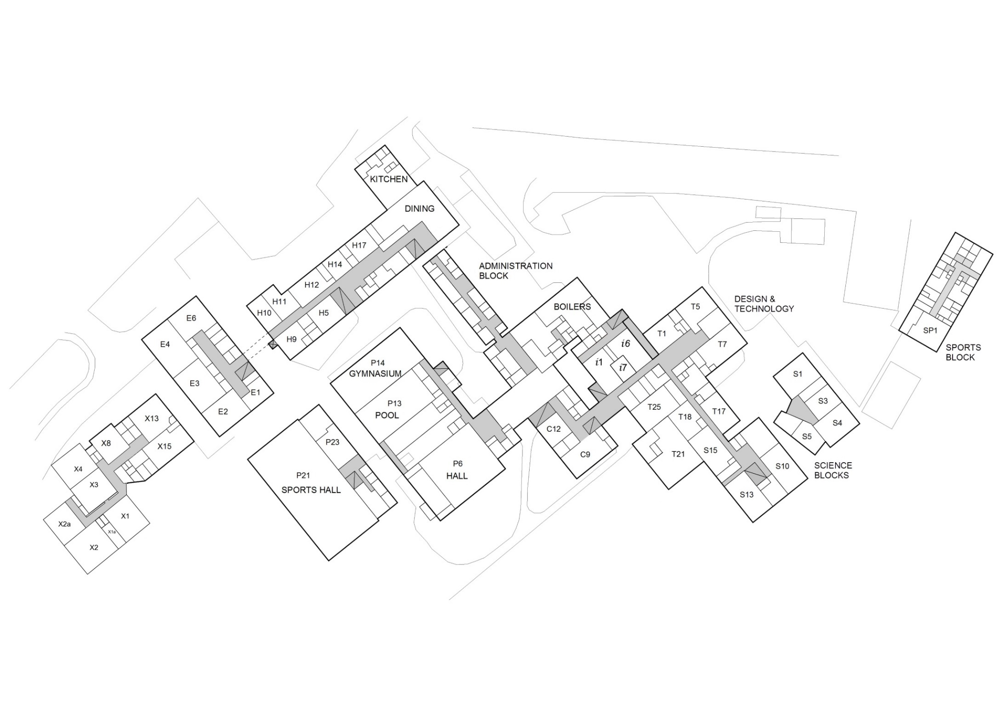

Appendix J2
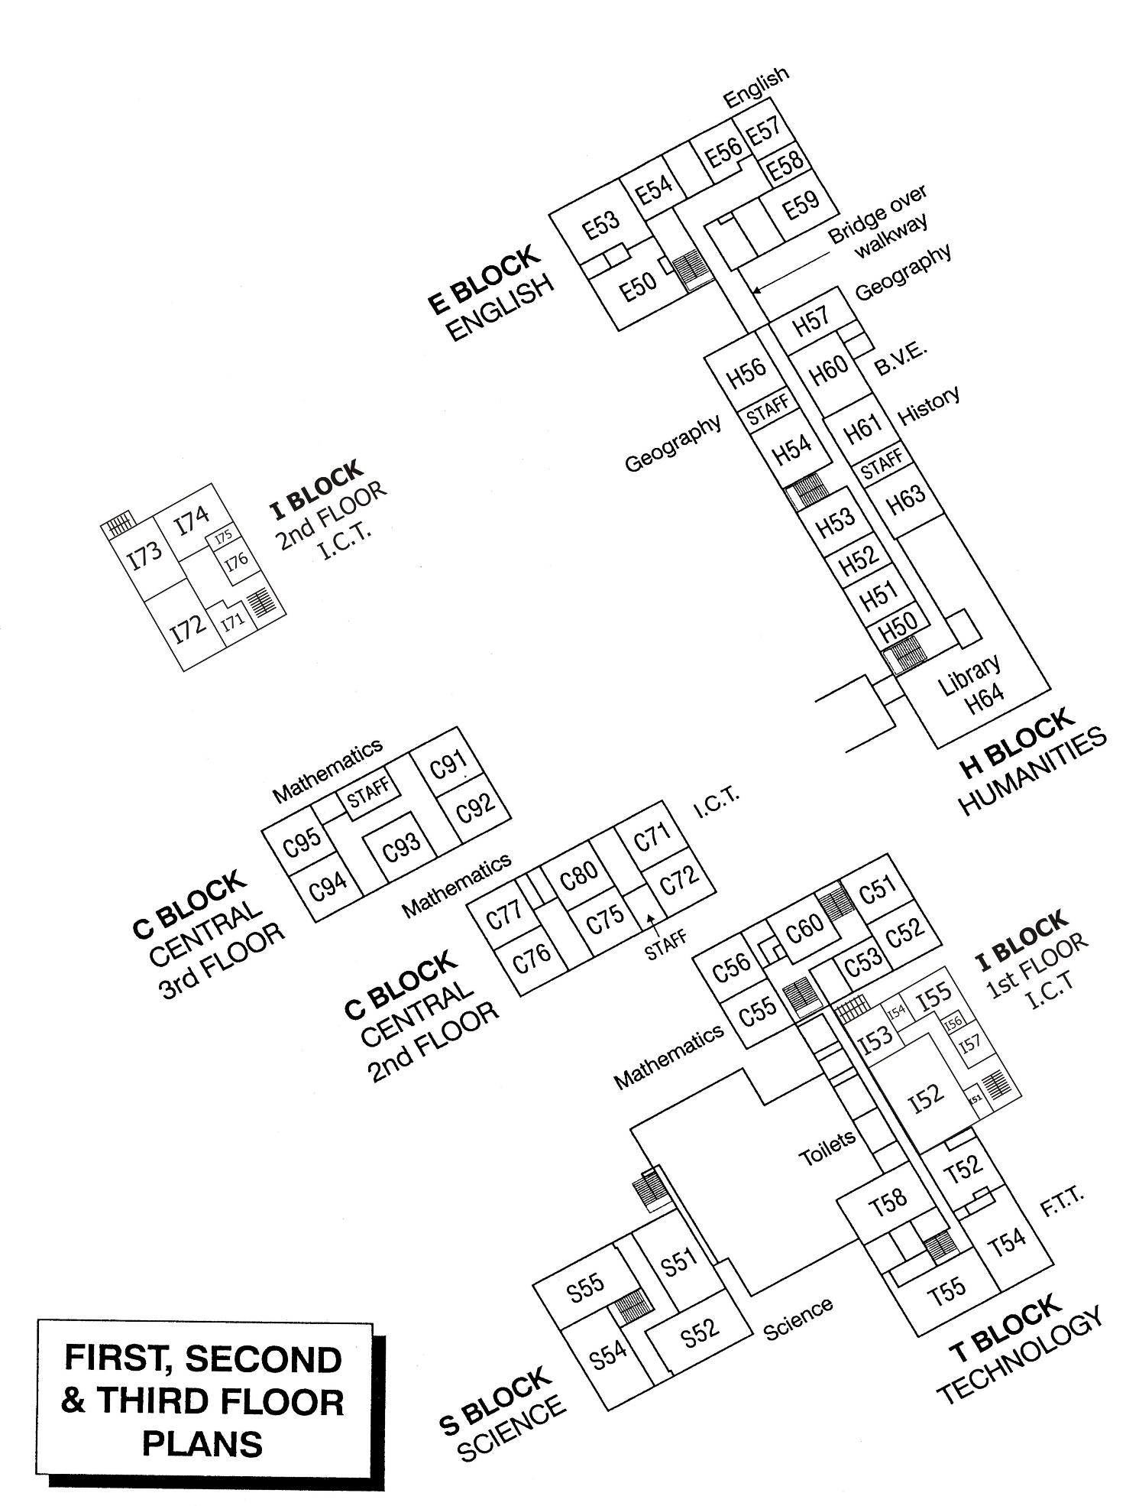

Appendix K

Shenfield High School
Dealing with site incidents - A Crisis Management Document

Site Details : Shenfield High School
Alexander Lane
Shenfield
Brentwood
Essex CM15 8RY
Headteacher: Ms C Herman
Email: shs@shenfield.essex.sch.uk
Tel : 01277 219131
Fax : 01277 226422

1. Main gas taps Boiler room
Opp Plant room (X Block)
Kitchen
Pavilion

2. Main electricity intake Bolier House
3. Main water intake In car park by Alexander Lane
X Block water intake In pavement in Chelmsford Road, adjacent exit
Pavilion In main boiler house

4. Site incident control room Headteacher's office A7

5. Media Briefing room A5

6. Next of kin details HR - SIMS

7. Registers - pupils Student Services-SIMS

8. Mobile phones 07517 949899 – Site Team

9. Room for accommodating parents i52 or Pavilion
of students involved in incidents

10. Dangerous chemicals storage

Oxygen + Hydrogen in Science Department:
Oxygen, Size V - S53
Hydrogen, Size B - S52
Co₂, small - Chemical Store, within Chemistry Prep. room

Shenfield High School is included in the register of principal emergency rest centres under
the Essex Civil Emergency Plan.

See Section 3.1 for the responsibilities for your School Incident Management Team

